Polly
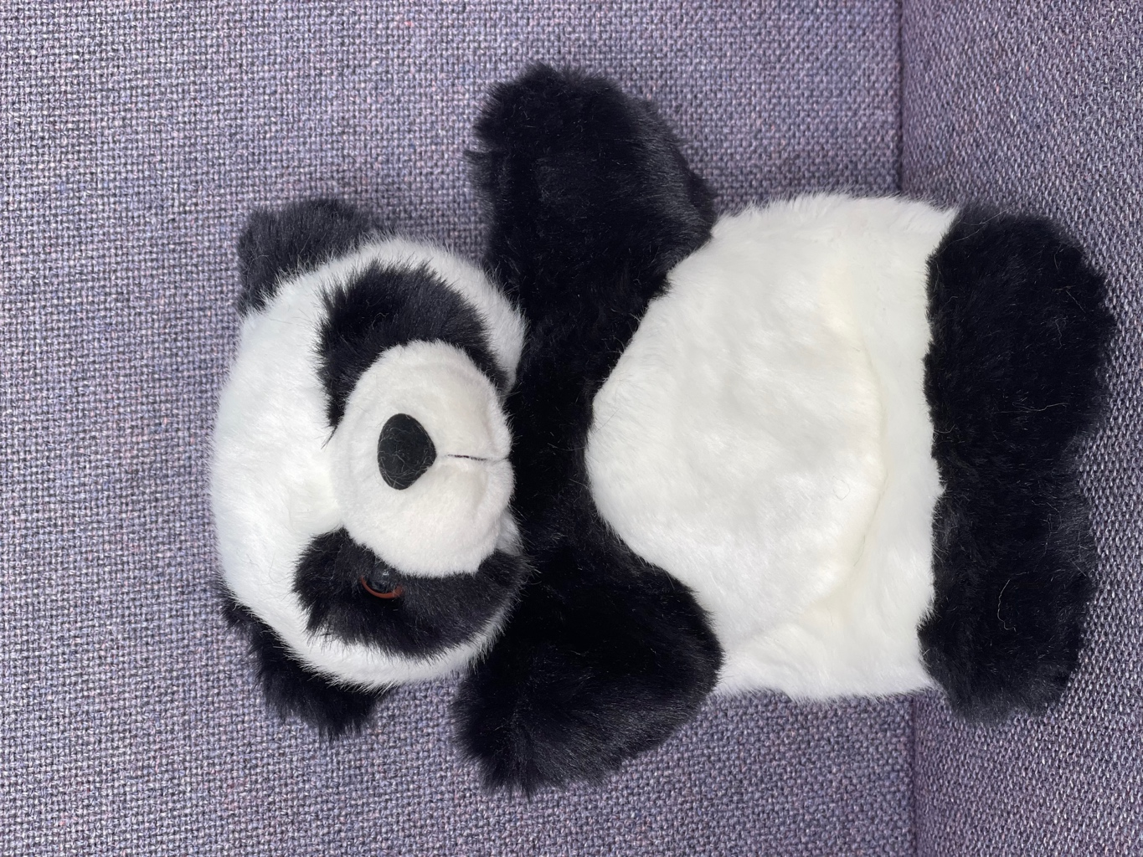
The Predictor Panda
She makes predictions as she reads using picture and text clues.
I think that this book will be about ….
I wonder if …
I predict…….because…….
This story is similar to …so I imagine that …….happens.

