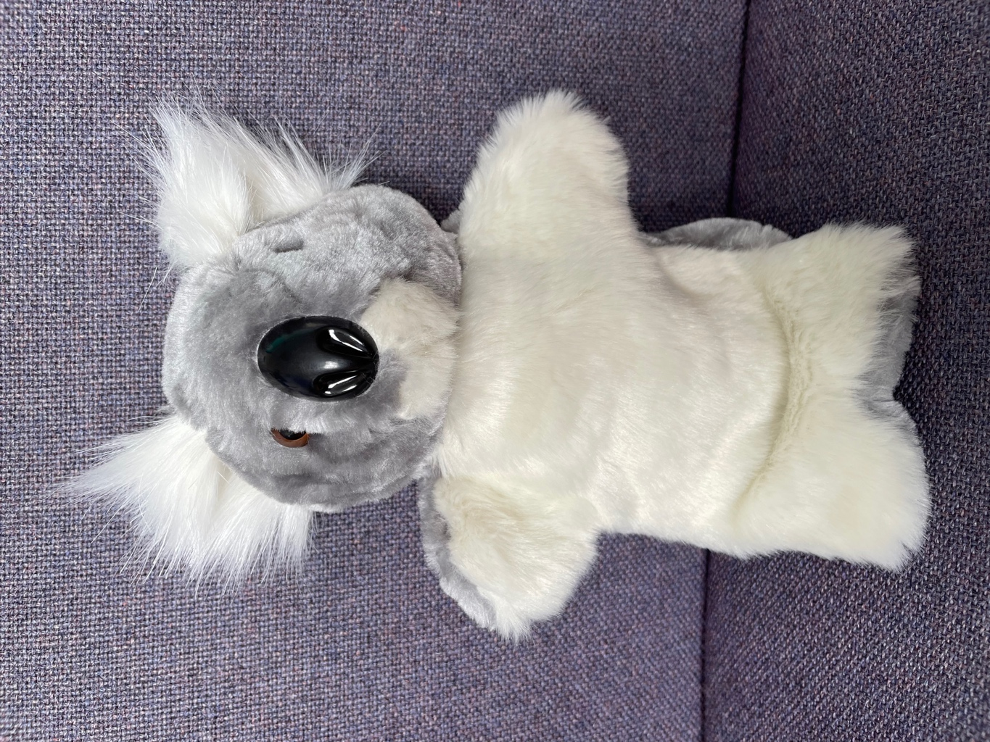
Quentin
The Questioner Koala
He asks questions as he reads.
What….?
Where….?
Why….?
When….?
Who….?
How….?

