Information for Parents
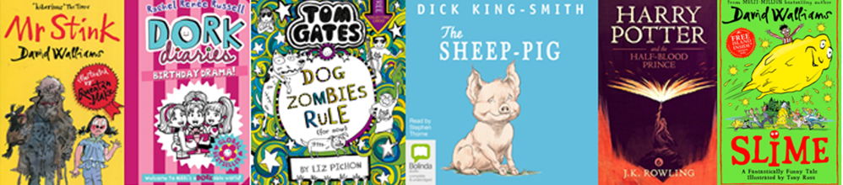
The Summer Reading Challenge
Despite current circumstances, the annual Summer Reading Challenge will still take place this year. The challenge for children aged 4-12 to read 6 books over the Summer will be a little different, you can find out more details about this year’s digital challenge at www.summerreadingchallenge.org.uk
To help children get free access to reading material, Cornwall Library Service have provided each child in the school with an electronic library card number. This will allow them free access to e-books and e-audiobooks through the Borrowbox library app. There are no overdue charges, no loan charges, it is completely free!
Children will be able to access this material in school and from home if a mobile device is available.
If you wish to access from home, the library card number will be provided by e-mail/letter/???* School to personalise**
You will need to:
- Download the Borrowbox app (available for all Android and Apple devices)
- Sign in.
- In the Library box select Cornwall Libraries Primary School
- Type your library card number in the Borrower Number box
- Your PIN is the last 4 digits of your library card number
- The first time you log in you will need to enter an e-mail address – this is not shared and is only used to let you know when your reservations are available or if a book needs to be renewed.
- If siblings are sharing a device then it is recommended that only one login is used. Borrowbox remembers which page of the book you have reached but if you log out and then back in again, this page number is lost. Each login can borrow up to 10 ebooks and 10 e-audiobooks so there should be enough for two users.
- Books are borrowed for 2 weeks after which they disappear from your device. If you haven’t finished you can renew for up to four more weeks. If you finish your book quickly or decide you don’t like it then you can return it early.
- You’re all set. Start reading or listening!
(Just like in a real library some books will have waiting lists. If a book you want is not available immediately click Reserve and add yourself to the end of the queue. If waiting lists become too long Cornwall Libraries will look to buy extra copies.) There will always be something available to borrow.
If you wish to upgrade this electronic membership to a full Cornwall Library membership then you can join up for free at your local library when these reopen and have access to the huge range of Books, DVDs, and activities that are available.
If your child already has a Cornwall Library Card they can of course use this. However you may prefer to use this new membership number when using Borrowbox as it will only contain children’s books.
Kind Regards,

