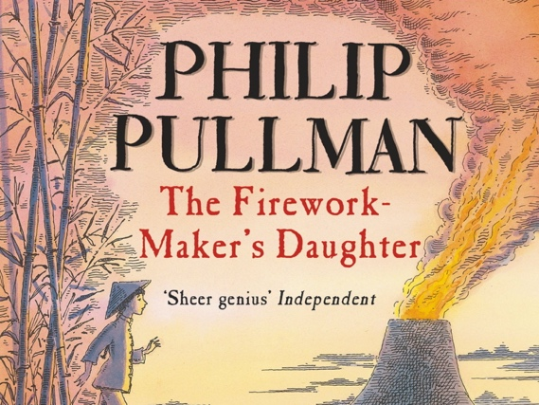

The Firework-Maker’s Daughter
Quest to Mount Merapi

A thousand miles ago, in a country east of the jungle and south of the mountains, there lived a Firework-Maker called Lalchand and his daughter Lila. Lila grew up watching her father create magnificent, jaw-dropping fireworks. Soon, she was joining in. As she grew older, she asked her father, “Am I a proper Firework-Maker now?”
“No, no,” he replied. “You still have a lot to learn! A true Firework-Maker must travel to the Grotto of Razvani, the Fire-Fiend, in the heart of Mount Merapi. Once there, they must bring back Royal Sulphur. The ingredient that makes the finest fireworks.”

Early the next morning, Lila left a note for her father on the workshop bench and crept away. When Lalchand awoke, he read Lila’s note in horror! He raced to find Chulak, Lila’s best friend. “Lila has gone off by herself to Mount Merapi! She doesn’t realise she needs a flask of magic water for protection, from the Goddess of the Emerald Lake.“ Chulak made a promise to Lalchand he would follow Lila and return her home safely. Heavy-hearted, Lalchand returned home.

Chulak walked all day, as evening fell, he reached the Emerald Lake. As if from nowhere, the Goddess appeared. One after another, the villagers bowed to her and asked for her help. Just as she was returning to the lake, Chulak thrust his way to the water’s edge and knelt down. “Goddess!” he called. “Please hear me too. We’ve got a friend who wants to be a Firework-Maker. So she’s gone to get Royal Sulphur from Razvani at Mount Merapi. She didn’t know about getting a flask of magic water for protection. Please, as a great favour, could you give us some? Then we can try to catch her up.” Chulak paused. The Goddess nodded and handed Chulak a small, silver flask. “Mount Merapi is far away. You had better set off at once! Your friend is lucky to have you.”

Meanwhile, Lila had come to the end of the wild, impenetrable jungle. As she came to a bend in the path, she saw it. Mount Merapi - powerful and dominating - rumbling in the distance. As she walked, the ground became steeper and steeper and it began to feel warm under her feet. She dragged herself on. Before long, she came to a great hole, as tall as a house. The moonlight shone into it a little way, but the hole went deeper still. The scent of sulphur filled the air and Lila knew she had reached her goal: the Grotto of the Fire-Fiend.

Lila stepped inside. The floor was baking hot! She walked on, deeper and deeper into the rock. Soon, the tunnel opened up into great, gloomy cavern. Empty of life. Her heart sank. There was nothing here. She crumbled to the floor.

As if that were a signal, a little flame licked out of the rocky wall for an instant, and went out. Then another. And another. Suddenly, the earth shook, with a harsh grating the wall tore open and the cavern was full of light. Into the heart of the light leapt Razvani, whose body was a mass of flame and whose face a mask of scorching light. In a voice like the roar of a forest fire, Razvani spoke. “By what right have you come to my Grotto?”
“I want to be a Firework-Maker,” she managed. Razvani laughed a great laugh.
“What do you want from me?”
“Royal Sulphur,” she gasped. He laughed even harder.
“You must walk in the flames, like every other Firework-Maker. I expect you have brought the magic water you require?”
“I’ve got nothing,” Lila cried. “I just wanted to be a Firework-Maker!”
“Still, you must walk into my flames. You have come for the Royal Sulphur - receive it from my hands!” She was terribly afraid. But she knew she must do it or return empty handed to her father.

She took a step forward. And another. Her poor feet burned. When she could bear it no more, she heard a great cry behind her…
“Lila! The water! Take it!”
A small figure thrust a flask into her hands. She tore off the lid and drank deeply. At once, a marvellous coolness spread through her body. By now, she was face to face with Razvani. But the flames were harmless now.
“Where is the Royal Sulphur?” she asked.
“It does not exist,” explained Razvani. “The quest for the Royal Sulphur is a trick to see of the young Firework-Maker has the passion and drive to create the most spectacular displays.” As he said that, the Fire-Fiend dwindled away.

Lila turned away, she felt dazed and disappointed. But then she saw Chulak and ran to him. Apart from slight burns to his feet also, he was well, and the pair climbed back down the volcano. Lalchand felt nothing but relief when Lila returned home and she grew to be one of the greatest Firework-Makers in history.

