Don’t forget phonics! https://www.youtube.com/playlist?list=PLDe74j1F52zQ24vACH9z4zO53N_JCYlSl

Monkey Puzzle

Session 1.
Listen to: Monkey Puzzle – Julia Donaldson and Axel Scheffler. https://www.bing.com/videos/search?q=youtube+monkey+puzzle&docid=608025815170419710&mid=FA15E34702269D520F19FA15E34702269D520F19&view=detail&FORM=VIRE
Practise your reading and try and sort the descriptions to the right animal.

Brown and furry and nice to cuddle | Elephant
None of my babies look like me | Spider
Black, hairy and fat | Parrot
Claws and feathery wings | Butterfly
Great, grey hunk | Monkey

You can also add your own for the other animals or challenge yourself to add some for animals not even in the book!
Animal | Description
Snake

Bat

Session 2.
Listen to: Monkey Puzzle – Julia Donaldson and Axel Scheffler.
(There are lots of versions on youtube …what’s your favourite?)

Try and sort these descriptions to the right senses.

hiss green slimy thick, baggy knees

fruit squawk, squabble and shriek black

swallow a fly croak brown
What does it feel like?

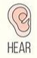What sound does it make?

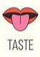What does it like to taste?

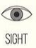What does it look like?
Session 3.
Listen to Monkey Puzzle.
Give a sensory description of your favourite animal. Can you add what it smells like?!
(What does an anteater sound like, Luke? Bettsie, how would you describe the feel of a unicorn horn?...)
My animal feels ______________________________________
__________________________________________________
You can hear my animal _________________________________
__________________________________________________

My animal likes to taste _________________________________
__________________________________________________

My animal looks _______________________________________
__________________________________________________

The smell of my animal is ________________________________
__________________________________________________

My animal is a _____________________________________ .

Session 4.
Using part of your description add a page for Monkey Puzzle where the butterfly shows monkey your creature.

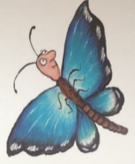
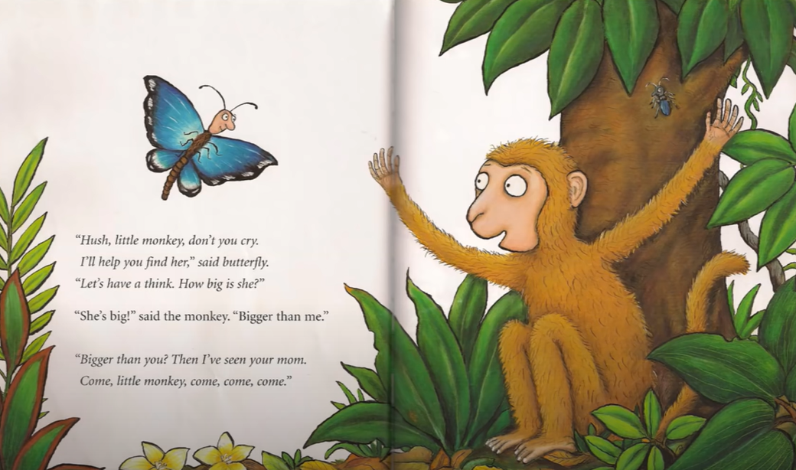

No, no, no!
My mum’s not

My mum’s not

That’s a ……………………………………!

Session 5.
Watch - https://youtu.be/QVyeBgzi7Qc
Can you re-tell the story of Monkey Puzzle? Maybe someone in your family could help be some animals. Maybe you could use some toys to help you out or even make some puppets or masks…
Have fun!

https://www.firstpalette.com/printable/monkey-mask.html

