English Home Learning Grid (Y2) – Non-fiction: Information Text – Japanese Animals

Please write the date and WALT in your book and complete each day.
There are links to games/videos that might support both parents and children.
Some of these activities may need adult support however other tasks can be completed independently. Please make a comment on how much your child was supported in each activity.

The link below describes the purpose and features of an Information Text in more detail:
https://www.theschoolrun.com/information-text

Tuesday 14th April 2020  WALT: research and write down key information in the form of notes.  Starter  Practice your note-taking. Watch the video and write down 3 key facts. Think about the following questions to help you.  https://www.bbc.co.uk/bitesize/clips/z87w2hv  Can you write down one similarity between the human and elephant?  How big is the elephants ear?  What is a difference between the lady and the elephant?  Activity – Researching Japanese Animals  Choose 1 animal that you would like to find out more about from the list on page 4.  Use books, Ipads or computers to help you research your chosen animal, using the question prompts on page 5.  I would like to see at least 3 notes to answer each question.  You can record your research notes on the spider diagram by printing it or drawing and completing your own spider diagram in your book.  Challenge  Create two additional questions that you would like to research and answer about your chosen animal.  (Adult guide, printables and examples can be found on pages 4 to 7 of the document)  NOTE: You do not have to print the resources, your child can copy the worksheet into their books or you can print it for them to work on. | Wednesday 15th April 2020  WALT: use a range of texts to identify the key features of an information text.  Starter  Activity – Key features of an information text  Choose 2 information texts to read and complete the attached features checklist.  Challenge  Create a success criteria ordering the key features into 3 groups:  Red: features that needed to be included.  Green: features that will make my writing more detailed and interesting to read.  Blue: features that would help the reader to find what they are looking for.  Adult guide, printables and examples can be found on pages 8 to 14 of the document)  NOTE: You do not have to print the resources, your child can copy the worksheet into their books or you can print it for them to work on.
Thursday 16th April 2020  WALT: turn notes into full sentences to create an informative and interesting animal information sheet.  Starter  Explore different sentence types (command, statement, question and exclamation) using the clips below and write one of each sentence type about the picture on page 16 . Note: each clip is only 30 seconds long so this will not take long!  Command: https://www.bbc.co.uk/bitesize/topics/zrqqtfr/articles/z8strwx  Statement: https://www.bbc.co.uk/bitesize/articles/z97r2nb  Question: https://www.bbc.co.uk/bitesize/topics/zrqqtfr/articles/z2xdng8  Exclamation: https://www.bbc.co.uk/bitesize/topics/zrqqtfr/articles/zqbjy4j  Activity – Write up  Write an introduction to tell the reader the main points that you will talk about in your information sheet. (Examples are further down on today’s section).  Write up 2 of your chosen questions. Don’t forget to use the sentences types above at least once each in your writing.  Challenge  Can you use sub-headings within your writing? You will need to write a new sub-heading for each question.  Adult guide, printables and examples can be found on pages 15 to 17 of the document)  NOTE: You do not have to print the resources, your child can copy the worksheet into their books or you can print it for them to work on. | Friday 17th April 2020  WALT: use the features of an information text to complete our information text.  Starter  Use conjunctions to add more detail to each sentence. Complete the sheet on page 19.  Activity – Write up  Write up the rest of your questions. Make sure you use conjunctions to add detail to your sentences.  Challenge  Can you use diagonal strokes to begin to join your handwriting?  Adult guide, printables and examples can be found on pages 18 to 21 of the document)  NOTE: You do not have to print the resources, your child can copy the worksheet into their books or you can print it for them to work on.
Glossary of terms
Conjunction: a conjunction is a word that joins one part of a text to another.
Co-ordinating conjunctions (but, and so) link words, phrases or clauses which are equally important.
Subordinating conjunctions (if, when, however, because, while) link a main clause with a subordinating (or dependent) clause.
You can find the conjunctions word mats on page 21.

Information text: An information text is a piece of non-fiction writing which gives information about a particular thing (for example: Cleopatra, Ancient Egypt, recycling or volcanoes). Information texts are sometimes called non-chronological reports, because they are giving information about something without mentioning the order in which it happened.

Notes: a brief record of points or ideas written down as an aid to memory.

Sentence Types Definitions and Examples

Sentence Type | Definition | Example
Command | Commands are a type of sentence in which someone is being told to do something.  Command sentences usually, but not always, start with an imperative (bossy) verb because they tell someone to do something. | Read on to find out more!  Look out for Dugongs when you visit Japan!
Statement | A statement sentence asserts or declares a fact, opinion or idea.  Statement sentences never ask a question, give a command or make a request. | Dugongs live in warm coastal waters.  Dugongs have bad eyesight.
Question | A question is a type of sentence that we ask or write to gain further information from a person or people responding.  Often, but not always, question sentences begin with one of the following words, who, what, when, where, why, how or have. | Have you ever seen a Dugong?  What do Dugongs eat?
Exclamation | An exclamation is forceful statement which expresses high levels of emotion or excitement.  In primary school, we always begin with ‘what’ or ‘how’ and are usually punctuated by an exclamation mark (!). | How exciting!  What a treat!

Tuesday 14th April 2020

WALT: research facts about Japan and write down key information in the form of notes.

Starter
Practice your note-taking.
https://www.bbc.co.uk/bitesize/clips/z87w2hv
Watch the video and write down 3 key facts. Think about the following questions to help you.
- Can you write down one similarity between the human and elephant?
- How big is an elephants ear?
- What is a difference between the lady and the elephant?

Activity – Researching Japan
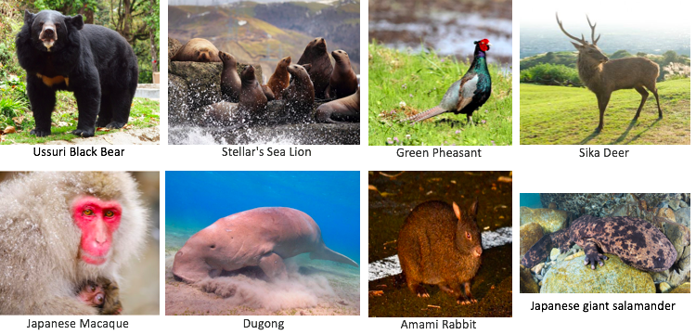
Choose 1 animal that you would like to find out more about from the list below:
Use books, Ipads or computers to help you research your chosen animal. I would like to see at least 3 facts about each question.
You can record your facts on the spider diagram by printing it or alternatively, you can draw and complete your own spider diagram in your book.

Challenge
Think of your own 2 additional questions that you would like to research and make notes on.

Questions to help you research
(Choose at least 3 questions to research and write 3 notes to answer each question).

Where do ______ live?
What do _____ eat?
How have _______ adapted to their habitat?
How big is a _______?

Fun facts (research 3 ‘fun’ or interesting facts about your chosen animal).

Miss Bowden has completed an example for you below

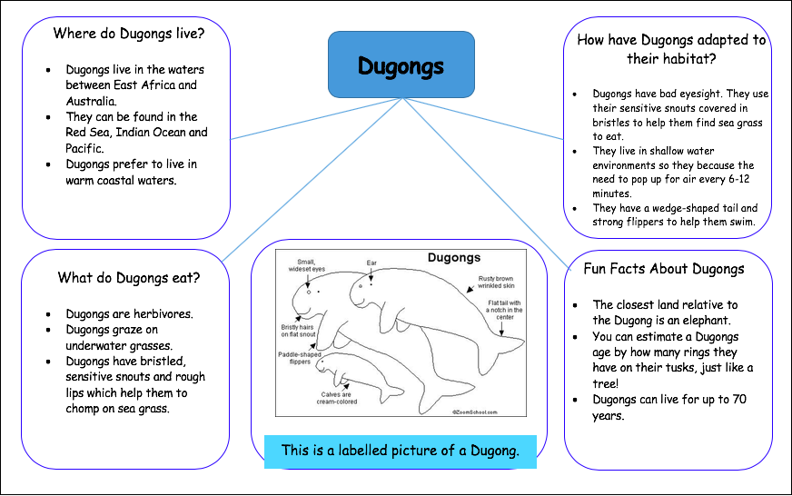
Completed example for note taking
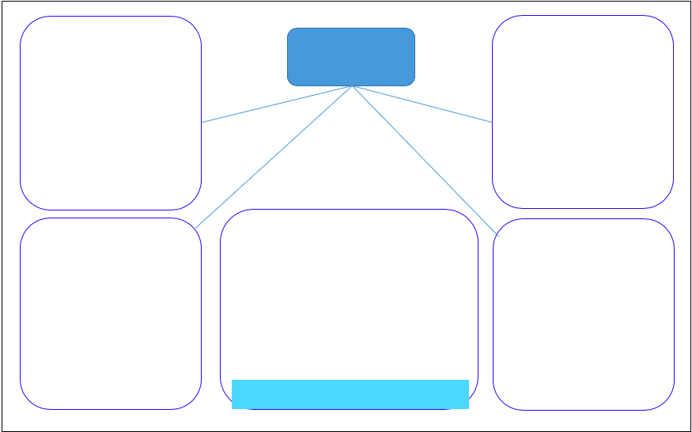
Worksheet/Example for note taking

Wednesday 15th April 2020

WALT: use a range of texts to identify the key features of an information text.

Starter: finish your notes from yesterday

Activity – Key features of an information text
Choose 2 information texts to read and complete the attached features checklist.

Challenge
Create a success criteria ordering the key features into 3 groups:
Red: features that needed to be included.
Green: features that will make my writing more detailed and interesting to read.
Blue: features that would help the reader to find what they are looking for.

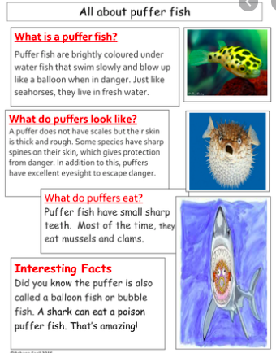
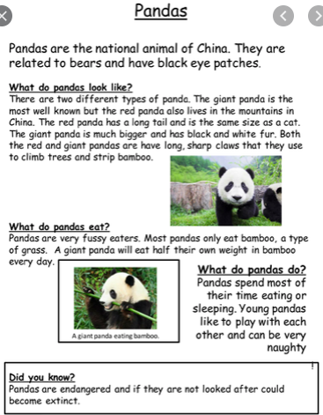
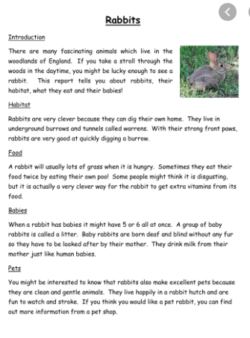
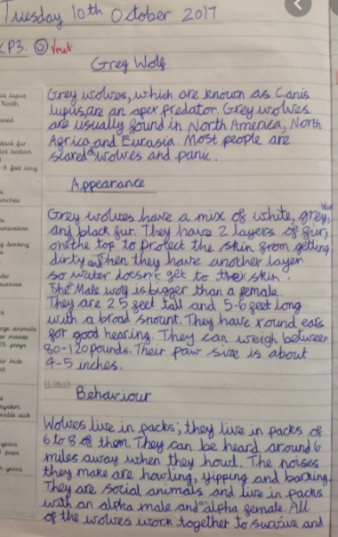

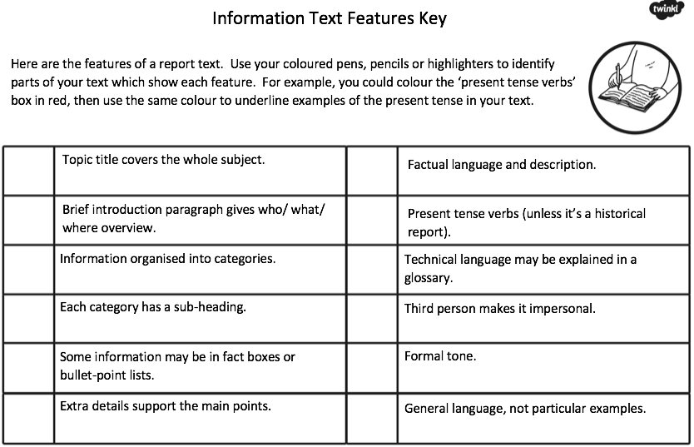
Features of an Information Text Checklist
Create a success criteria ordering the key features into 3 groups:
Challenge: Success Criteria
Red: features that needed to be included.
Green: features that will make my writing more detailed and interesting to read.
Blue: features that would help the reader to find what they are looking for.
Success Criteria: Writing an Information Text 15/04/20
I can… | include an appropriate title

Thursday 16th April

WALT: turn notes into full sentences to create an informative and interesting information text.

Starter
Explore different sentence types (command, statement, question and exclamation) using the clips below and write one of each sentence type about the picture on the following page. Note: each clip is only 30 seconds long so this will not take long!
Command: https://www.bbc.co.uk/bitesize/topics/zrqqtfr/articles/z8strwx
Statement: https://www.bbc.co.uk/bitesize/articles/z97r2nb
Question: https://www.bbc.co.uk/bitesize/topics/zrqqtfr/articles/z2xdng8
Exclamation: https://www.bbc.co.uk/bitesize/topics/zrqqtfr/articles/zqbjy4j

Activity – Write up
Write an introduction to tell the reader the main points that you will talk about in your text. (Examples are further down on today’s section).

Write up 2 of your chosen questions. Don’t forget to use the sentences types above at least once each in your writing.

Challenge
Can you use sub-headings within your writing? You will need to write a new sub-heading for each question.

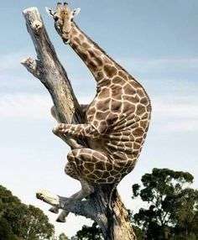
Command:

Statement:

Question:

Exclamation:

Example of today’s task

Dugongs

Introduction
Dugongs are large mammals that live their whole life in the sea. They are sometimes called "sea cows" as they eat large amounts of sea grass. Dugongs are more closely related to elephants than to other sea creatures. Their closest aquatic relative is the manatee, a fresh water species found in America and West Africa. This leaflet will tell you all about Dugongs, including what they eat, where they live and how they adapt to their habitat. Read on to find out more.

What do Dugongs eat?
Dugongs are herbivores and eat underwater grass. They have bristly, sensitive snouts to help them find their food and rough lips to help them chew it. How exciting!
Where do Dugongs live?
Dugongs live in the waters between East Africa and Australia. They can be found in the Red Sea, Indian Ocean and Pacific. Dugongs prefer to live in warm, coastal waters because this is where they can find the tastiest underwater grass. Have you ever seen a Dugong? Look out for one when you visit Japan.

KEY (to help stuck children and adults!)
Headings
Sub-headings
Use of command/statement/question/exclamation sentences

Friday 17th April 2020

WALT: use the features of an information text to complete our leaflets.

Starter
Watch the video:
https://www.bbc.co.uk/bitesize/topics/zwwp8mn/articles/z9wvqhv

Use conjunctions to add more detail to each sentence. Complete the sheet below (you can write the answers in your book).

Activity – Write up
Write up the rest of your facts. Make sure you use conjunctions to add detail to your sentences. Use the conjunctions word mats to help you vary your conjunctions.

Challenge
Can you use diagonal strokes to begin to join your handwriting?

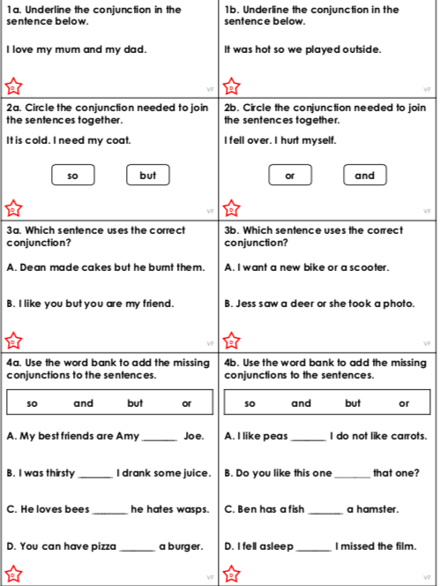
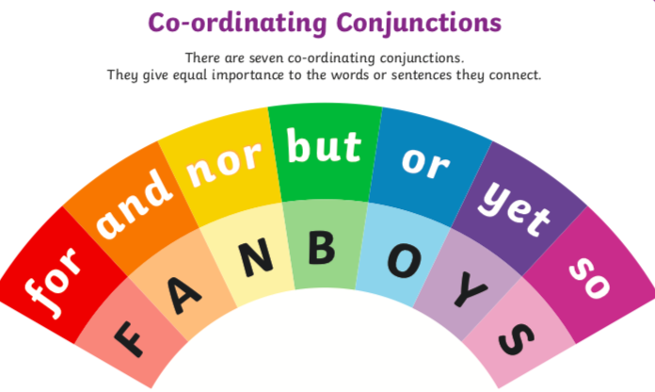
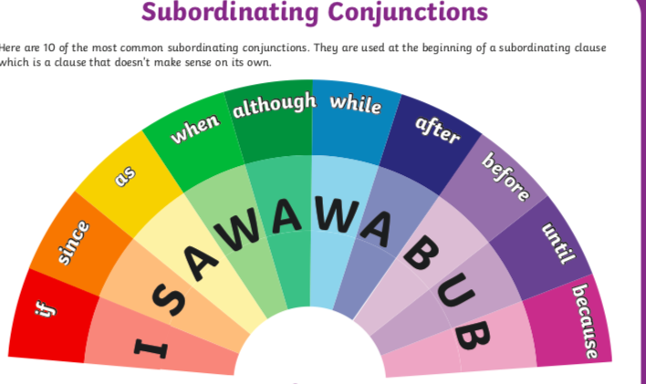

Example of today’s task

Dugongs

Introduction
Dugongs are large mammals that live their whole life in the sea. They are sometimes called "sea cows" because they eat large amounts of sea grass. Dugongs are more closely related to elephants than to other sea creatures. Their closest aquatic relative is the manatee, a fresh water species found in America and West Africa. This leaflet will tell you all about Dugongs, including what they eat, where they live and how they adapt to their habitat. Read on to find out more.

What do Dugongs eat?
Dugongs are herbivores and eat underwater grass. They have bristly, sensitive snouts to help them find their food and rough lips to help them chew it. How exciting!
Where do Dugongs live?
Dugongs live in the waters between East Africa and Australia. They can be found in the Red Sea, Indian Ocean and Pacific. Dugongs prefer to live in warm, coastal waters because this is where they can find the tastiest underwater grass. Have you ever seen a Dugong? Look out for one when you visit Japan.

KEY (to help stuck children and adults!)
Headings
Sub-headings
Use of command/statement/question/exclamation sentences
Conjunctions

