Curriculum Home Learning Grid (Y2)- Geography - Japan

Please write the date and WALT in your book and complete each day.
There are links to games/videos that might support both parents and children.
Some of these activities may need adult support however other tasks can be completed independently. Please make a comment on how much your child was supported in each activity.
Resources are found below the grid.

Tuesday 14th April  WALT: understand where Japan is in the world  Activity – Labelling a Map  - Find Japan on the Map – print or trace the map on the resources pages and colour in Japan.  - Label the world’s 7 continents and 5 oceans using the map on page 5 to help you.  - Label the Equator on your map.  Challenge: Can you use the maps and link below to help you label the UK and its 4 countries?  World Map Link: https://www.mapsofworld.com  Adult guide, printables and examples can be found on pages 4 to 5 of the document)  NOTE: You do not have to print the resources, your child can copy the worksheet into their books or you can print it for them to work on. | Wednesday 15th April  WALT: create a snapshot of Japan to show a summary of the country.  Activity: Japan Snapshot  Use your researching skills to complete the Snapshot of Japan.  (This can be created as a poster to avoid printing).  Website Links:  https://www.3dgeography.co.uk/geography-of-japan  https://www.natgeokids.com/uk/discover/geography/countries/facts-about-japan/  Adult guide, printables and examples can be found on page 6 of the document)  NOTE: You do not have to print the resources, your child can copy the worksheet into their books or you can print it for them to work on.
Thursday 16th April  WALT: understand similarities and differences between Japan and the UK from a human geography perspective.  Activity: Venn Diagram  Watch the video and use the links below to make notes on Tokyo, Japan and London, UK. Complete the Venn Diagram using your notes – write down any similarities in the middle part of the Venn Diagram.  Video and Website Links:  https://www.bbc.co.uk/teach/class-clips-video/geography-ks1-ks2-your-world-tokyo-london/zv9pbdm  https://www.3dgeography.co.uk/geography-of-japan  https://www.3dgeography.co.uk/geography-of-the-uk  Challenge: Can you now compare your similarities between Tokyo and London to Looe, what is similar and what is different?  Adult guide, printables and examples can be found on pages 7 to 8 of the document)  NOTE: You do not have to print the resources, your child can copy the worksheet into their books or you can print it for them to work on. | Friday 17th April  WALT: understand similarities and differences between Japan and the UK from a physical geography perspective.  Activity: Comparing the Physical Geography of Japan and the UK  Watch the video and use the links below to make notes on Tokyo, Japan and Looe. Complete the second Venn Diagram using your notes – write down any similarities in the middle part of the Venn Diagram.  Japan  Focus on the ‘geography and landscape’ part: https://www.natgeokids.com/uk/discover/geography/countries/facts-about-japan/  https://web-japan.org/kidsweb/explore/nature/index.html  https://www.nationalgeographic.com/news/2011/3/110311-tsunami-facts-japan-earthquake-hawaii/  Use your local knowledge to help you with filling in the facts about Looe. You could go on a walk as part of your daily exercise to help you.  Challenge: Research the weather in Tokyo and Looe and create a weather report video or poster based on your findings.  Adult guide, printables and examples can be found on page 9 of the document)  NOTE: You do not have to print the resources, your child can copy the worksheet into their books or you can print it for them to work on.
Glossary of terms
Human geography=landmarks linked to geography that have been created by humans (e.g temple)
Physical geography=landmarks linked to geography that have been created naturally (e.g mountain)
Industry

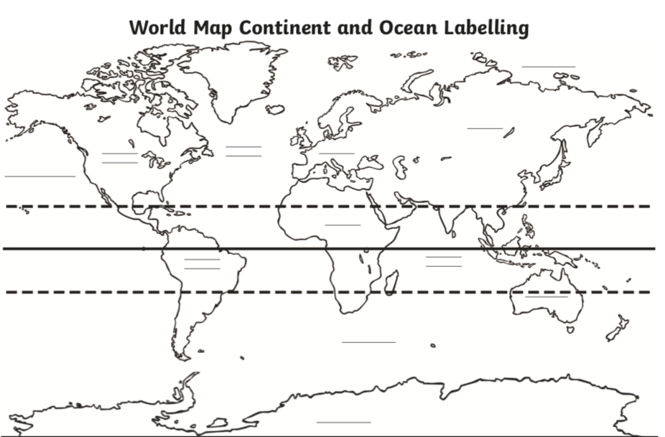
Tuesday 14th April – World Map Worksheet
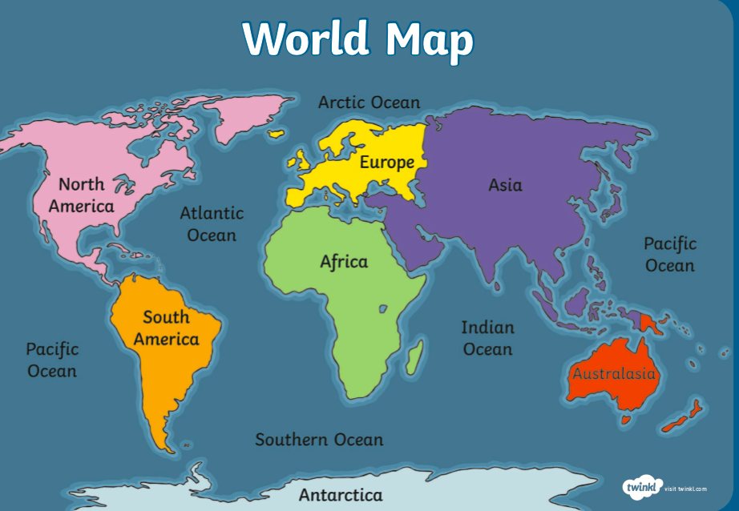
Tuesday 14th April – World Map Support Sheet
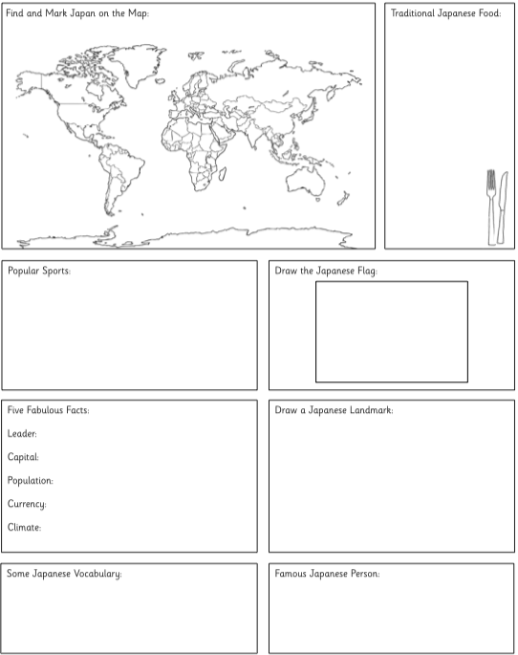
Wednesday 15th April – Japan Snapshot

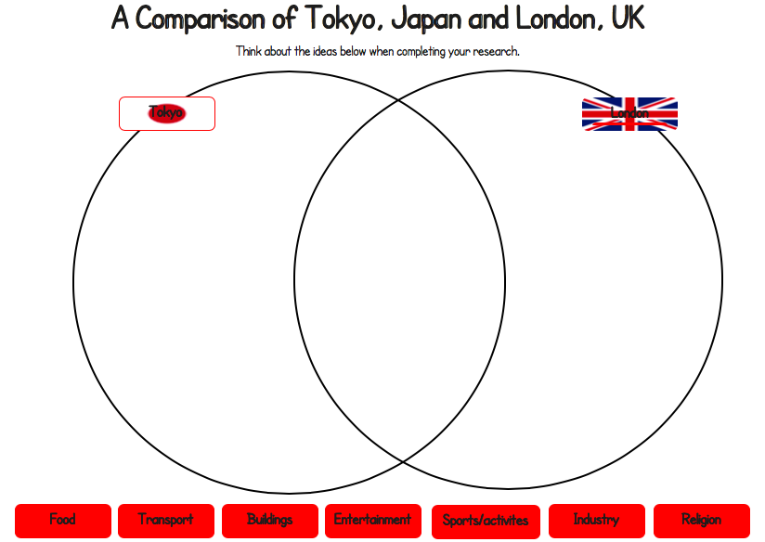
Thursday 16th April – Venn Diagram
Challenge: Comparing findings from the Venn Diagram with Gunnislake

Similarities between Gunnislake and London and Tokyo | Differences between Gunnislake and London and Tokyo

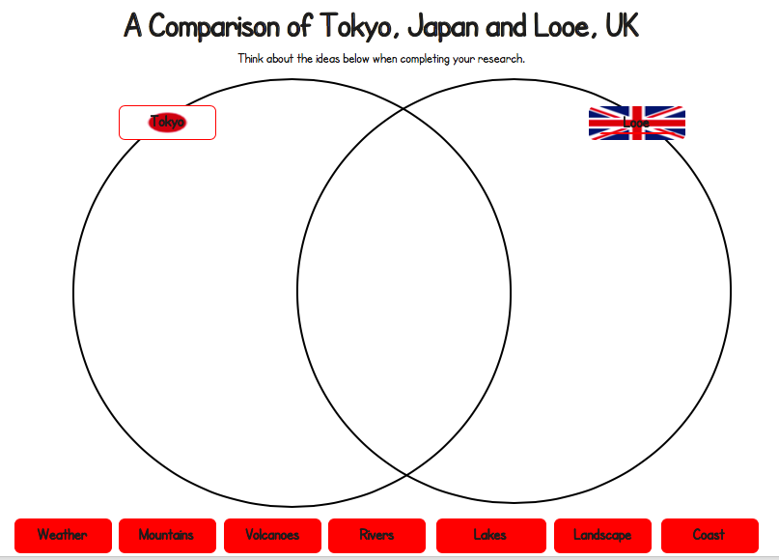
Friday 17th April – Venn Diagram 2

A comparison of Gunnislake and Tokyo.
Tokyo
Gunnislake

