Don’t forget phonics! https://www.youtube.com/playlist?list=PLDe74j1F52zQ24vACH9z4zO53N_JCYlSl
Welcome Home, Bear
Session 1. Watch https://www.bing.com/videos/search?q=welcome+home+bear&&view=detail&mid=2B50708E9571B453EB492B50708E9571B453EB49&rvsmid=28FACC64BAEA054E45FD28FACC64BAEA054E45FD&FORM=VDRVRV
It’s a bit like the story “No place like home” by Jonathan Emmett that we read in class.
Match the description to the habitat and say which animal lives there.
Animal Mole Bear Orangutan Goat
Bird Hippo Camel Octopus
Habitat Nest Burrow Ocean Rainforest
Riverbank Woods Cliffside Desert
Description | Habitat | Animal
Mud
Stuffy, dirty, underground
Lots of trees and LOTS of rain
Steep and high
High in the trees
Hot and sandy
Deep and wet
Grass and trees
Session 2. Watch https://www.bing.com/videos/search?q=welcome+home+bear&&view=detail&mid=2B50708E9571B453EB492B50708E9571B453EB49&rvsmid=28FACC64BAEA054E45FD28FACC64BAEA054E45FD&FORM=VDRVRV
The descriptions of the habitats are very simple. I think we can do better!
Pick at least 2 habitats from https://www.bbc.co.uk/bitesize/topics/zx882hv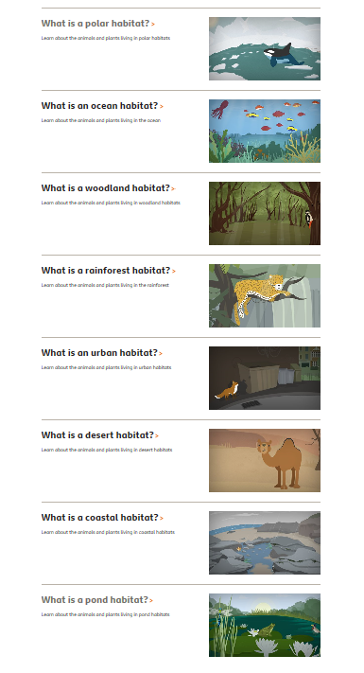

They give you lots of descriptive words. (Remember what you see, hear, feel etc can help with description).
For each habitat write down the words that will help you. This is an example.
Dirty Sandy Rocky
Dark
Dry and dusty
Underground
Crepuscular

Using paper and pencil you can add as many lines as you like!

Session 3.
Choose one habitat, from last session where you have your fab word choices. Describe that habitat in detail.
I’ve picked a habitat that’s not on the list – can you guess where it is?
My habitat is dark, but dry. Some say it is dirty, but there are many kinds of dirt. My habitat is sometimes rocky and bumpy. Sometimes there are twisty, dangling, tasty roots. Although, my habitat can be soft and crumbly like cake mixture. I love it’s crepuscular light.

How will you challenge yourself for your description?
- An “and” sentence – My habitat is ……………..and …………………….. .
- Whizzy vocabulary.
- A list sentence – My habitat has …………….., ……………………., ……………… (noun).
(Example: My habitat has twisty, dangling, tasty roots. My habitat has windy, cold, snowy plains. My habitat has tall, leafy, exotic trees.)
- A metaphor
(Remember it is “as” or “like” for example: ‘soft and crumbly like cake mixture’.)

My habitat is ____________________________________________________________________________________________________________

Session 4 an 5 combined.

Pick an animal you like – it could be a favourite cuddly or one you have seen at a zoo or on TV…
What would be it’s ideal habitat? Draw a picture or make a model. Whilst you are making your habitat tell your grown up what the animal needs for it’s home.
Based on our learning, think about if your animal will need cold/hot, trees/water, mud/sand …
It’s good to have fun! You could add some extras for your animal….
Should your toy polar bear live in an igloo? Would a monkey like a tree house with a bathroom? (Shower made by holes in a leaf and toilet dropping down to the forest floor?!) Octopuses are very intelligent (Whilst they need water…. Would they also like access to youtube?).
Talking to your grown-up is a really important part of developing you literacy skills.

I hope you have fun

