Don’t forget phonics and reading. https://www.youtube.com/playlist?list=PLDe74j1F52zQ24vACH9z4zO53N_JCYlSl
https://home.oxfordowl.co.uk/

Mini-beast week

Session 1
Watch: https://youtu.be/RDNGLYYj2Sg
Most sentences end with a full stop. This when we are telling someone something.
At the end of a question we need a question mark. Is the sentence asking a question?
Exclamation marks are used at the end of sentences when someone might be surprised, excited, shocked or angry. Often you can spot these by thinking of it as yelling!
Add the correct punctuation to these sentences from Billy’s Beetle.
- Have you seen my beetle
- And so the search continued
- Leave, Sniffy dog
- Where can it be
- It’s the beetle
Can you write your own question about the book? (Remember questions often start with; Who, Why, Where, When or How. Don’t forget to end it with a question mark.

___________________________________________________

Session 2
Watch: https://youtu.be/Mq_Pee53RpE
In “What the Ladybird heard.” there are lots of rhyming words. Can you match them up?
Dog Right
Night Crept
Shed Word
Miaow Hog
Slept Cow
Purred Ahead
It’s a fun book to join in. The author reads it on https://www.bing.com/videos/search?q=ladybird+donaldson&&view=detail&mid=29E9E6320A666F074FED29E9E6320A666F074FED&&FORM=VRDGAR&ru=%2Fvideos%2Fsearch%3Fq%3Dladybird%2Bdonaldson%26FORM%3DHDRSC3
It can really help when reading out loud to try and put expression in our voices. If you can moo in a happy way and moo in a cross way, then you are practising your reading skills!

Session 3
Watch: https://youtu.be/Yz7zsrgfKJ0
In “The Very Greedy Bee” the bee has quite an adventure. During his day he does a lot of different things. You might remember words that tell us what someone is doing are called verbs. When it describes something someone has done in the past we usually add an -ed ending. Can you finish this table? Add 2 more verbs for the last boxes.
Verb | Past (add -ed ending)
collect | collected
buzz
crash
glow
walk
help

Session 4
Watch: https://youtu.be/nEPYKmIt4dU
Can you add some more animals to the story “The Very Busy Spider”?

“_______________,____________!” said the __________.

“Do you want to _______________________________?”

The spider didn’t answer. She was very busy spinning her web.

“_______________,____________!” said the __________.

“Do you want to _______________________________?”

The spider didn’t answer. She was very busy spinning her web.

“_______________,____________!” said the __________.

“Do you want to _______________________________?”

The spider didn’t answer. She was very busy spinning her web.

Did you spot the question mark? And an exclamation mark!

Session 5
Watch : https://youtu.be/tmji4ySMtsk “Mad about minibeasts!”
Which has been you favourite book this week?
Write a book review to say why you liked it.
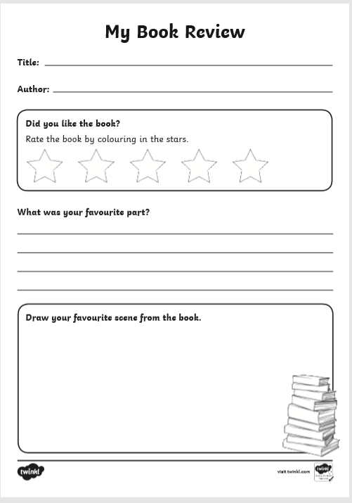
Extra ideas
Try making a bug house – there are lots of ideas online including: https://schoolgardening.rhs.org.uk/Resources/Activity/Make-a-simple-bug-or-ladybird-home

Draw a map of the farm from “What the Ladybird heard.” but see if you can put in the animals where they hid at night.
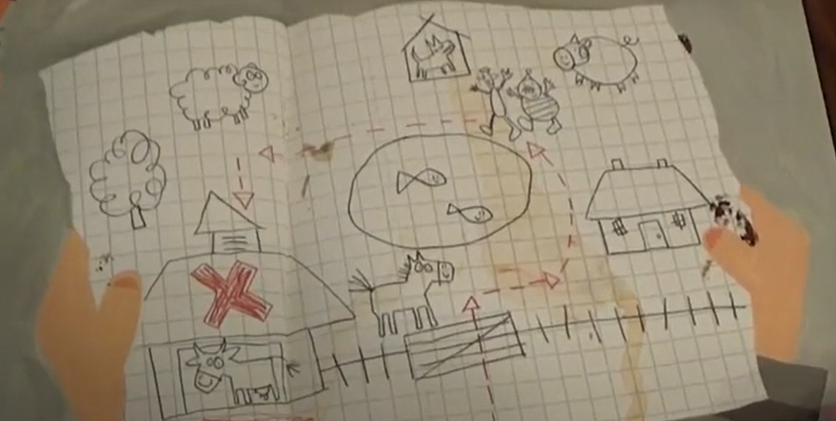

See how many mini-beasts you can spot in your garden or on a walk. I have spotted so many butterflies already this year including yellow, blue and orange tipped. Can you identify what mini-beasts you saw?

Watch “Why ants work together.” From Tinga Tinga tales. https://youtu.be/5_1zZaDcc84 Can you make up a story to explain something about another animal? How did bee get his stripes? Why does wasp sting? Why does earthworm have no legs?
Have fun!

