Poetry
Poetry can help express emotions. This week there are ideas for you to try this out yourselves. This emotion wheel might help you with some ideas – but remember to only use words that you understand.
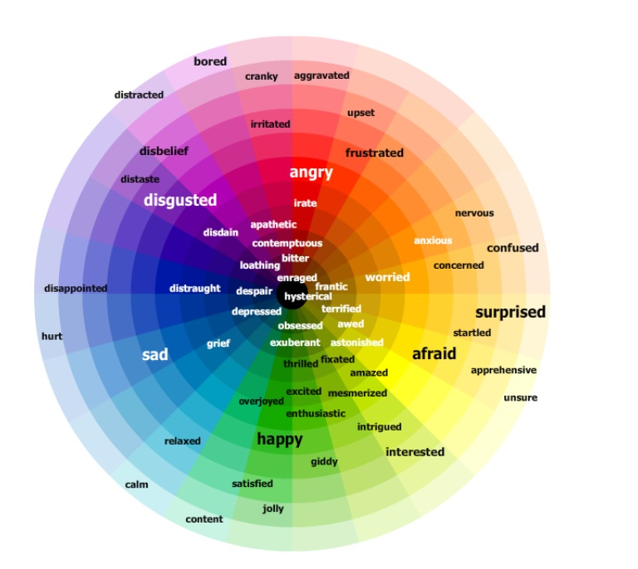

Session One
Shape poems are very simple. You just fill the shape with words about the shape. Our shape is going to be you! Can you fill it up with words about how you are feeling?

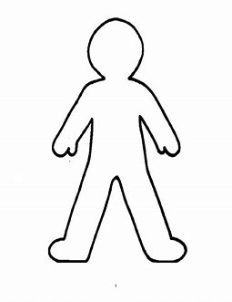
Session 2.
Today we going to think about why we are feeling some of those emotions to make our own rainbow.
Each line of the poem starts with
I am
Then write how you are feeling.
Next add
…because…
Finally, colour the stripe the colour you think matches your emotion.
It doesn’t have to look like a real rainbow. If you are sad and worried it might be a mainly blue rainbow or if you are feeling cross and angry it might be mainly red.
Here is an example:
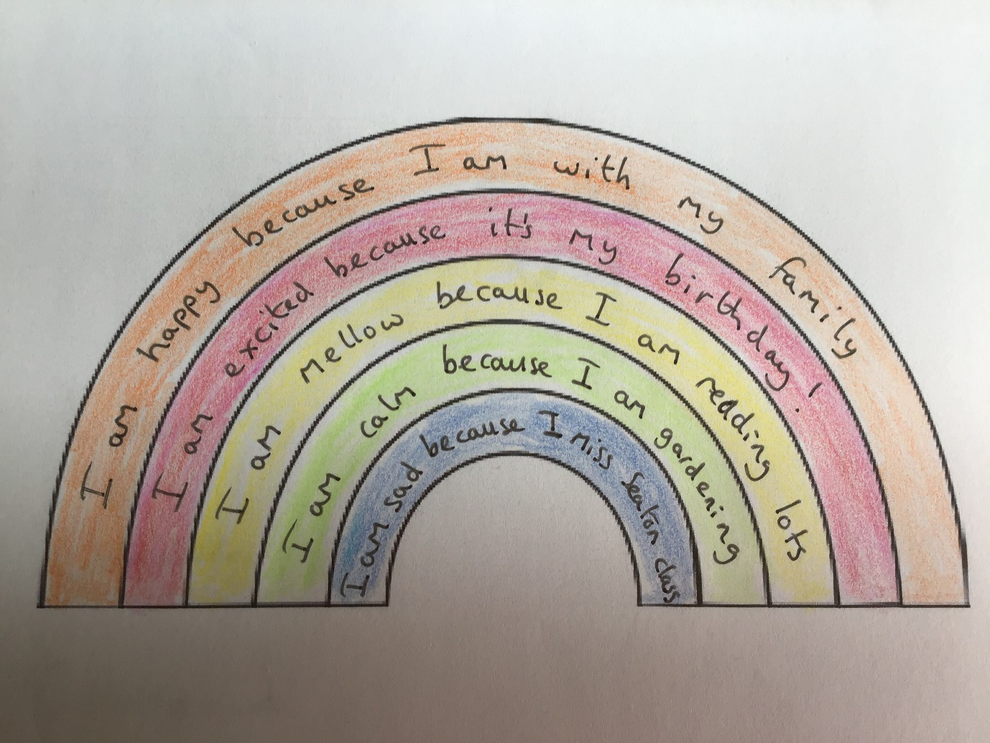

Session 3
Sticking with the idea of how we are feeling. How are you feeling about lockdown?
Today I’d like you to try and Acrostic Poem. This is where the first letter of each line forms a word.

Examples:
Lying on the sofa Loving time on my own
On my own Out in the garden all the time
CBBC on TV Can’t wait to see my friends again
Killing time Keeping busy
Doing nothing Doing baking, colouring, playing…
On my own again Our family plays games
When will lockdown end? Winner!
Nobody knows Now, let’s play again!

L
O
C
K
D
O
W
N

Session 4
Whilst poetry is great for expressing emotions, some poetry can help us feel different emotions. Let’s see if we can make everyone feel amused because they are listening to a funny poem!
https://www.youtube.com/user/artificedesign
This Michael Rosen’s channel. Hope you find something to make you smile!

Session 5
Watch
https://www.bbc.co.uk/teach/class-clips-video/english-ks1-ks2-understanding-poetry/zvrjscw
Poetry is really closely linked to songs.
Bryant Oden uses a lot of repetition and plays with stress and syllables. His channel is linked below. What is repeated in the duck song? How many syllables in Hippotomonstrosesquipedaliophobia in “The Long Word Song?”
Don’t worry if some of these ideas seem a bit difficult – you can still enjoy some silly songs!
https://www.youtube.com/user/songdrops
Have fun!

If you would like to show us any of your poems you can put them on Seesaw or email us:
jclatworthy@delawareprimary.co.uk

kgee@delawareprimary.co.uk

