Angles, w/b 18th May
Each day the Maths challenges will become slightly more challenging. It is possible to stop on any day if they are proving too much of a challenge and go over similar activities to those set on previous days.

Monday 18th May
Today I am learning to find missing angles in a scalene triangle.

The angles inside a triangle always add up to 180°. In a scalene triangle, the angles will all be different.

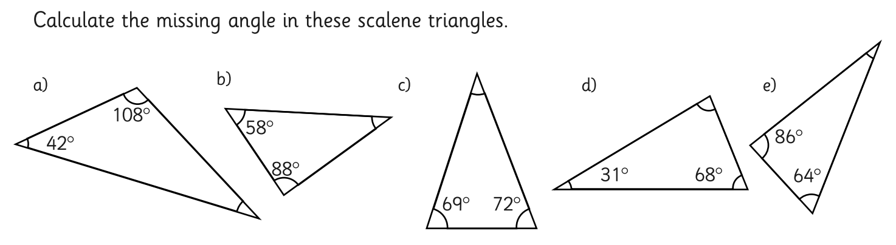

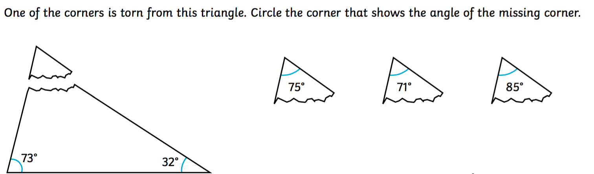
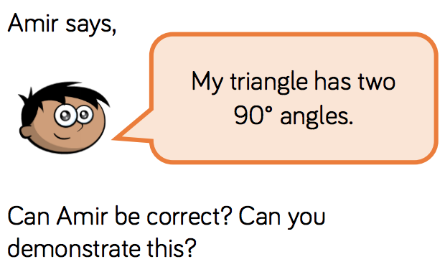
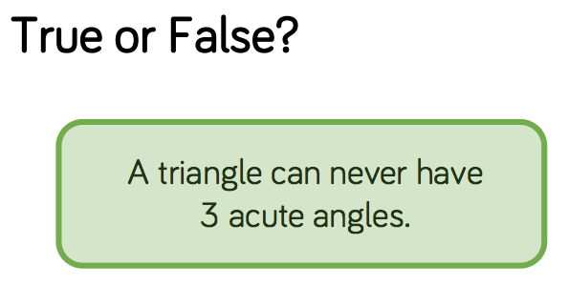

Tuesday 19th May
Today I am learning to find missing angles in different triangles.

The angles inside a triangle always add up to 180°. In a scalene triangle, the angles will all be different. In an isoceles triangle, two of the angles will be the sameand one will be different. In an equilateral triangle, the angles will all be the same.

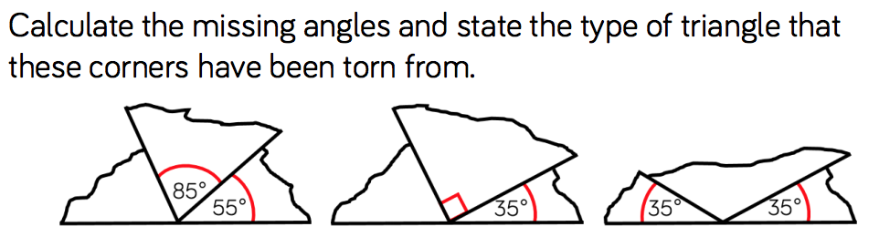
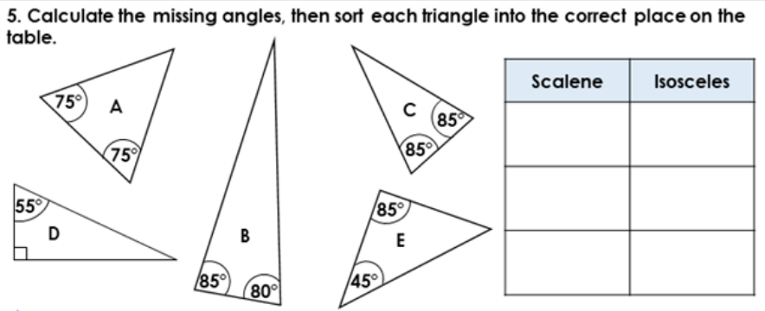

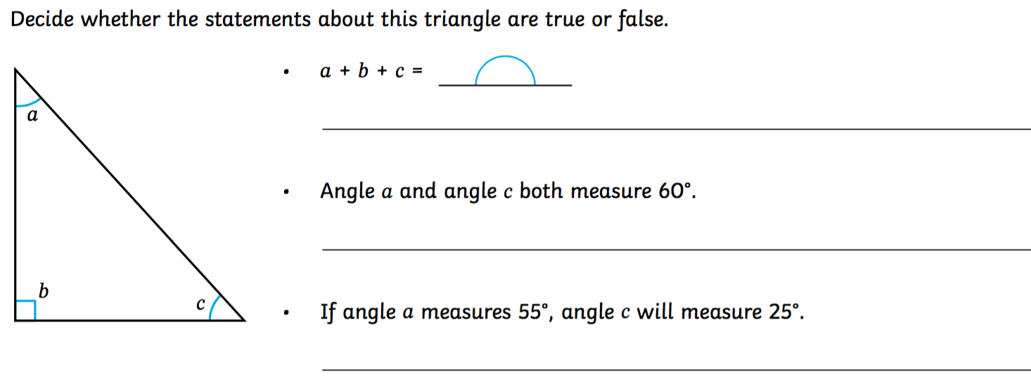

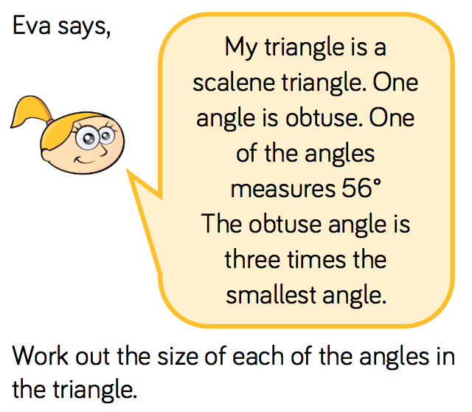
CHALLENGE:

Wednesday 20th May
Today I am learning to find missing angles in different triangles.

Remember; the angles inside a triangle always add up to 180°. In a scalene triangle, the angles will all be different. In an isoceles triangle, two of the angles will be the sameand one will be different. In an equilateral triangle, the angles will all be the same.
We use hatch marks (a cross line through each side) to show which sides are equal in length. We can use this to recognise which of the angles are equal.

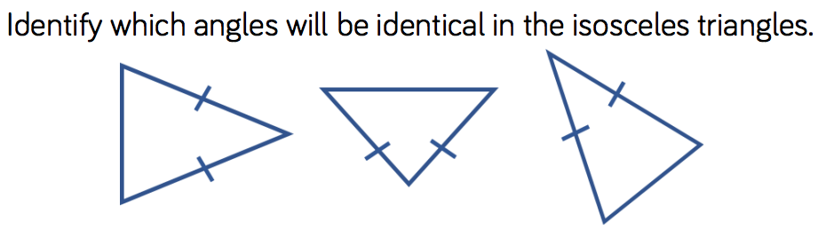

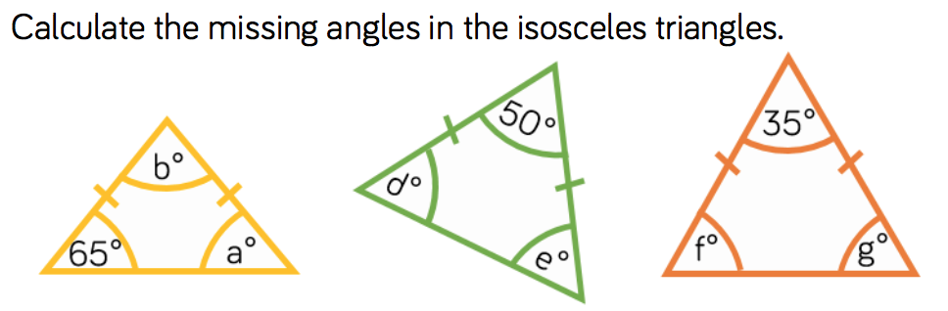

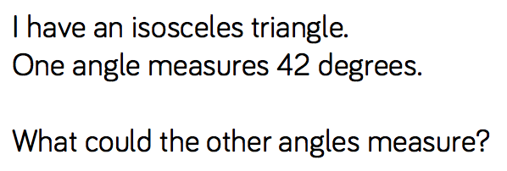

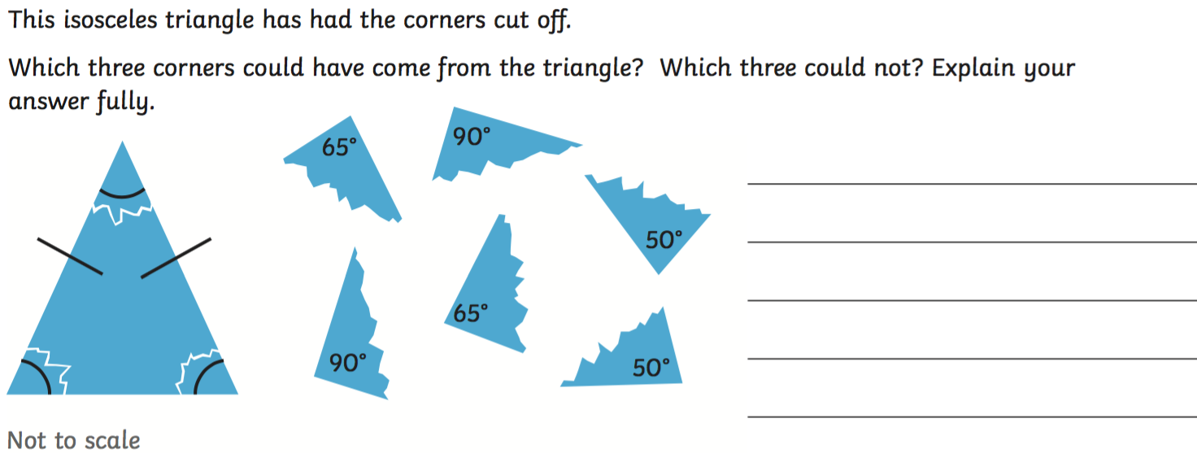

Thursday 21st May
Today I am learning to calculate a variety of angles.

You now need to link all your angles learning together. These questions will use your learning about the angles inside a triangle (equilateral, isosceles and scalene), as well as the angles on a straight line, angles in a full circle and opposite angles.

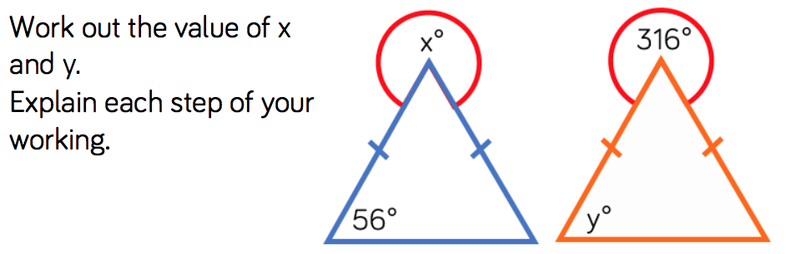

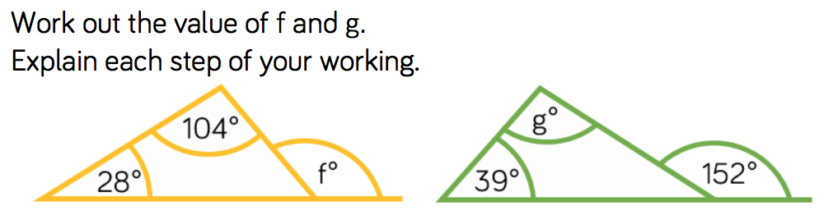

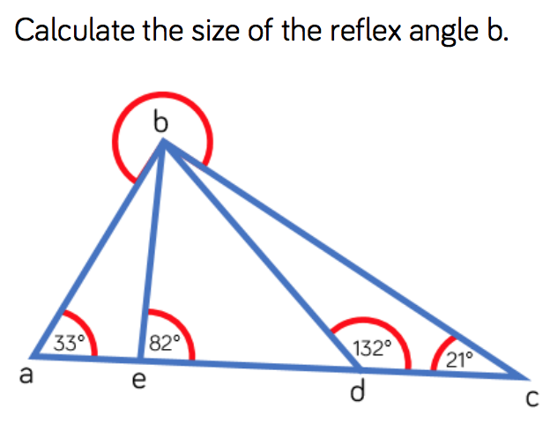
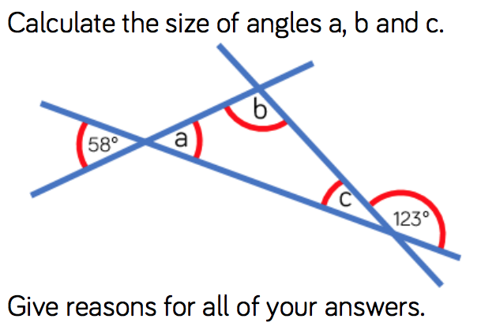

Friday 22nd May
Today I am learning to calculate a variety of angles.

