Literacy, w/b 18th May

Monday 18th May
Today I am learning to add prefixes using a hyphen.
Hyphens can be used to join a prefix to a root word, especially if the prefix ends in a vowel letter and the root word also begins with one.
co-ordinate
co-operate
co-own
re-enter
re-examine
re-elect
re-invest
re-write
pre-existing
ultra-ambitious

Practise each spelling using: look, cover, write check.
Find out the meaning of any of the words on the list you are unsure about.
Why do you think re-write is usually written with a hyphen, even though the root word (write) doesn’t begin with a vowel?
Write an INTERESTING sentence using each word.
Can you find any more examples with this spelling pattern in the book you are reading?

19th and 20th May
Today I am learning to plan and write using the features of a non-chronological report.

Using your research from last week and carrying out any further research as necessary, this week I would like you to plan and write a non-chronological report about Ancient Greece. You need to select 3 to 5 of the topics below to research and then use these as your subheadings. I have attached a planning sheet for you to put these subheadings onto; remember what we have talked about in class about how to make notes to complete your plan. Make sure you plan an introduction too.
Possible subheadings: Clothing, Food and Drink, Pottery, Philosophers, Theatre, Houses, Architecture, Schools.
Tomorrow, when you write your diary entry, use the rubric with the success criteria to help you.

http://www.primaryhomeworkhelp.co.uk/greece/

https://www.dkfindout.com/uk/history/ancient-greece/

https://www.theschoolrun.com/homework-help/greek-life-and-culture

https://www.ducksters.com/history/ancient_greece.php

https://www.historyforkids.net/ancient-greece.html

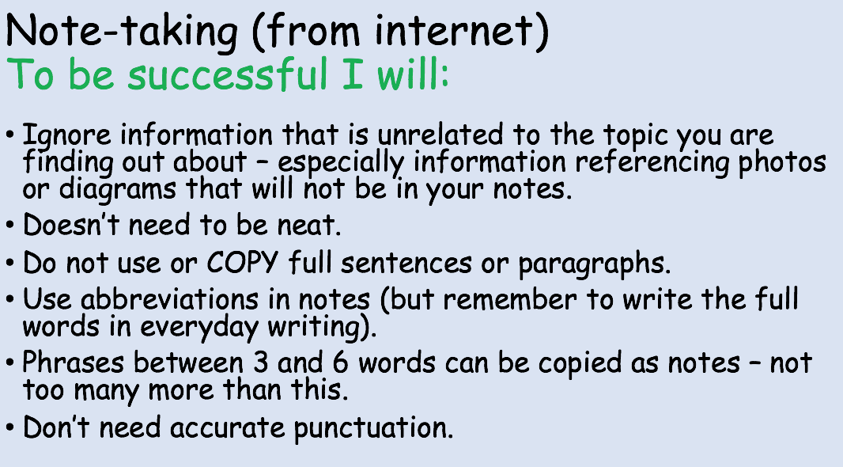
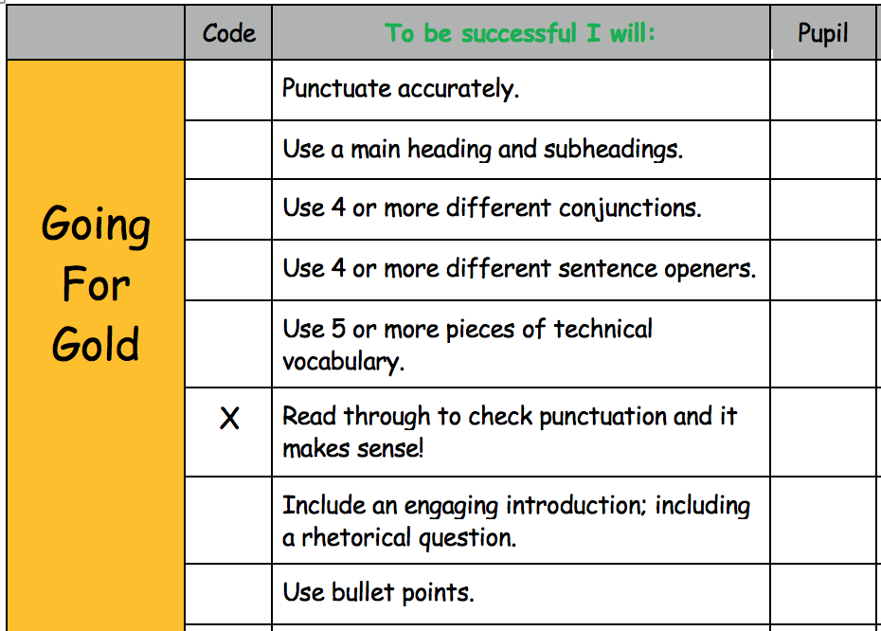

Thursday 21st May
Today I am learning to retrieve and infer information from a text.

See separate document for reading comprehension with the Ancient Greece theme.

Friday 22nd May
Today I am learning to answer mixed SPaG questions.

