I know you are all brilliant at instruction writing by now.
Bossy Verbs
I bet you can all remember those BOSSY verbs!
Simon says.. put your hands on your head…Simon says jump up and down… now STOP!
Did you spot Simon didn’t say stop?
Those BOSSY verbs (we sometimes called imperative verbs) tell someone what to do. We can add a lovely polite please and thank you, but we do need them to make our instructions clear and easy to understand.

Order
Unlike some of our writing, it is usually really important instructions are followed in order.
To do this we often use
- A system
- Showing numbers
- For each step…

Or maybe the time connectives you have all learned so well…

Spot the time connectives
M | A | F | I | R | S | T | O | F | A | B | L | O | S | T
E | H | A | F | T | E | R | T | H | A | T | A | R | E | F
A | O | F | S | E | C | E | D | A | F | I | T | L | Y | N
W | L | A | S | T | O | F | A | L | L | V | E | W | Y | E
H | D | T | H | G | N | E | X | T | S | Z | R | A | T | X
I | J | I | K | L | D | P | Q | H | T | N | O | C | H | S
M | E | A | N | W | H | I | L | E | U | T | H | R | I | D
F | C | O | D | T | E | F | I | N | A | L | L | Y | I | F

FIRST NEXT THEN FINALLY SECOND
AFTER THAT LATER LAST OF ALL MEANWHILE

Look at these posters can you spot the bossy verbs, a number system and any time connectives?
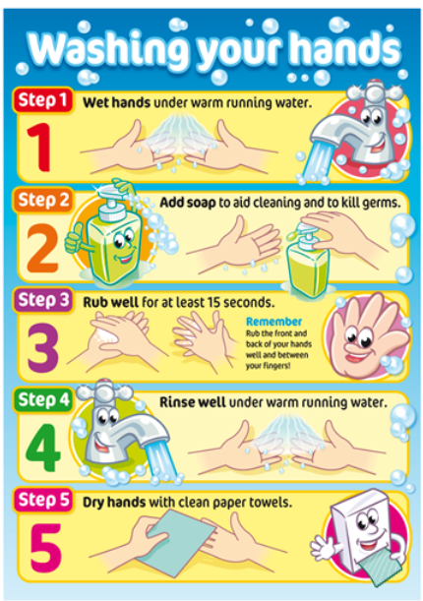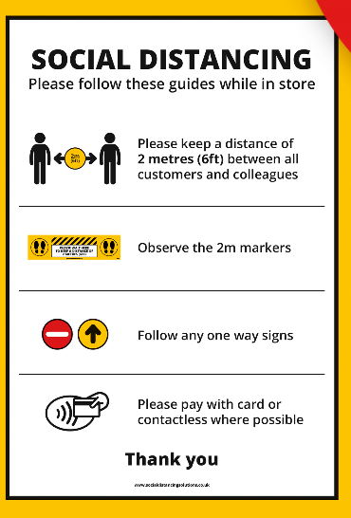
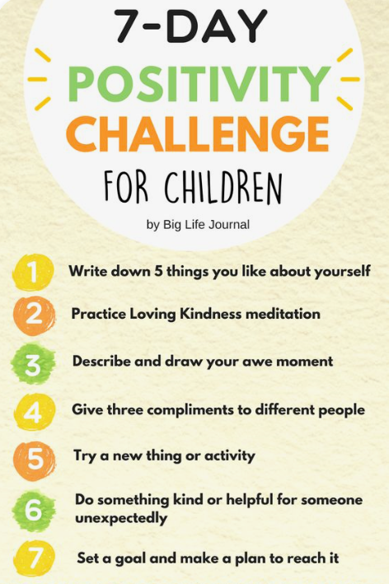
Session 2
Write a set of instructions for handwashing.
Remember we practised handwashing in class in March before we started Distance Learning.
Mrs Gee had blue paint on her hand and it spread really fast if people shared and high-fived! Because we could see it, many people didn’t want to share . Then we all tried following instructions about in-between the fingers, back of hands and palms… What can you remember? Try and use a number system or time connectives and don’t forget to use BOSSY verbs!

Session 3
This sort of writing is essential if you might like a future job working with computers.
Computers follow instructions from the beginning to the end of a programme.
Writing a list of instructions for a computer is writing an algorithm. I know most of you have tried this by helping BeeBot and will probably remember the word algorithm.

How could you help a robot follow the rules to walk to his lunch table?
He is not allowed to sit next to anyone else.

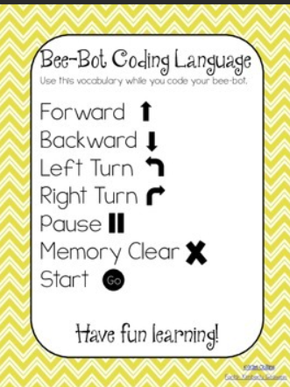

Session 4
Make your own poster for social distancing or hand washing and give some helpful pictures.
Are you helping people in a shop, people in a classroom, people you meet on a walk…. maybe you are helping an alien visitor who needs very general instructions!
Try and make your poster clear and easy to read. It should be colourful and eye-catching so people notice it and read what you have to say.

Session 5
You guys always have ideas adults never think about. Can you think of ideas for social distancing that are practical or silly and fun… or maybe all three!
Please send in ANY ideas, sometimes that little spark of imagination can go really, REALLY far!
Have fun!
