Maths
Each of these sessions follow what we are doing in the classroom. It is best to try and make it as visual and practical as possible. We use ten frames (attached with the rest of the home learning) to help with counting and grouping numbers. Here are some additional activities which can be done alongside the usual Whit Rose PDF files.

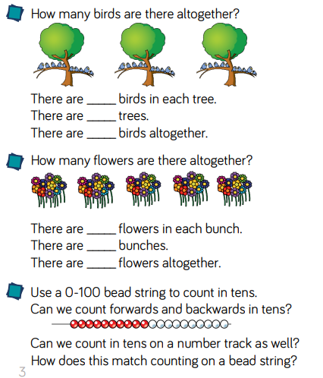
Session 1 – Count in 10s
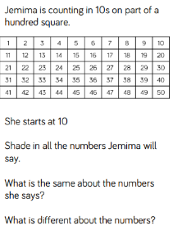

Session 2 – Making equal groups
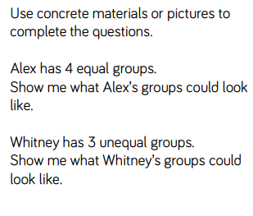
Explore what the term ‘equal’ mean?
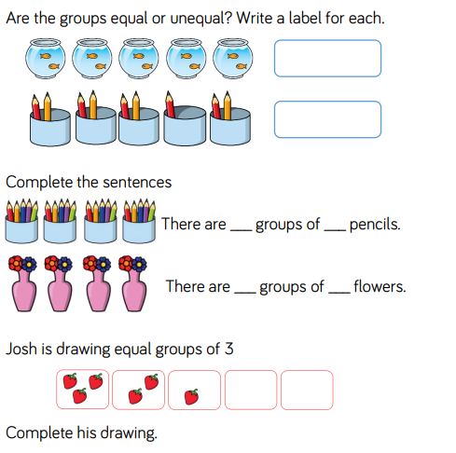

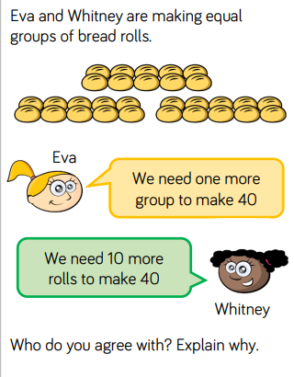
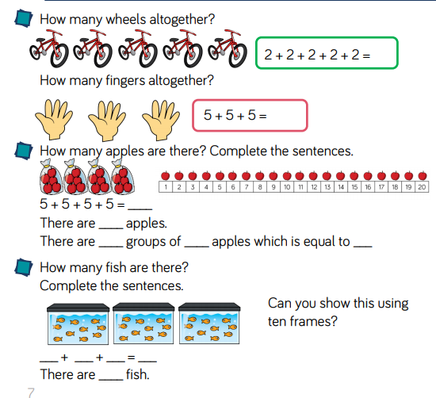
Session 3 – Adding equal groups

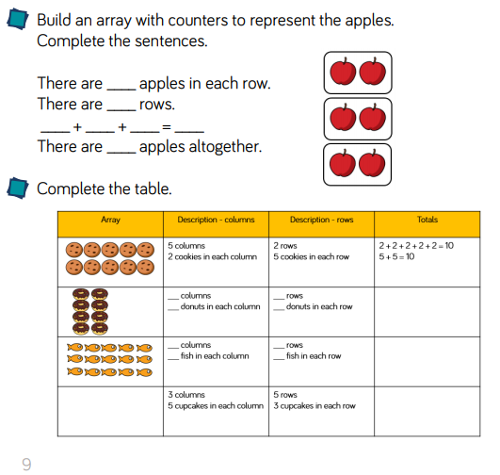
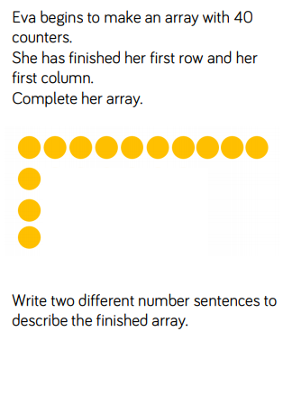
Session 4 – Making arrays

Session 5 – Making doubles.
