Poemish!
Warning – this week’s literacy is utter nonsense!

Session 1
Watch https://youtu.be/qZKoDRhmWxk “Ish” by Peter Reynolds.
This week’s poetry (and art) suggestions are meant to let you have fun. Don’t get worried about getting it “right”, there is no right… this week we are writing things that are poemish!
Let’s start by thinking about nonsense words.

If I told you one of these is a baloobah and one is a kikiti, which do you think would be which. Why do you think Its that way around?
Most people would say is a kikiti, because it has more ‘sticky,

spiky’ letters. It might make you think of stick, prick, spike…
Most people would say is a baloobah, because it has lots of round

letters in it and to say them our mouth makes round shapes. It might make you think of balloon, round, globe…

Let’s try making some of our own words following patterns.
“Wh” starts words like whistle, whoosh, whiz and whirl. They all sound like movement in the air.
Can you make up some “wh” words?

wh…………… wh………………. wh………………..
“Cr” starts words like crush, crumble, crack and crumple.
Can you make up some “cr” words?

cr………………. cr…………………. cr…………………
“Sp” starts words like spray, spurt, splatter and splash.
Can you make up some wet sounding “sp” words?

sp………………. sp…………………. sp………………..
Pick which ones are your favourites and see if you can use them in a sentence.

Example
The whangling balloon whirflelooped up into the sky.
The monster crugged and cratched the castle to pieces.
The hosepipe sprang a leak and water sploofed all over the place!

Session 2
Roald Dahl was amazing at making up funny words. The BFG uses lots when he is speaking.
Read the following and think about what you think the made-up words mean.
Then have a go at squishing two words together to make new ones.
(When writing this I accidentally squished two and words and got ‘twords’!)
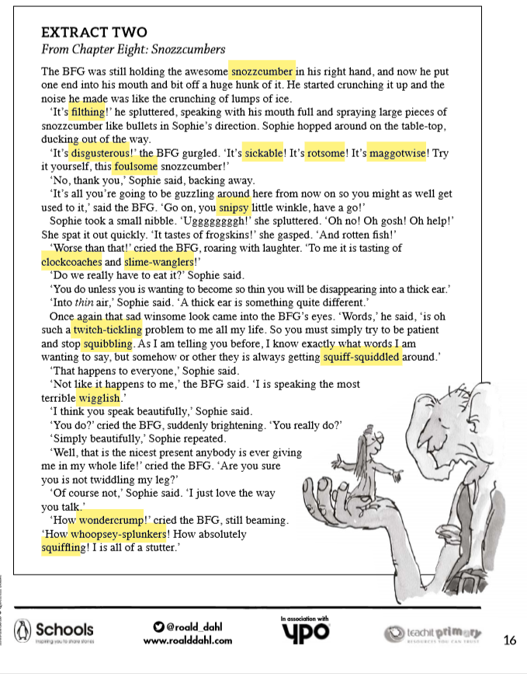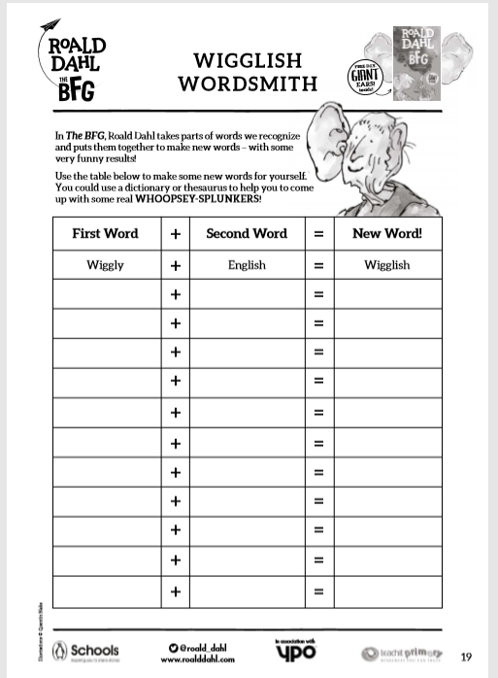

Session 3
Create your own monster and label it using your wibsquiffling nonsense words.
Does it have swongwhishly tail it can whoofle around when it’s happy?
Are its ears bigantic?
Try and match some of your nonsense words you have created this week to describe different parts of its body.
If you want inspiration (and have good internet connection) Jon Burgerman shows a fun way to draw a pet monster on this video:
https://www.bbc.co.uk/cbbc/watch/bp-how-to-draw-a-pet-monster?collection=bp-how-to-guides-curation

Session 4
https://www.bbc.co.uk/bitesize/topics/z4mmn39/articles/zgbyw6f
(It introduces nonsense poetry)
Have fun writing something poemish!
Write your own nonsense poem about your monster using ideas from your labelled picture. (It doesn’t need to rhyme.)

Example:
Beware the bigormous Floogersnot!
It looks friendly, but it’s not.
Its fur is silky and flooflely soft.
Its bright, violet eyes are as large as a ploon!
But while you stare into its eyes and stroke the soft fur…you should have been watching its mouth…
The strikkle long teeth can snap you in tword.
Run away! Run away! If you ever spot
a Floogersnot!
If you can challenge yourself to write your own completely, that would great.
If you think you need a bit more help you could fill in this template:

Introducing the …………………………….. ………………………………………. .

It looks ……………………………………………………………………………………………

Its eyes are ……………………and ……………………………………………………….

It has …………………………………………………………………………………………………

Its ……………………… are ……………………………………………………………………

If you ever meet a ………………………………….. ……………………………………

you should ………………………………………………………………………!

Session 5
If you can, watch some poets perform their nonsense poems.
Spike Milligan
https://youtu.be/tzHU1t7zzPw
Michael Rosen
https://youtu.be/kt28bVw0xYw

Practise and perform your own nonsense poem.

Can you find any other nonsense poems you enjoy?
Have fun!

