Session 1
This is a version of “The 3 Billy Goats Gruff”. Practise reading the story a few times using the story map.

Once upon a time, there were three Billy Goats Gruff. They lived in a field next to a bridge. The field on the other side of the bridge had grass which was much greener and looked delicious.
Unfortunately, under the bridge lived an enormous, terrifying troll.
One day, the three Billy Goats had an idea. First, the youngest and smallest Billy Goat went across the bridge.
“Who’s that trip-trapping across MY bridge?” said the troll. “I will eat them for my tea!”
“Don’t eat me.” said the littlest goat. “My brother is coming soon and he is much bigger than me.” So, the troll let him go into the wide, green field and eat the juicy grass.
Next, the middle Billy Goat went across the bridge.
“Who’s that trip-trapping across MY bridge?” roared the troll. “I will eat them for my tea!”
“Don’t eat me.” replied the middle-sized goat. “My brother is coming soon and he is much bigger than me.” So, the troll let him go into the wide, green field and eat the juicy grass.
Finally, the biggest Billy Goat went across the bridge.
“Who’s that trip-trapping across MY bridge?” thundered the troll. “I will eat them for my tea!”
The biggest Billy Goat was strong and he butted the troll’s bottom! The troll flew in the air, landed in the river and was never seen again.
The three Billy Goats Gruff played in the wide, green field and ate the juicy grass and lived happily ever after.

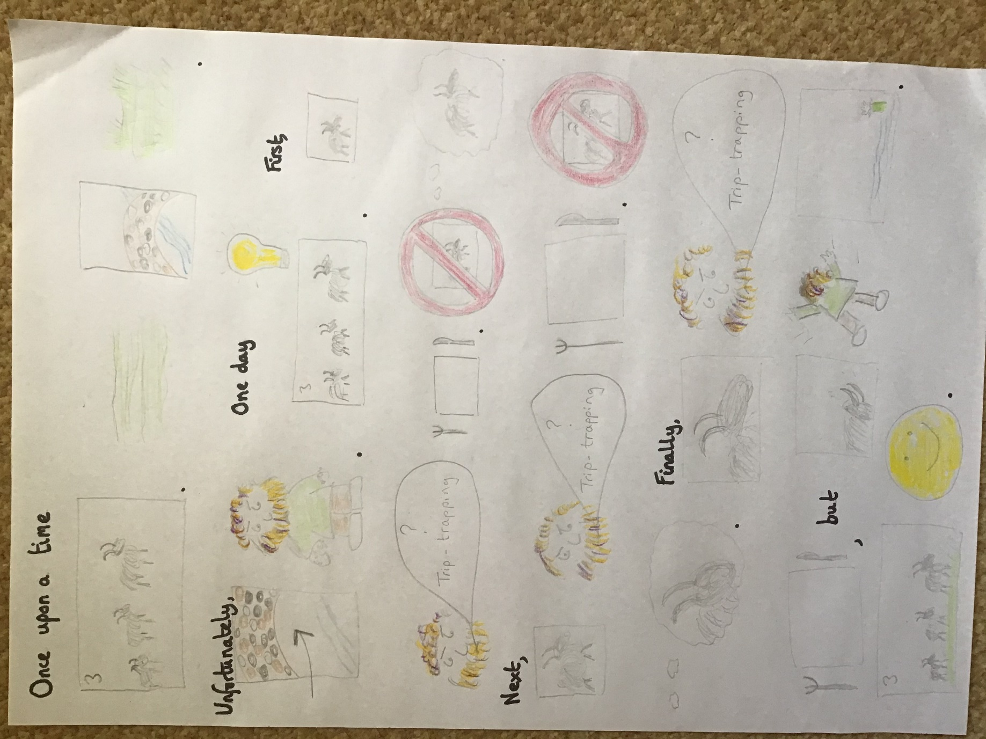

Extension:
If you can tell the story without the story map, what would you add to help you improve the story?
If you can do a great troll voice maybe add to your story map “Who’s that trip-trapping over my bridge?” the troll said grumpily.
Maybe you have great ideas to describe your 3 characters (you might try a list or a metaphor)– little, tiny, miniscule first goat or the last goat was as big as a planet?
Session 2
It’s time to make your own version!
1/ Change your animal – you will still need a small, medium and large one for the story to work
Instead of the 3 Billy Goats Gruff, what about 3 Fluffy Bunny Rabbits or 3 Gigantic Woolly Mammoths? They could be unicorns or anteaters… whatever!
2/ Change your obstacle for them to cross
Instead of a bridge, could your troll live on a mountain or inside a tunnel or beside some stepping stones. I’m sure you can think of lots of ideas.
Instead of “trip-trapping” across the bridge, what will they do? Huff-puff over a mountain? Scribble-scrabble through a tunnel?
3/ What will happen to the troll?
This could be quite tricky to fit to your animal and obstacle – so take some time to think.
Does the biggest fluffy bunny hop so fast across stepping stones the troll falls in the river? Does the biggest woolly mammoth block the tunnel with a tree trunk so the troll can’t come through?
Again, I’m sure you will have all sorts of amazing ideas – I look forward to seeing some.
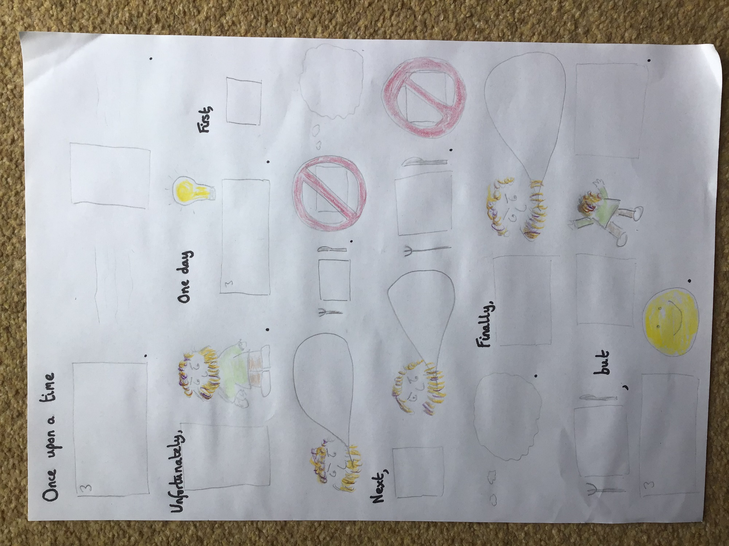

Session 3 and 4 – Two sessions as you will probably need a break trying to write something this long, but I know you can do it!
Use your changed story map and write your own version.
Take your time and see if you can include…
- Great handwriting
- Finger spaces
- Punctuation
- Your story making sense
- Remember to make all the changes
- Include some extra description
Session 5
How did you do?
Can you complete the success criteria with someone from your family? Tick the objectives you think you managed to do and then write what you were most proud that you achieved and what you might try and improve next time.
I tried to… | I think | My family member thinks
Show great handwriting
Remember finger spaces
Include punctuation
Make my story make sense
Remember to make all the changes
Include some extra description
I am proud of…..

Next time I will try to….

If you would like to email a picture of your story to kgee@delawareprimary.co.uk or jclatworthy@delawareprimary.co.uk we would love to see your work.

Extra
If the troll only eats goats, is he a carnivore, omnivore or herbivore?

Why is the troll described as terrifying? Do you think the troll is bad?

What do you think happens to the troll next? Does he find a new bridge to live under? Is he scared of goats?!

We have used some words called ‘connectives’ when we have written instructions. ‘First’ is the first one in this story – can you find two more?

Can you add illustrations for your story?

This is a really challenging activity, but we have worked in this style before. I really hope you give your families a real WOW moment showing just how brilliant you are at writing in Year One.

Have fun !

