Session 1.
Identify key features of non-chronological report.
Can you find the following features in these non-chronological reports about Ankylosaurus?

1/ Heading – The title telling you what the whole report is about.

2/ Subheading – A little title, telling you what a section of the report is about.

3/ Bullet points
- These are used to give short facts.
- They make it quicker to read than lengthy paragraphs.
- They can also help you find information quickly.
4/ Illustration, photograph or diagram – a picture to help describe what you are talking about
5/ Caption – a label, to tell you what the illustration, photo or diagram is.
6/ Text box – A little fact in a box/circle, usually including information you want to find on every page or a fun “DID YOU KNOW?” fact.

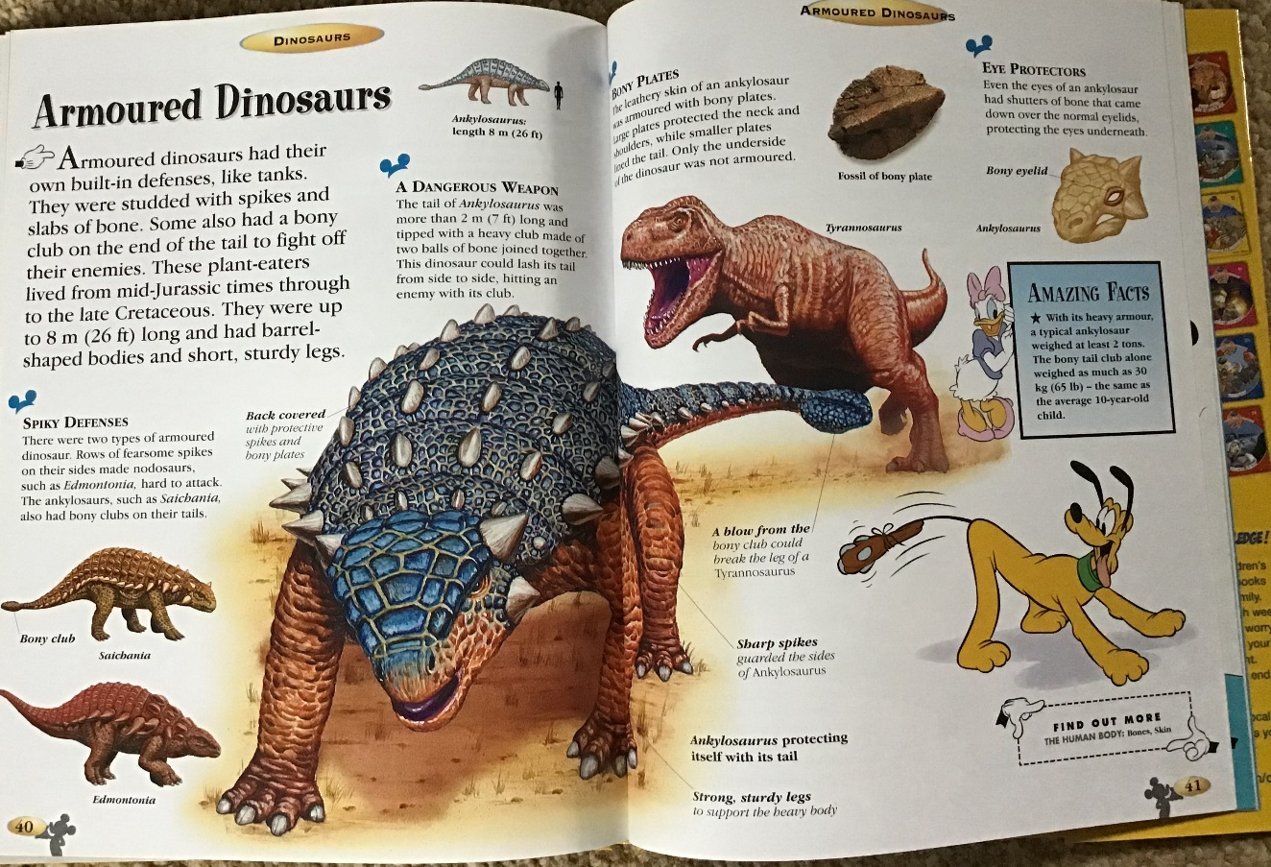

Ankylosaurus Facts
Check out our cool Ankylosaurus facts for kids and have fun learning more about this amazing dinosaur.
The Ankylosaurus was a big dinosaur that featured huge plates of body armour to protect itself from attackers, and if that wasn’t enough it also had a massive tail club that was strong enough to break bones. Read on for more interesting facts and information about the Ankylosaurus.

- The name Ankylosaurus means ‘fused lizard’.
- Ankylosaurus lived at the end of the Cretaceous Period (around 66 million years ago). They were one of the last dinosaurs remaining before the large extinction event that occurred around this time.
- The Ankylosaurus was a large dinosaur. Scientists estimate it reached a length of around 9 metres (30 feet) and a weight of around 6000 kg (13000 lb).
- Ankylosaurus were herbivores (plant eaters) and had small teeth relative to their body size.
- The signature feature of Ankylosaurus was its body armour. Huge plates of bone were embedded into the skin which helped protect the Ankylosaurus against attackers. Similar body armour is found on a crocodile or armadillo.
- The Ankylosaurus had a massive tail club that it could use to generate a large amount of force, potentially breaking the bones of another dinosaur while defending itself.
- Ankylosaurus pictures:

https://www.sciencekids.co.nz/sciencefacts/dinosaurs/ankylosaurus.html
Well done if you spotted some of those features.
Not every report includes all of the features.
You might have spotted a few that didn’t have an arrow – SUPER well done if you did that

Which features do you think are most helpful?

When you write your own report, I would like you to include:
- Heading
- Subheadings
- Illustration
Are you going to challenge yourself to add a caption or a text box?

If you found this quite easy, please make sure you look at all three texts again and see what you can read.
Maybe you could look up the dates for Jurassic and Cretaceous?

Hope you have fun learning and look at session 2.

