Session 2 and 3
Writing notes.
You may read or watch quite a lot to make a short note.
This is such an important skill.
Please try hard to only write down key words and not copy full sentences. (Then when you write your report it will be in your own words).
Example:
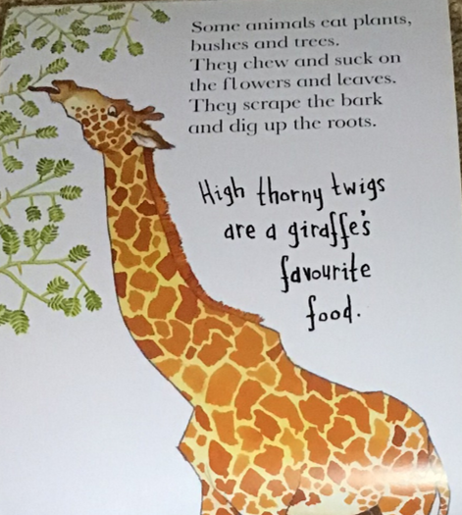

Giraffe food:
- High thorny twigs

Use the following template or draw your own boxes on a sheet of paper, to record facts about an animal of your choice.
If you are looking on the internet
https://kids.nationalgeographic.com/animals
https://www.sciencekids.co.nz/sciencefacts/animals
are useful.
You could use the information on ankylosaurs in session 1 or butterflies on the attached file.

You might include the following categories:
- Appearance (what they look like)
- Food
- Babies
- Habitat (where they live)
- Behaviour
- Predators
- Fun facts

Read on for an example about giraffes.

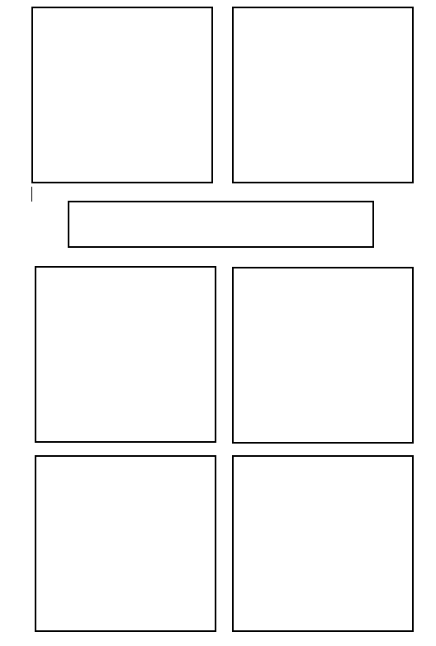

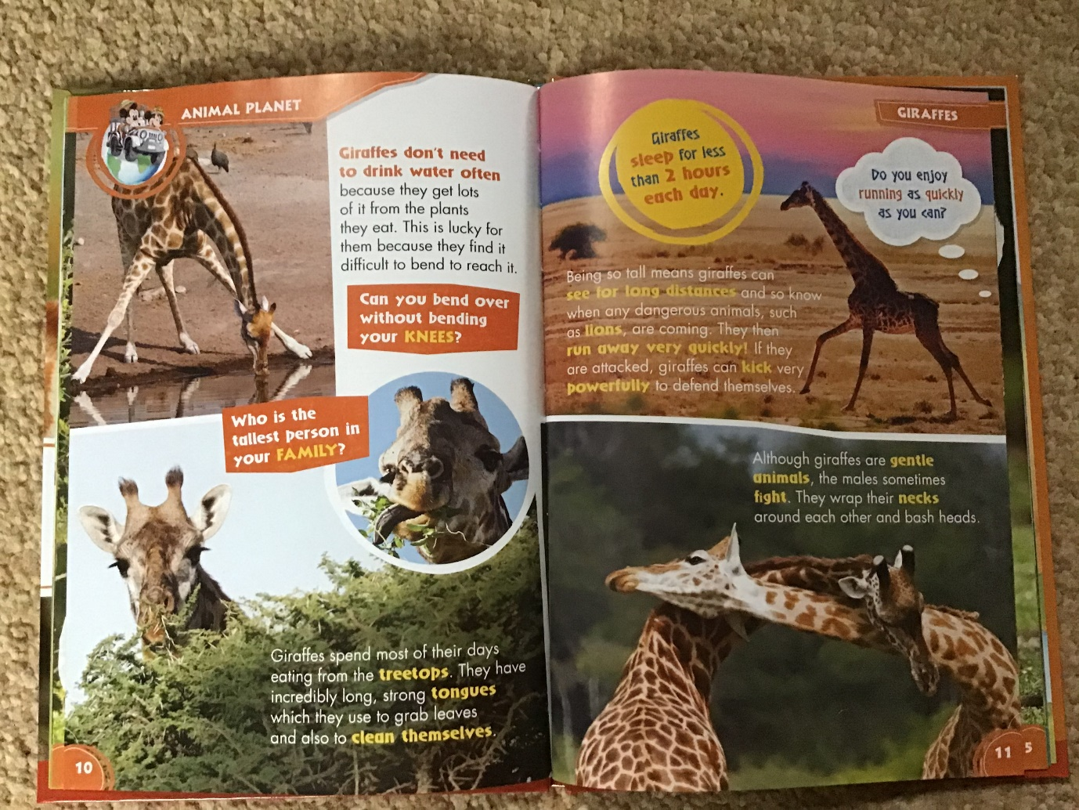

Sometimes you might make notes from what you see in the picture instead of the writing.

The writing doesn’t say about the colour or pattern.

The writing doesn’t say about the colour of the giraffe’s tongue.

These are still useful observations for describing a giraffe.
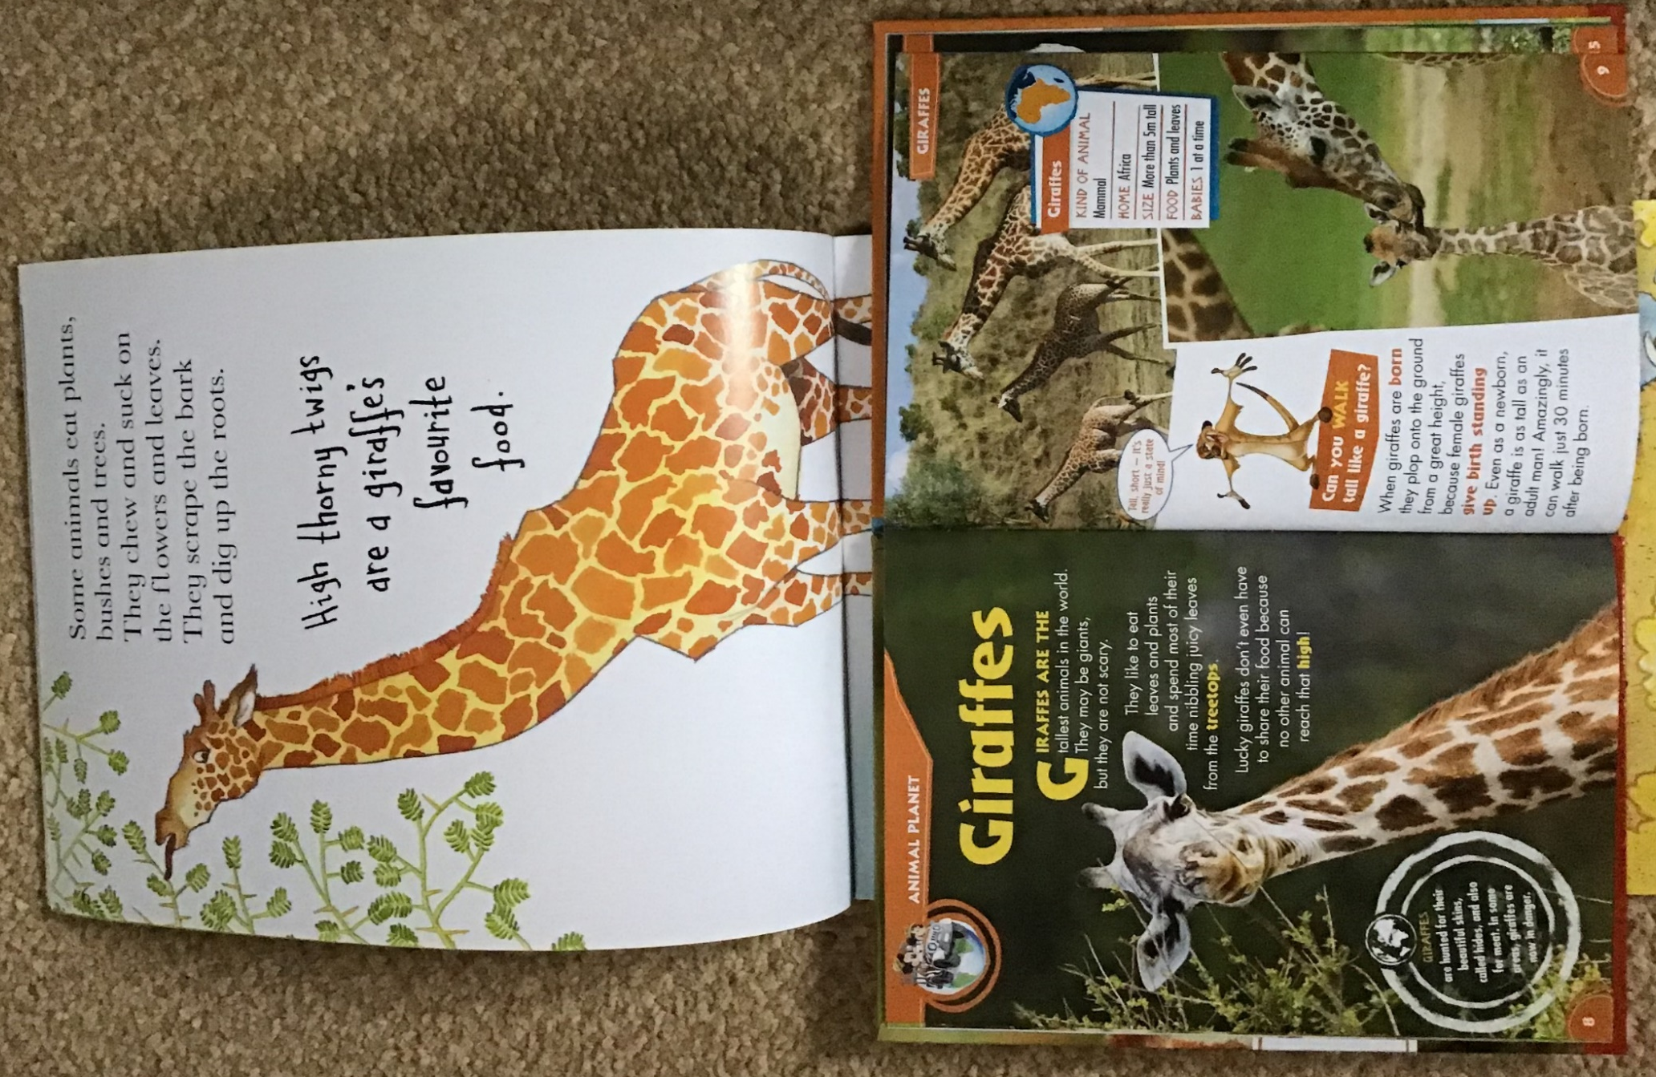
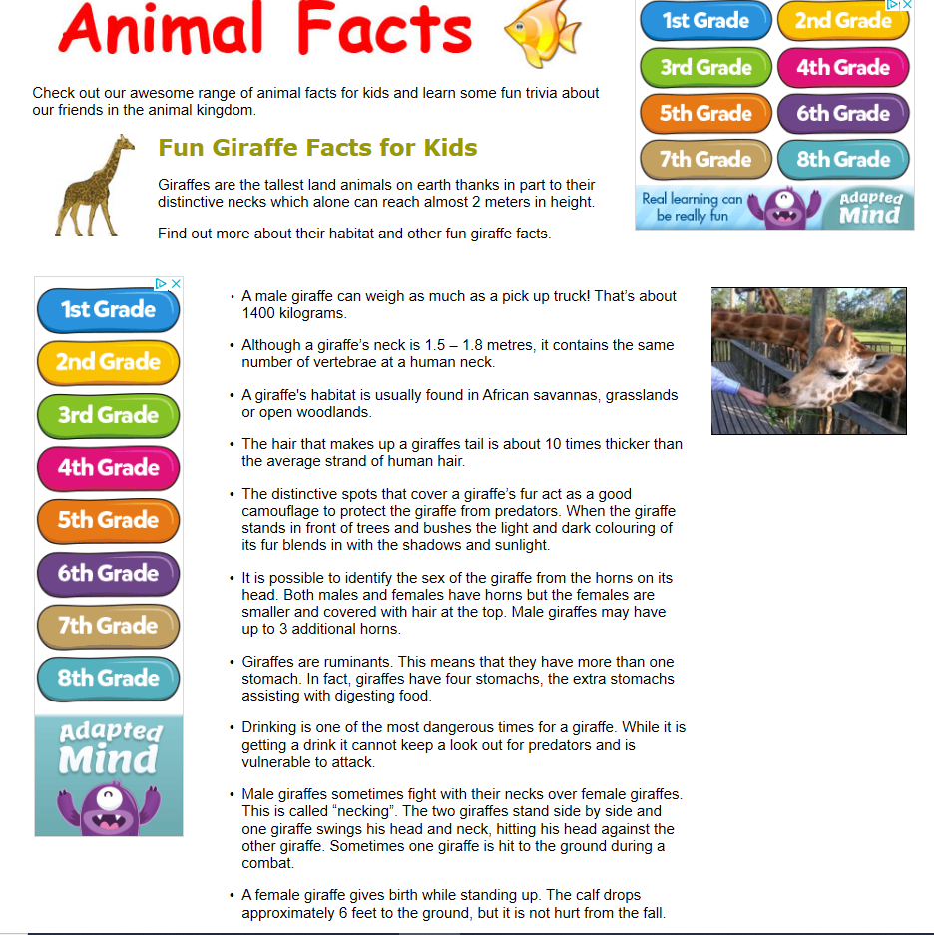

https://www.sciencekids.co.nz/sciencefacts/animals/giraffe.html

Giraffes
Did you know?
Tongues are black

Tallest animal in world
Behaviour
Sleep less than 2 hours a day
Gentle, but sometimes fight
Habitat
Africa
Grasslands, savannas and open woodland
Babies
1 at a time
Can walk after 30 minutes
Food
High thorny twigs
Herbivore (only eats plants)
Appearance
Tall
Long neck
Cream and brown
Check pattern

