Session 3, 4 and 5
This is a big task and we will probably be working at slightly different rates. You might find the note-taking tricky or be really keen and writing lots of ideas.
If you have finished writing your report by the end of session 3 – maybe you could find a couple more facts to add in session 4 and then make your report colourful in session 5.
If you have finished writing your report by the end of session 4 – maybe you could use session 5 to make your report really colourful.
If you haven’t finished your report by the end of session 4, use session 5 to finish it off.
Short, colourful reports are often used for leaflets. Less colourful reports which contain more information are more useful for people very interested in a subject. Whichever style you write, you are practising good skills!
Writing the report.
You will probably have more information for some sub-headings than others.
I would like you to include Appearance and Habitat, but then you can choose 2 (or more!) other areas, from your notes, to write about. Finally, can you give an illustration with a caption (a label that says what your picture is)?
This time you are trying to write in full sentences.
Example:
My notes about giraffes say… Habitat – Africa
Now I can write… Giraffes live in Africa.
I might also start some sentences with “They…”
Giraffes

Behaviour
Giraffes sleep less than two hours a day.
Appearance
Giraffes are the tallest animal in the world.
They are cream coloured and have a brown check pattern.
Habitat
Giraffes live on grassland, savannas and open woodland.
They live in Africa.

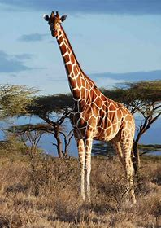

Did you know?
Giraffes have black tongues!

A giraffe.

