I have picked a delightful story for us to read this week.
“The Quiltmaker’s Gift” Jeff Brumbeau and illustrated by Gail de Marcken
You can read it at the International Children’s Digital Library (http://en.childrenslibrary.org/ direct link to the book below
http://www.childrenslibrary.org/icdl/BookReader?bookid=brmqltm_00260001&twoPage=true&route=simple_0_0_quiltmaker_English_0&size=0&fullscreen=false&pnum1=1&lang=English&ilang=English)
There are also lots of versions of it being read on youtube. https://youtu.be/vV7RCjfLRBM (keeps the pictures still )

Session 1
Listen to the story “The Quiltmaker’s Gift.” Then try and answer the comprehension questions. It is a very long story, so you might need to hear some of it more than once to help you find the answers.
1/ Why won’t the quiltmaker sell a quilt to the king?

2/ Which animal breaks the chain to set the quiltmaker free?

3/ Why do you think the king starts to smile when the children are playing on his merry-go-round?

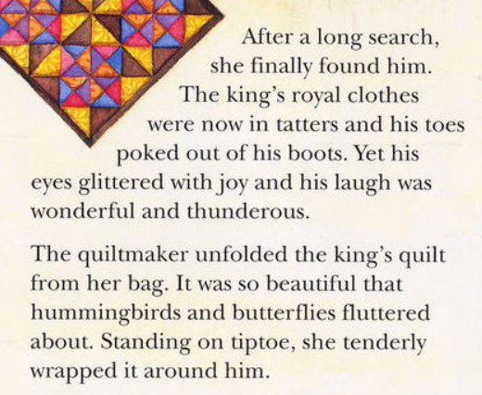
4/ Match the words to their meanings.

Tatters As loud as thunder

Thunderous Gently

Tenderly Worn to pieces

5/ What does the king give the quiltmaker?

6/ Is the king happier at the start or the end of the book? Why?

Session 2 Listen to the story again.
Put the events from the story in order (You may want to cut up the different sections or just number them).
Then, starting with the first one, see if you can re-tell the story (say what you see in the picture ). If you are up for a challenge, try and remember some details – What did the quiltmaker ask the bear to collect? What did the king do in-between leaving the quiltmaker and returning in the morning?
Your detail might explain why they are wearing a very funny uniform!
Please talk to someone in your family (or a teddy bear). This is a talking – NOT writing task. (There is a lovely LONG writing task to look forward to next session!)

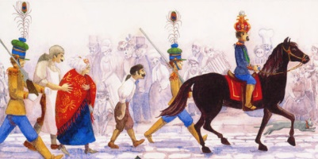
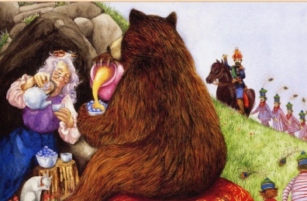

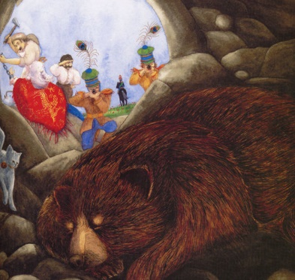
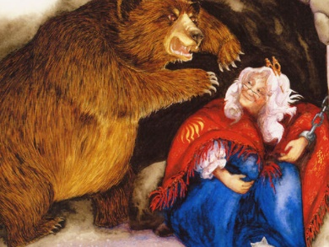
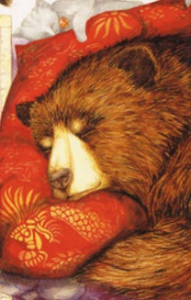

Session 3 Listen to the story again.
Today we are going to try writing part of the story. (If you are stuck remember to say what you see in the picture ).
If you are up for a challenge, try and remember some details – How big was the island? Why did the bird need help? How was the wind described?
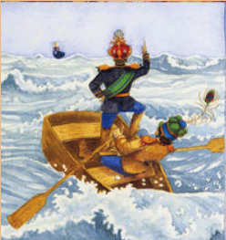
…………………………………………………………………………………….

……………………………………………………………………………………..

………………………………………………………………………………………
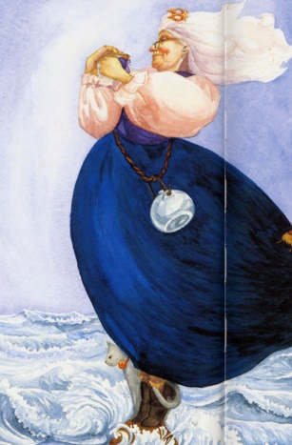
……………………………………………………………………………………..

………………………………………………………………………………………

……………………………………………………………………………………..

………………………………………………………………………………………
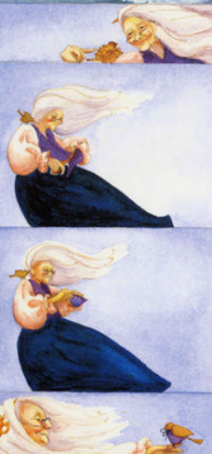

……………………………………………………………………………………..

………………………………………………………………………………………

……………………………………………………………………………………..

………………………………………………………………………………………

……………………………………………………………………………………..

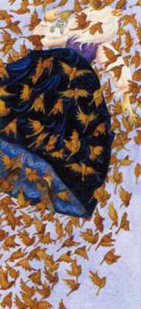
………………………………………………………………………………………

……………………………………………………………………………………..

……………………………………………………………………………………..

………………………………………………………………………………………

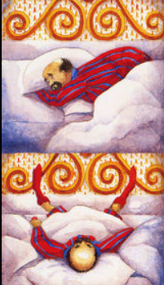
………………………………………………………………………………………

……………………………………………………………………………………..

………………………………………………………………………………………

……………………………………………………………………………………..

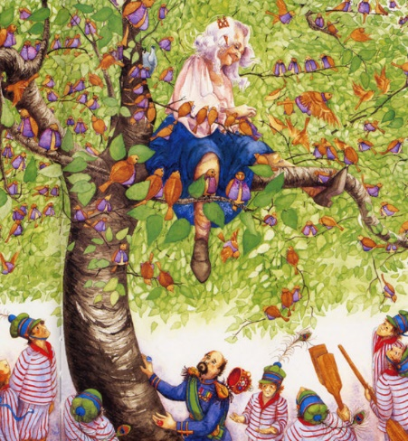
………………………………………………………………………………………

……………………………………………………………………………………..

……………………………………………………………………………………..

………………………………………………………………………………………

………………………………………………………………………………………………………………………………………………

……………………………………………………………………………………………………………………………………………….
Session 4
Now we are going to try and add a part of the story.
When the king chains the quiltmaker near the bear, she makes him a comfy pillow from her shawl.
When the king puts the quiltmaker on the tiny island, she makes the birds jackets from her waistcoat.
Let’s try and think of another thing the king could have done, where the quiltmaker makes something, so an animal helps her.

Put on a raft in a river In a pit with a lion

full of crocodiles
PROBLEM

On an iceberg with a Polar Bear

Add 2 more, then choose your favourite.
Now, have a think what she could make for the animal. Will she use her long socks or maybe her petticoat?
(If you are struggling for ideas, maybe listen to “The Smartest Giant in Town.”
https://youtu.be/cfiPrA8E3qE )

She uses her………………………………………………………. to make a

…………………………………………………for the ………………………………………. .

Session 5
Have a go at colouring or drawing your own patch for a quilt. It would be lovely if we could put all of them together when we are all back in school.
Can you write a description for it - like the start of the story?
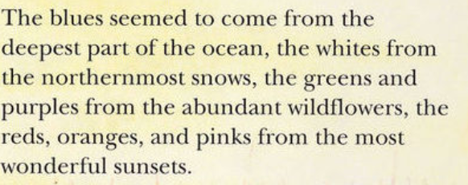
These patches are illustrated in the book’s front cover.
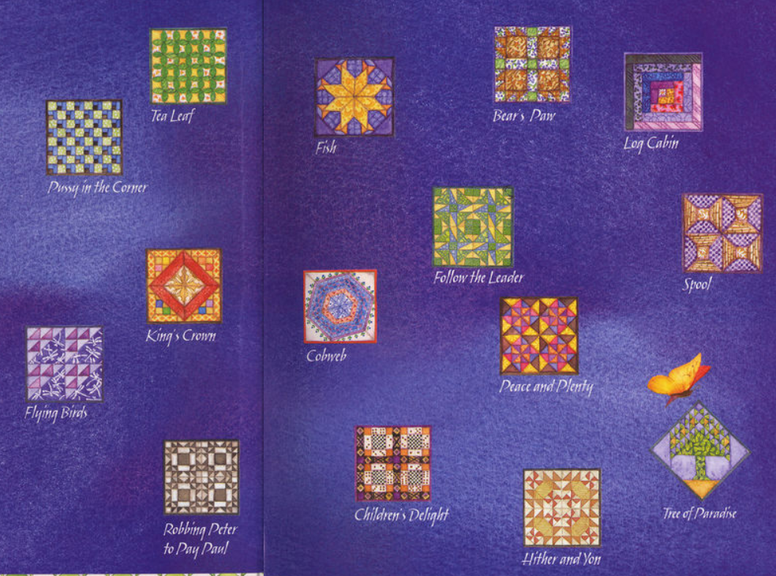

Example description:
This patch is called Fish.
The colours are blues from the shimmering sea and orange like the bright, burning sun.

My quilt patch is called…………………………………………………………….
The colours are……………………………from………………………………………..
……………………………………………………………………………………………… and
……………………..like………………………………………………………………………………………………………………………………………………. .

