Ideas to prepare for Summer Holidays

Session 1
Boredom Buster boxes – list all your ideas on slips of paper. Here are a few ideas to get you started:

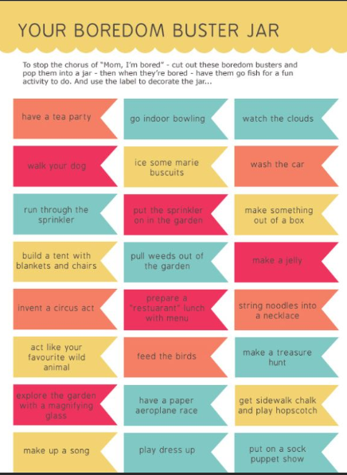
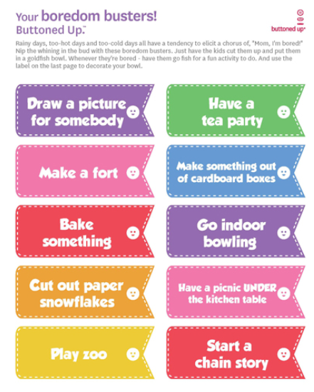

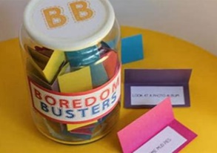
Add all your ideas to a container and now you have a Boredom Buster Box!
Any time you are bored in the holidays, pick out an idea and give it a go.
You might want to colour code your ideas. Maybe all blue ones are things you can do on your own and no-one else is available. Maybe all yellow ones are things you can do inside if the weather is bad…
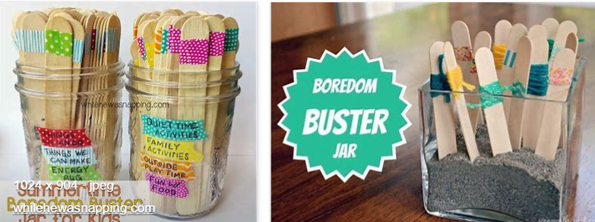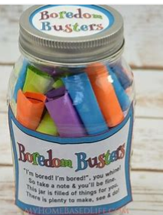

You could even make your own box to put your ideas in.

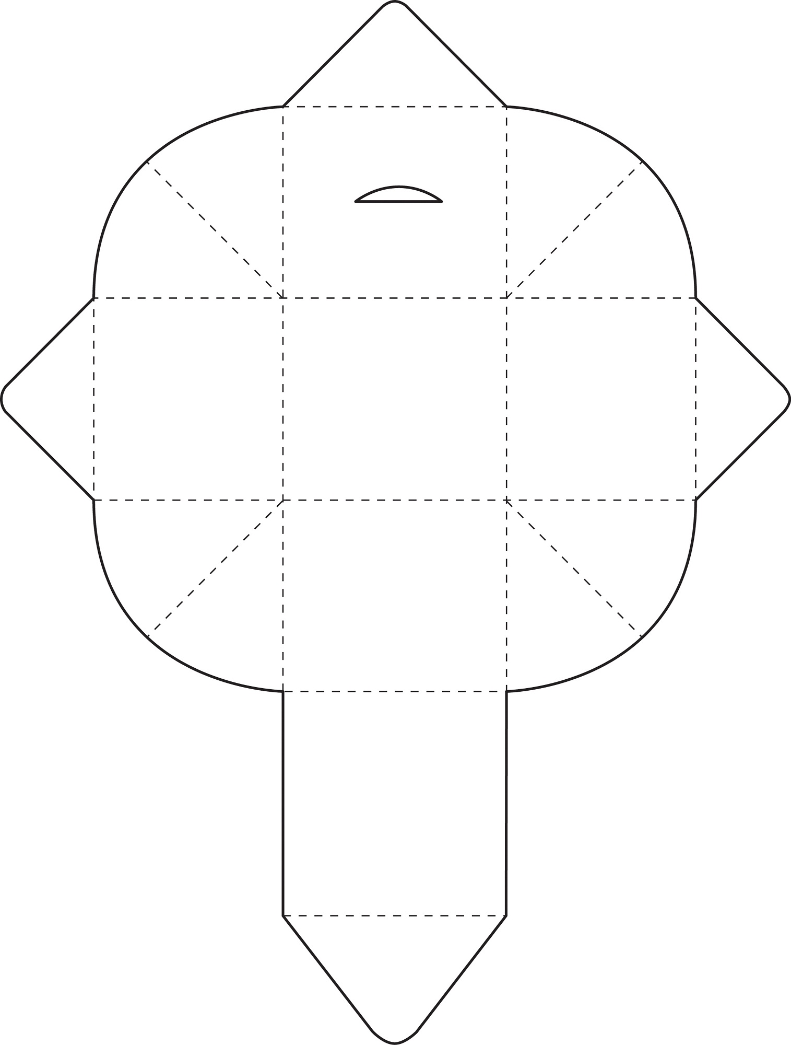

Session 2
Make a game for others to play with you. Can you write instructions?
Are there forfeits if you land on some squares?
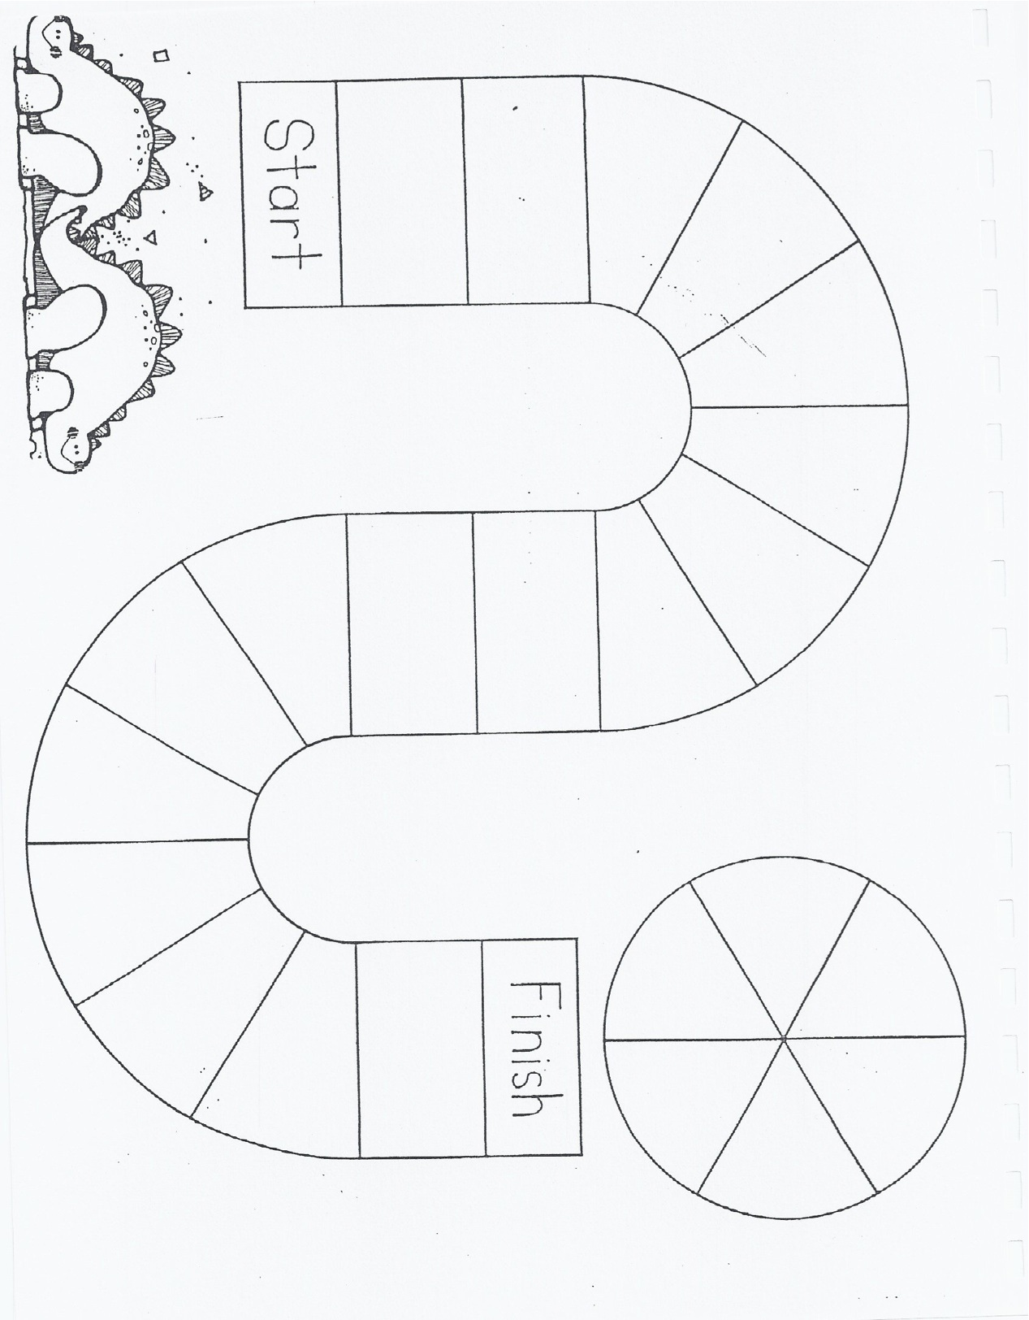
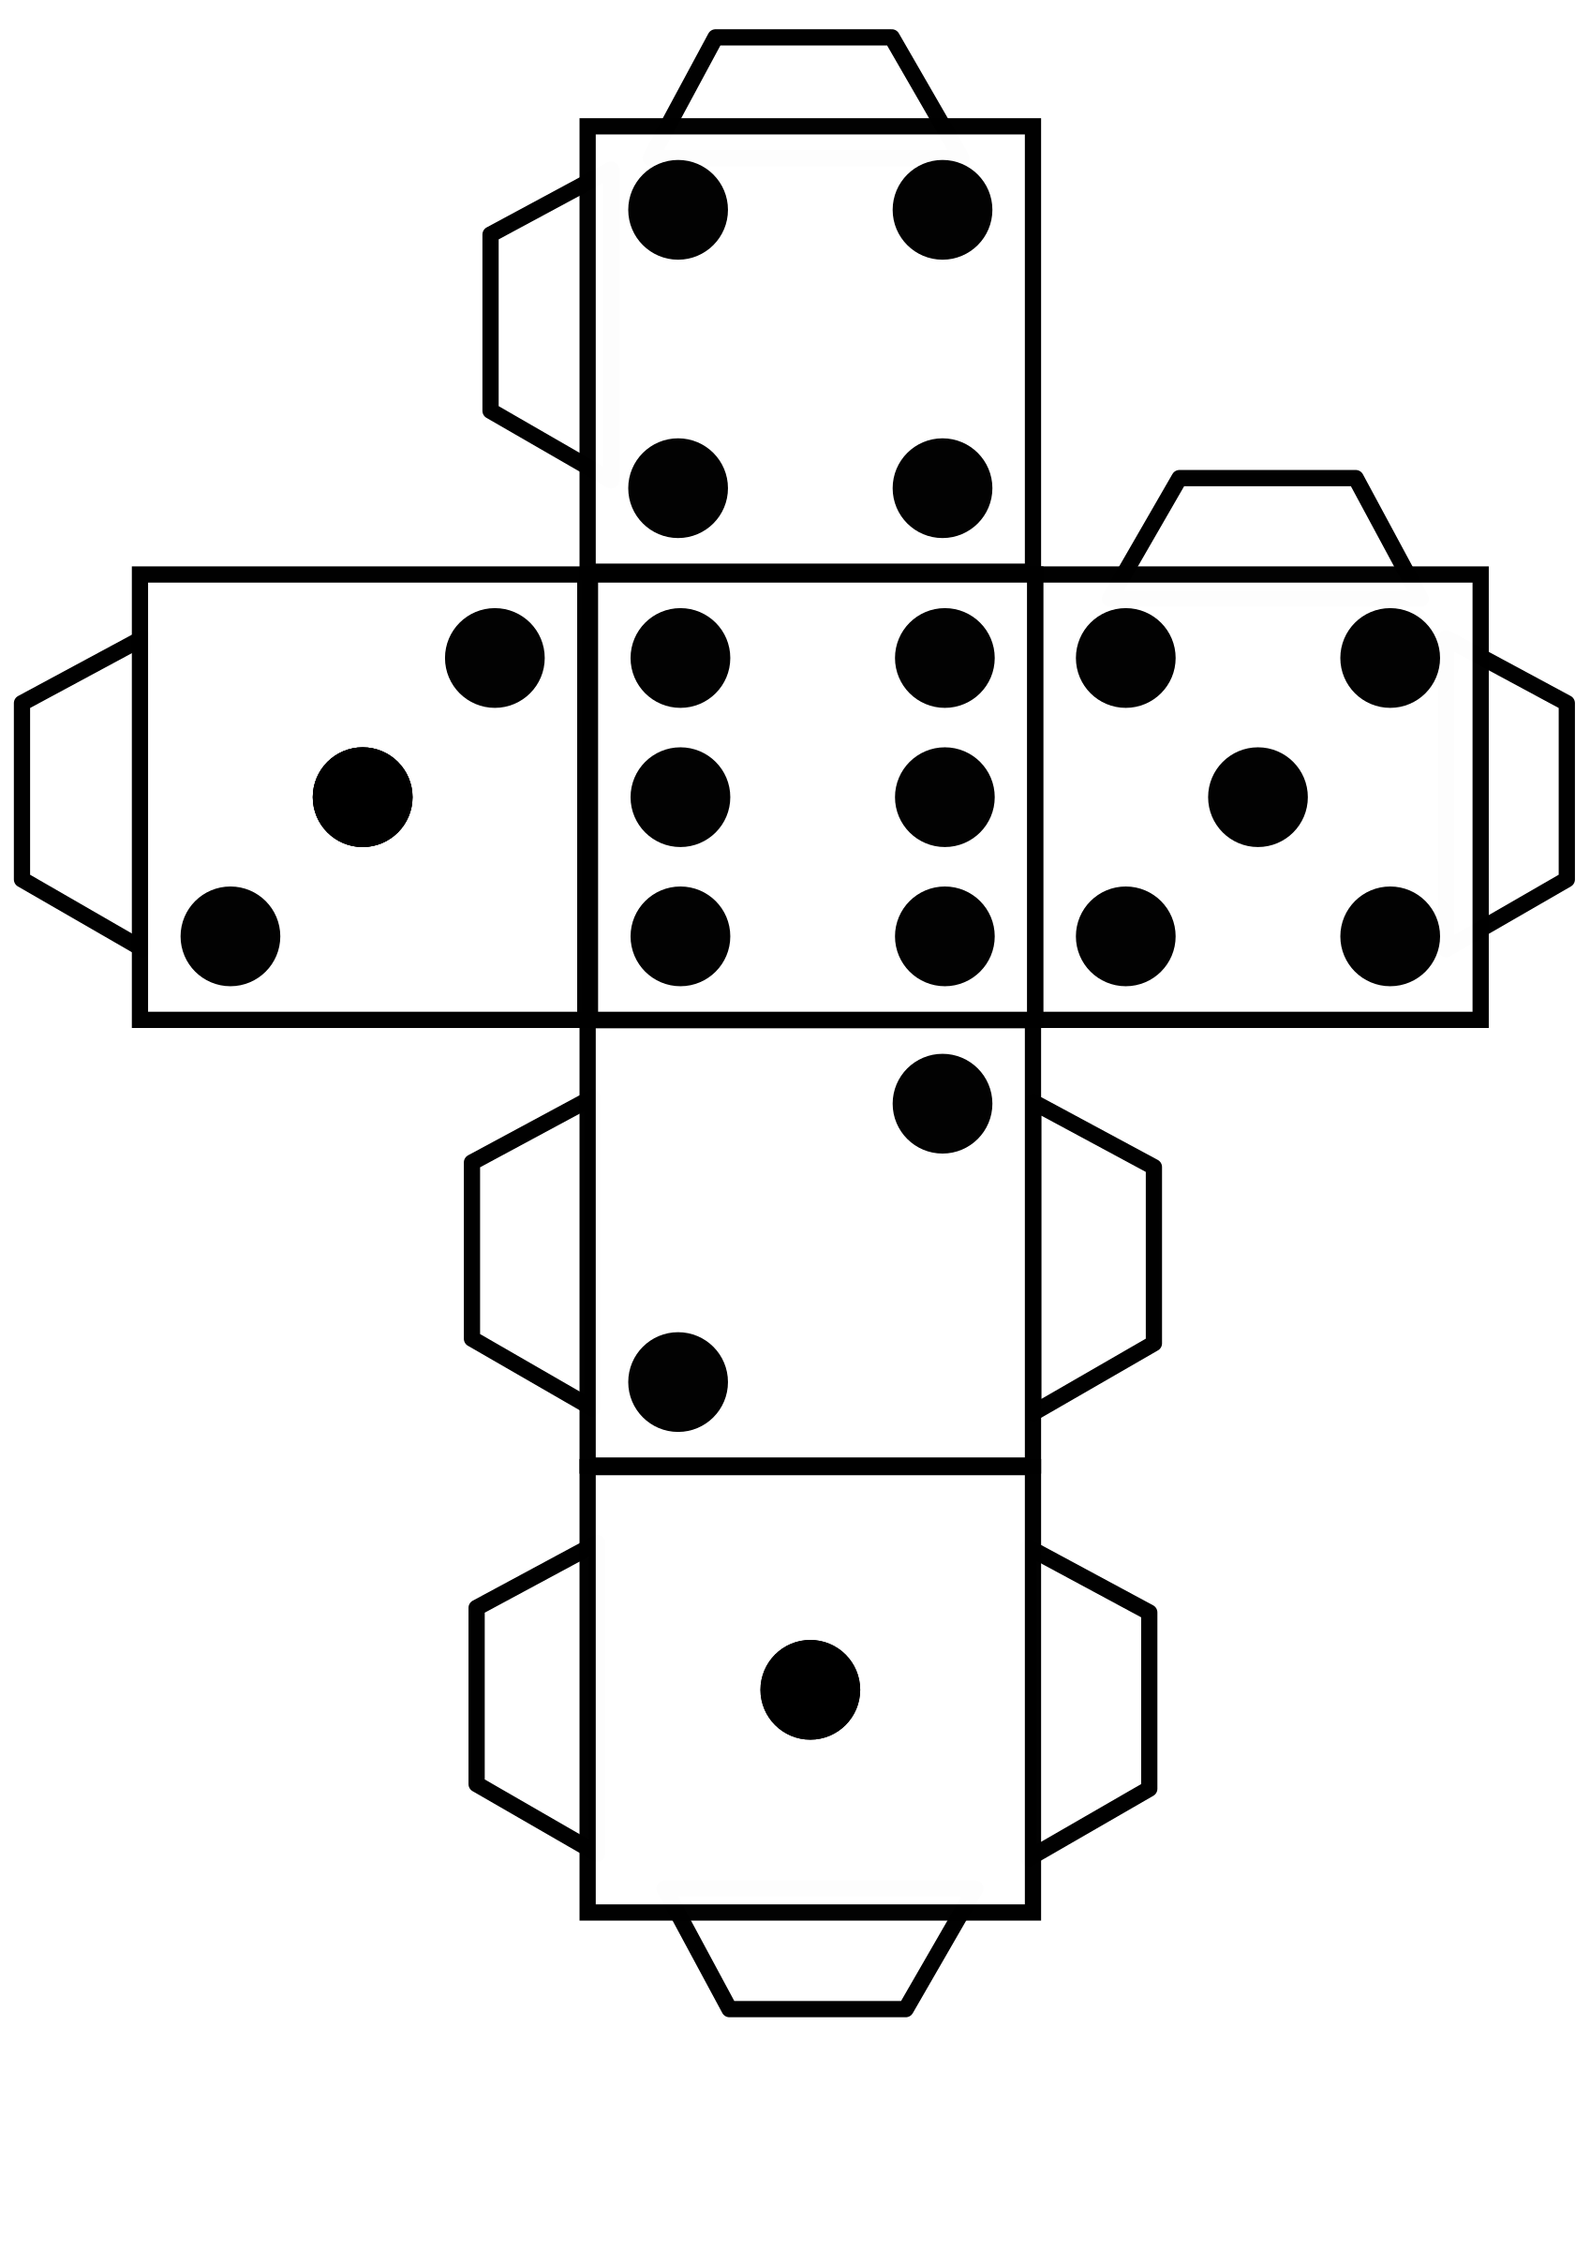

Some other fun ideas:
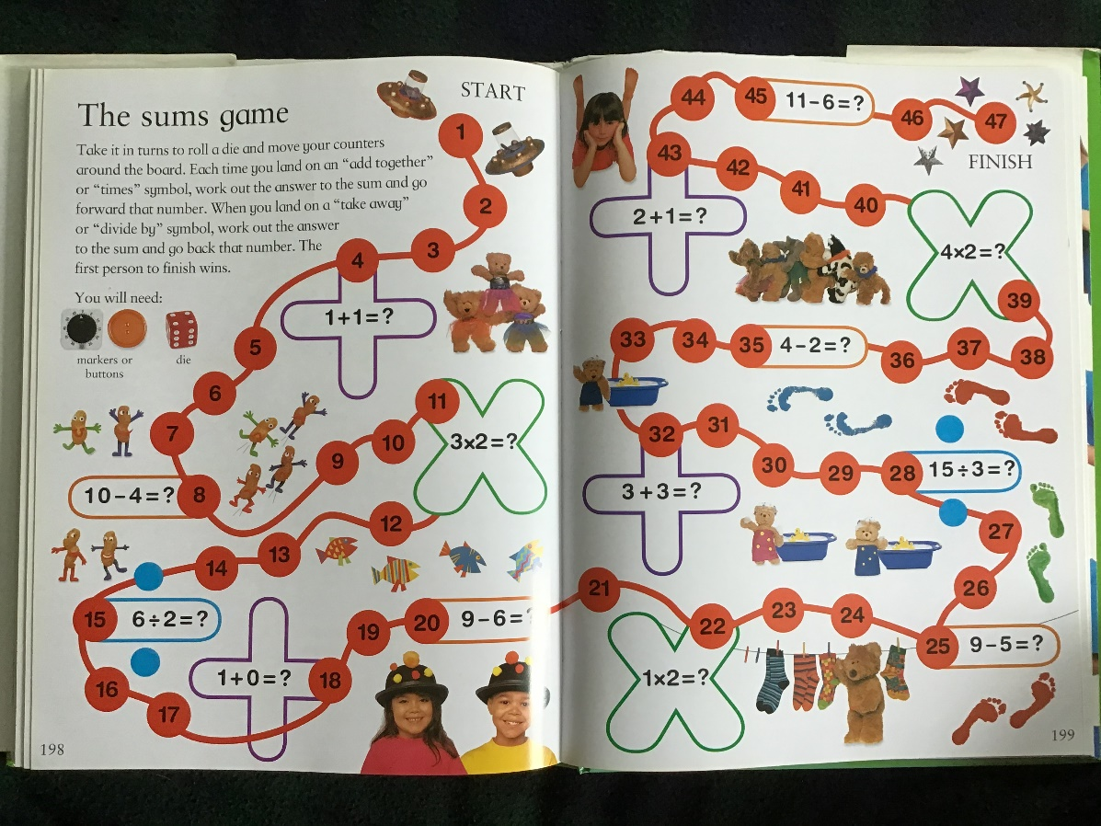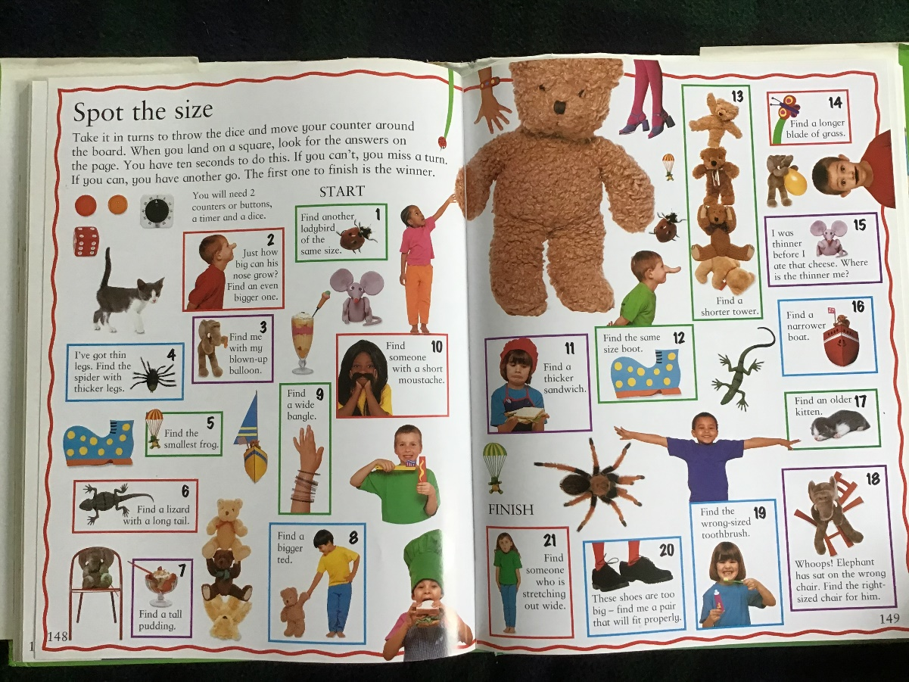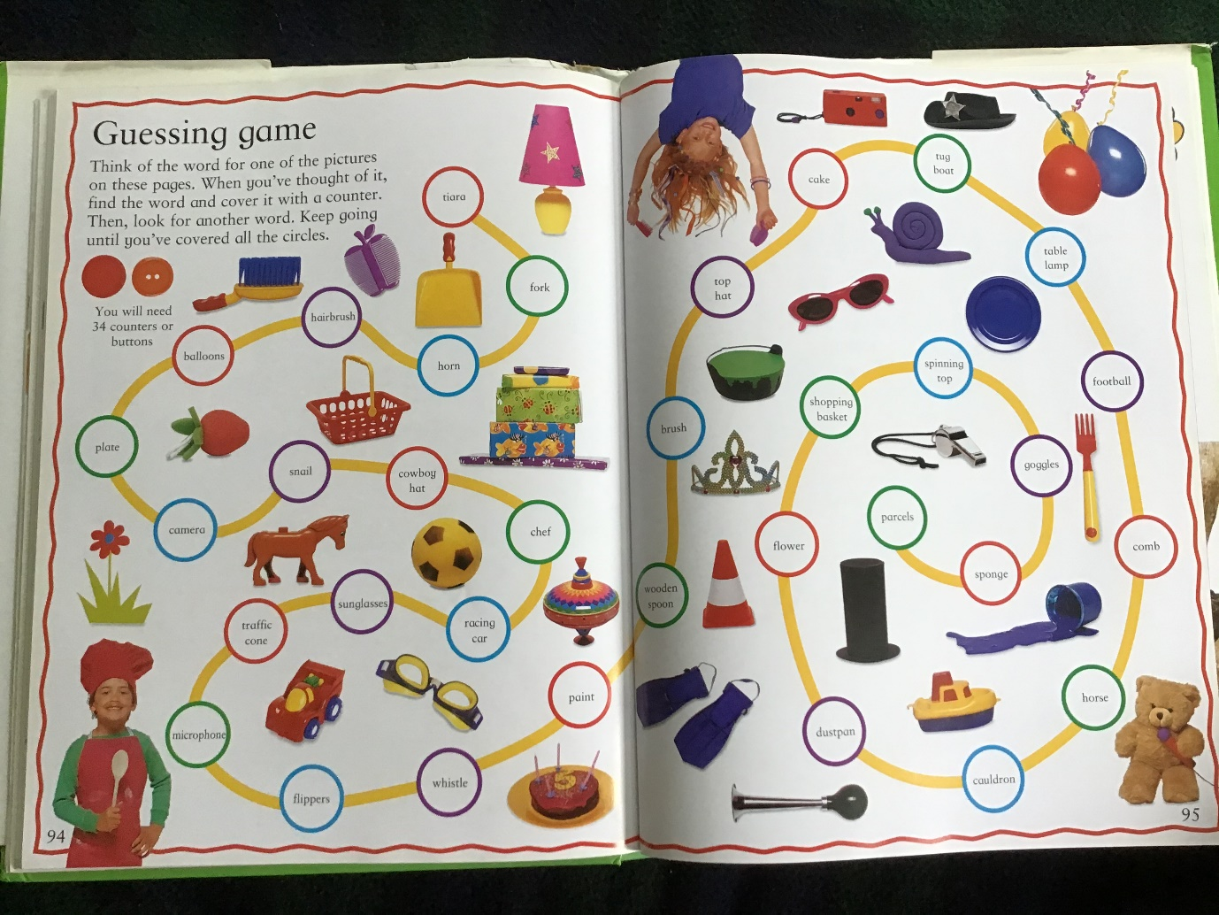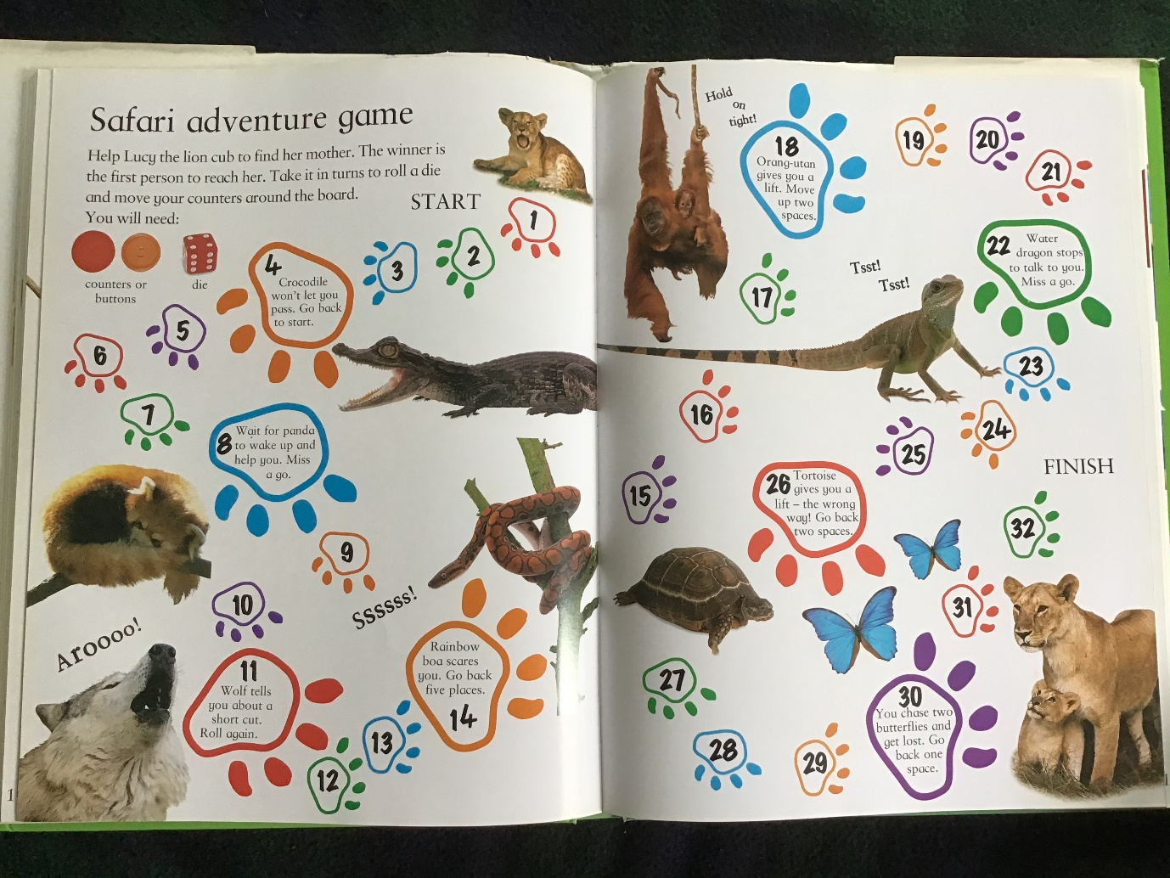

Session 3
Comics
Can you create your own Super Hero – Where are they from? What is their super power?
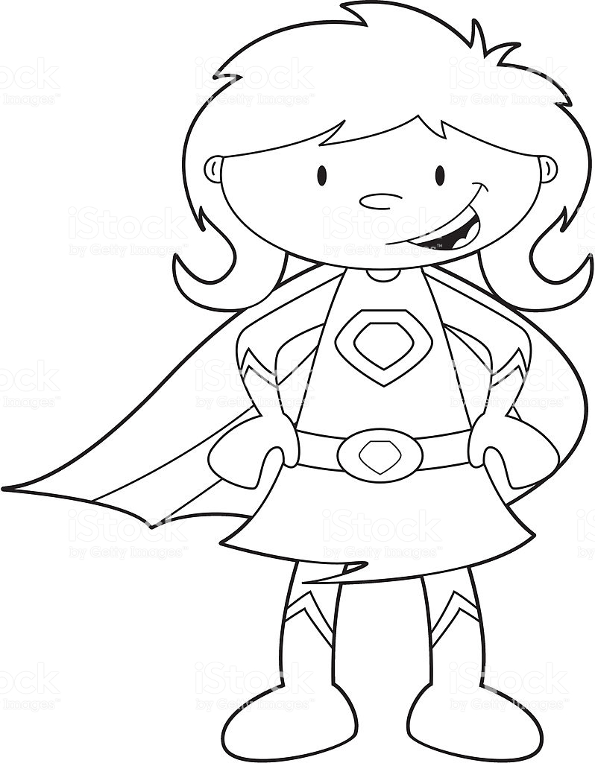
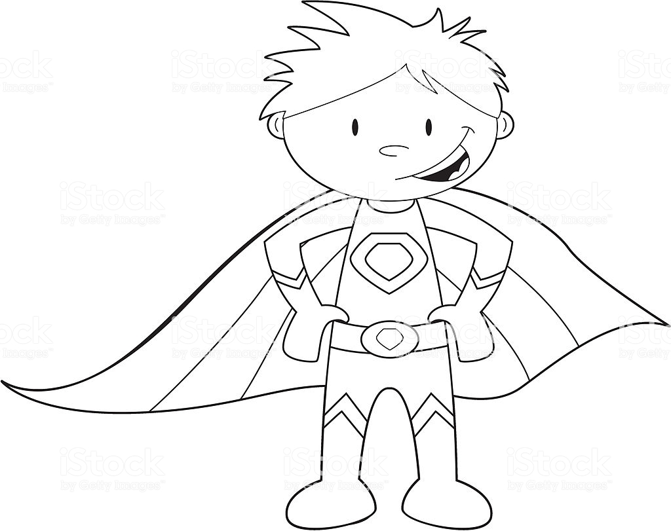

Then, can you write a little comic strip about what your character is doing?
How about an animal or a fairy or a school boy? 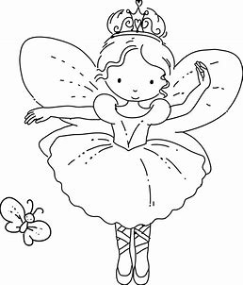

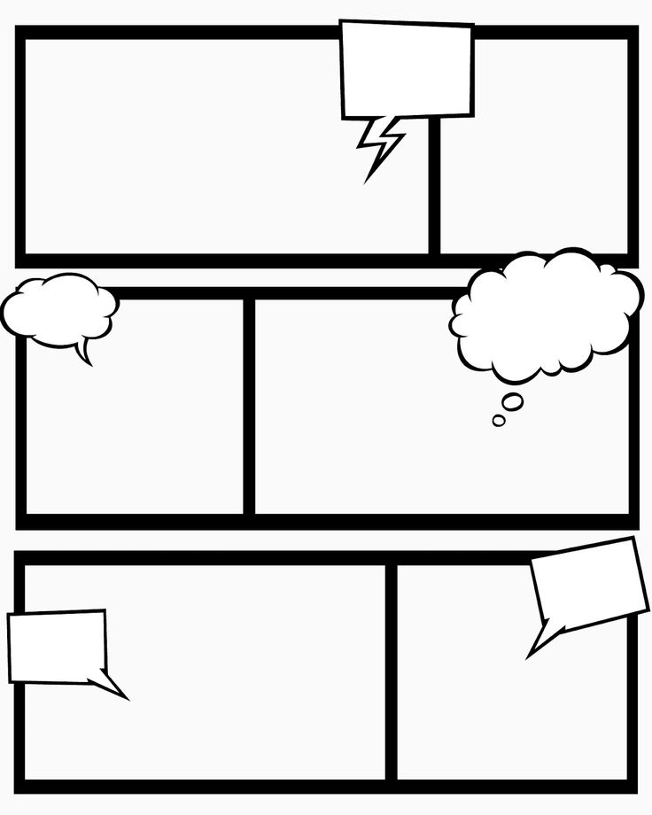

Session 4
Story/Drawing ideas
Roll a die to get a random combination of ideas. (You can use the dice template from session 2 if you don’t have dice at home).

Dice roll | Person/object | Place | Action | Person/object
1 | Princess | Spaceship | Fall in love | Prince
2 | Potato | Igloo | Start a war | Tomato
3 | Snail | Tent | Go fishing | Hippopotamus
4 | Teacher | Jungle | Buy a dog | Ogre
5 | Sausage | Swamp | Go on holiday | Cat
6 | Fairy | Castle | Write a song | Banana

Fill in…
Once upon a time, there was a ………………………………(person/object) who lived in a……………………………(place). They………………………(action) with a ………………………………(person/object).

How would the story continue? Can you illustrate the scene?
Session 5
Write a wish list – might not all be able to happen, but if you have:
1/ Visit the moon
2/ Become a millionaire
3/ Have an ice cream cone with sprinkles
4/ Learn to fly
By the end of the holidays; you may not be any richer, you may not have visited the moon or learnt to fly, but you might have enjoyed a yummy ice-cream!

Have fun!

