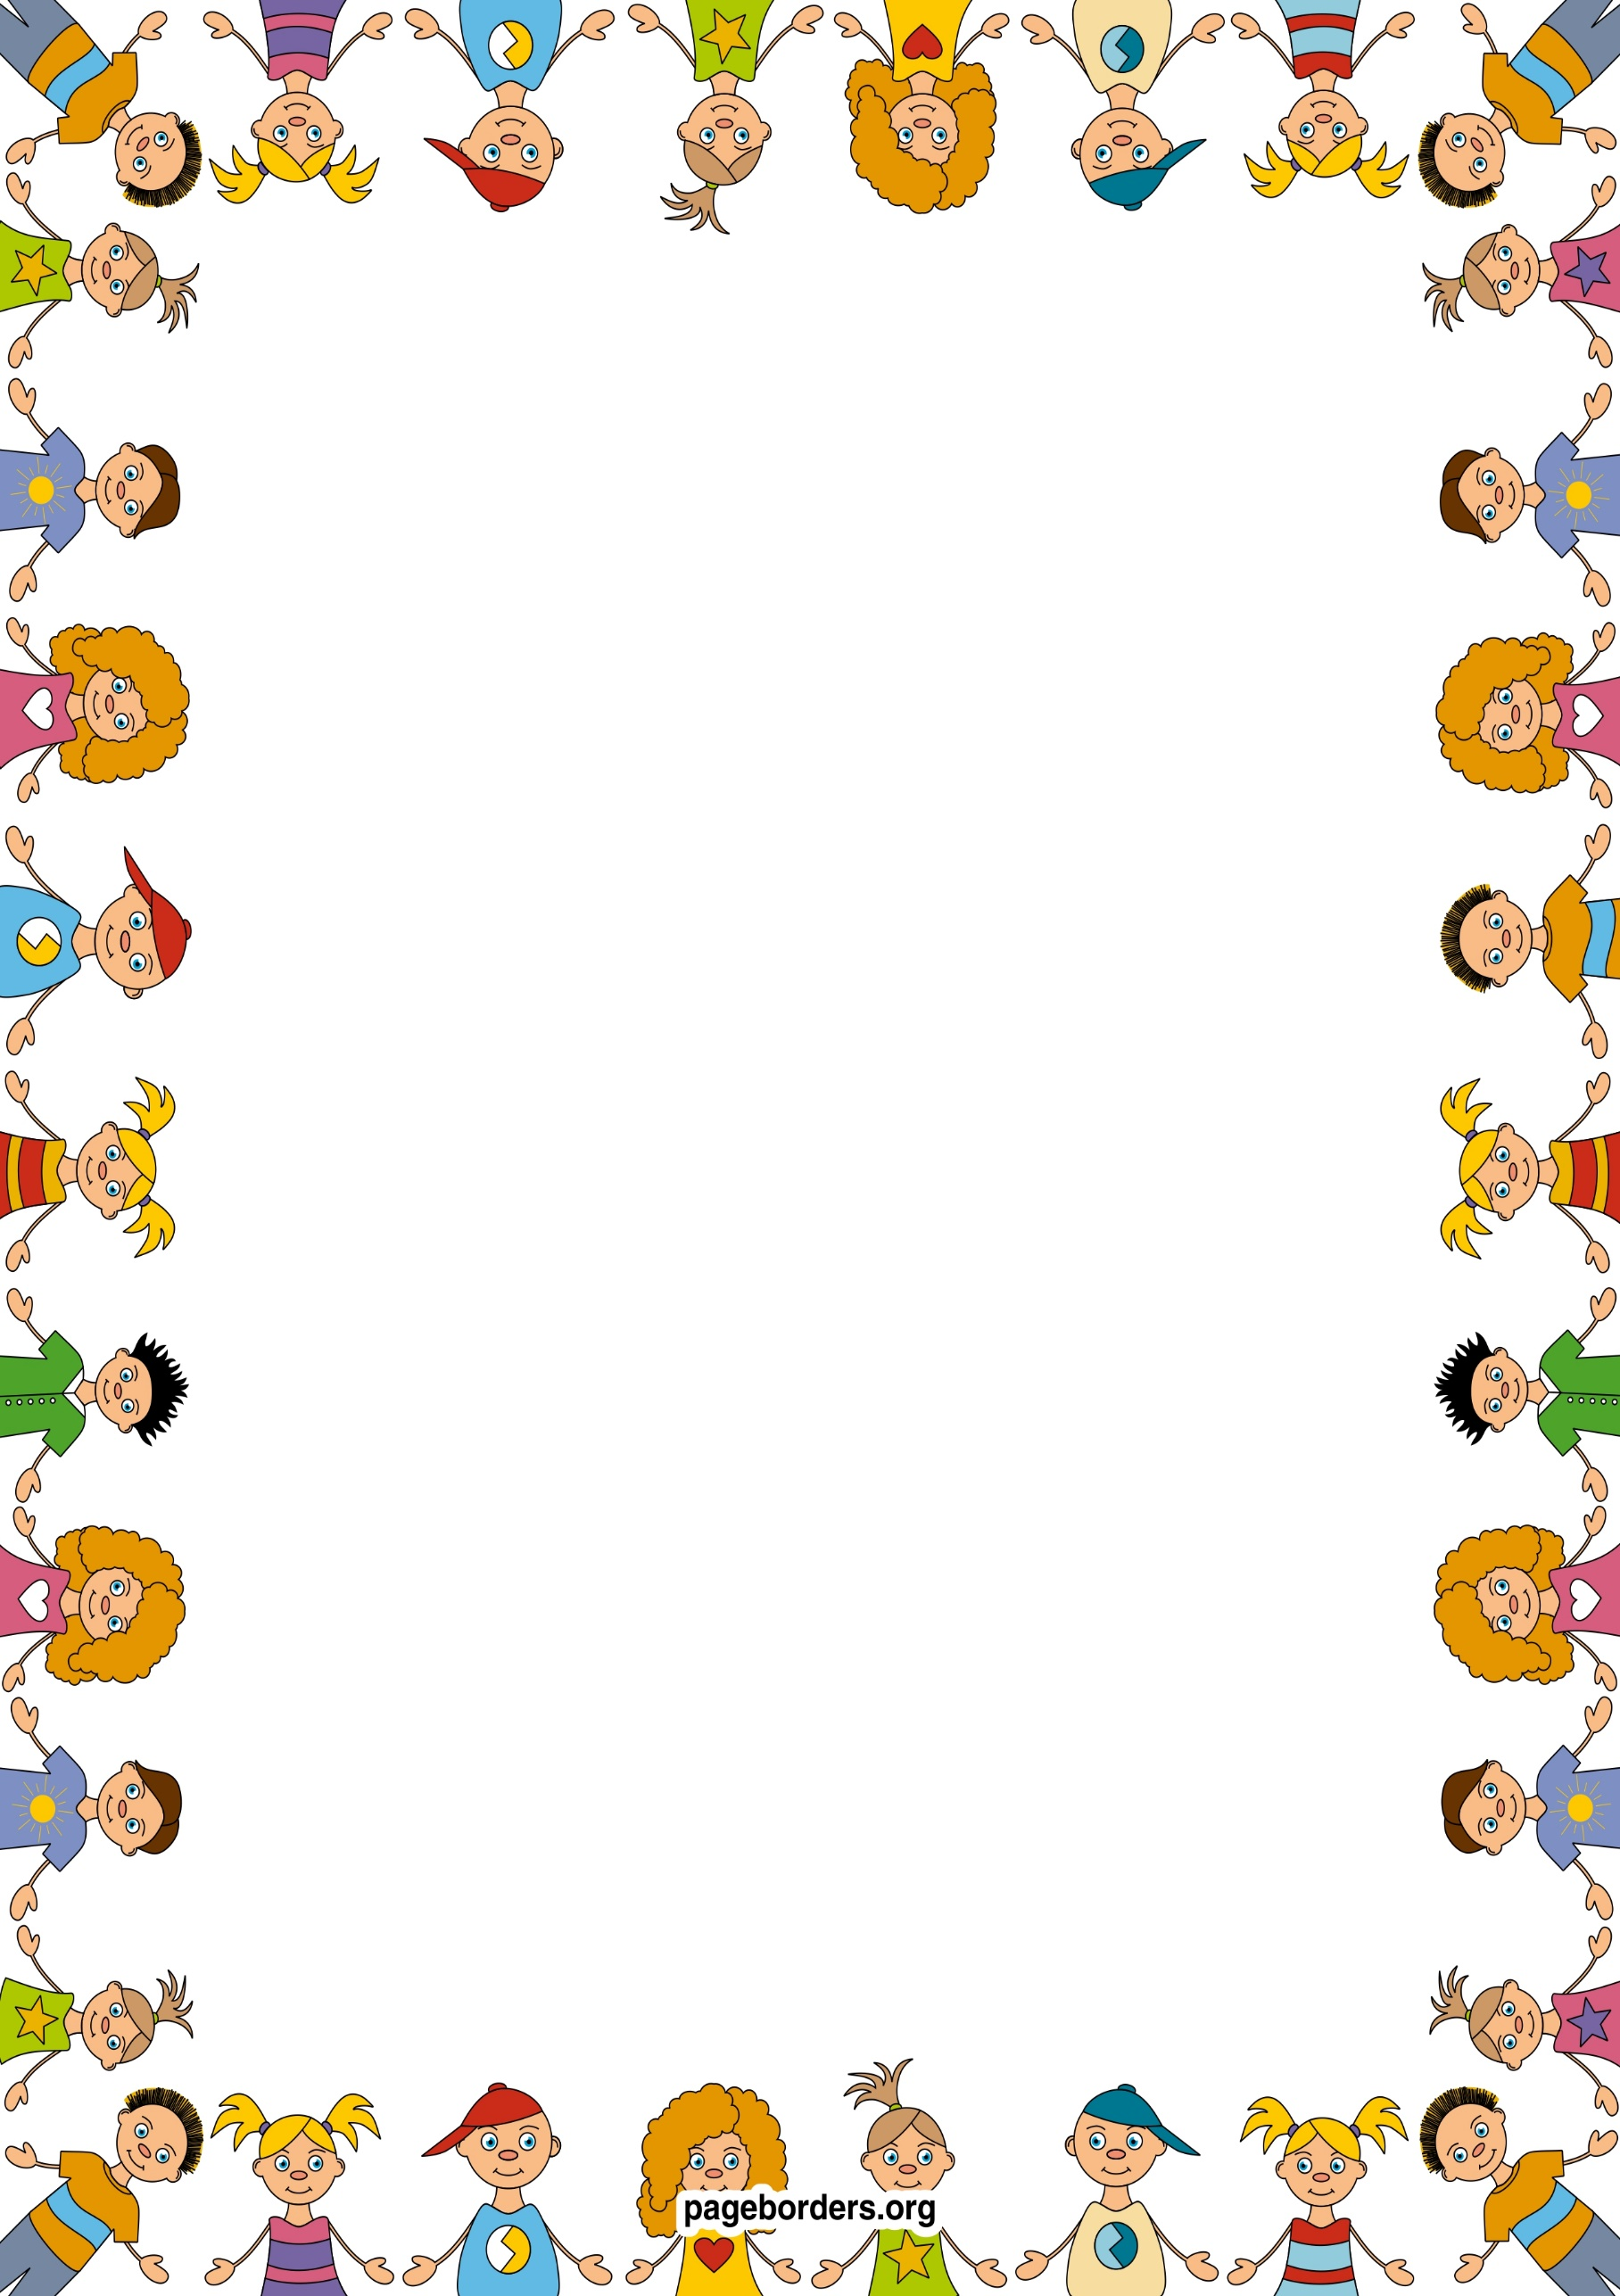

## Mathematics (M)

* Count, recognize and order numbers to 20
* Add and subtract within 10/20
* Find the difference between 2 numbers.
* PV:
* Compare myself, my friends and family and putting my findings into simple graphs and tables
* Order the events in my day.

Continuous provision

* I will be learning to name and describe simple 2D.
* I will be sorting shapes and objects by colour and size
* I will be learning to create repeating patterns.

## Literacy (L)

* Learn to recognise and write name.
* Read, sequence and respond to a range of fiction books and poems (Titch. This is the Hand)
* Learn the different sounds that letters make (phonics)
* Learn to form letters correctly
* Learn to blend and segment sounds to read and write simple words.
* Learn to write a label (family members in a picture)

**Personal Social Emotional Development (PSED)**

* What it means to be unique
* Explore different emotions
* Talk about likes and dislikes
* Turn taking games
* Trying out new activities independently and select resources independently.
* learning routines of the school day
* thinking about the feelings of others

## Communication and Language (CL)

* Talk about myself using describing words such as tall, short.
* Ask questions to get to know my friends in my new class.
* Talk about my family and others important to me.
* Sequence of events in stories and saying what happened in the beginning, middle and end.
* Use role play to imagine and recreate roles in real life family situations and fictional stories.

## Understanding the World (UW)

* Use all five senses to investigate area around them. Senses station.
* Recognise similarities and differences between each other
* Name different parts of the body.
* Recognising change as we grow older. Compare baby photos
* Discuss ways to keep ourselves healthy.
* Birthday celebrations

1. Me and my family 5. Growing and Changing
2. I am unique 6. Senses
3. Body Parts 7. Keeping healthy
4. Faces and Emotions

ARC – Autumn 1 2020

Marvellous Me

## Expressive Arts & Design (EAD)

* Draw pictures of myself using mirrors.
* Draw / paint pictures of my family
* Using ICT for art
* Naming and mix favourite colours
* Use a range of objects to print with e.g. shoes, hands
* Learn new songs that relate to the body
* Make puppets of themselves and friends
* Act out stories with puppets.

## Physical Development (PD)

* Discuss ways to keep ourselves healthy
* Describing the changes my body after being active.
* Moving with control and co-ordination over, under, through various small apparatus.
* Use a range of small and large equipment.
* Use a range of malleable materials in my play.
* What can my hands/ feet/ body parts do?