ARC Newsletter Autumn Term September 2020

Dear Parents and children

Welcome back! We hope that you have all had a wonderful Summer Holiday. It has been so lovely to welcome back our ARC ‘oldies’ and welcome our two new children, Joe and Freddie into the ARC.

We thought it might be useful to give an update on ARC staff so that you can put a face to the member of staff that your child might be talking about!
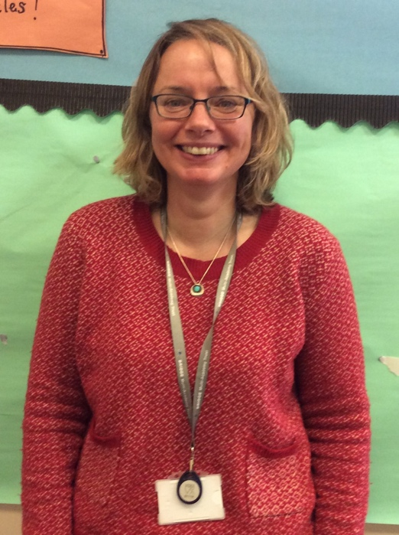
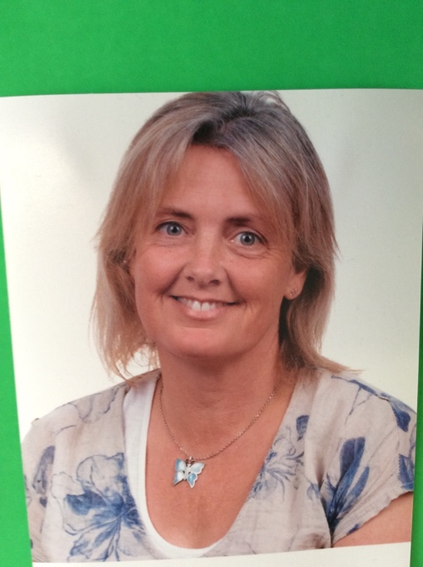
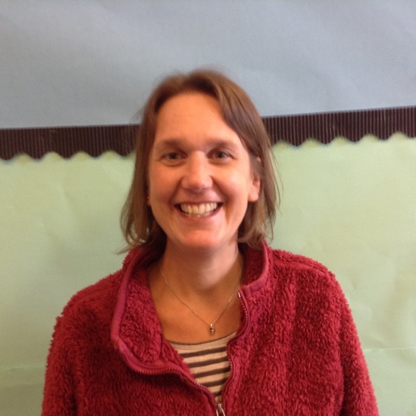

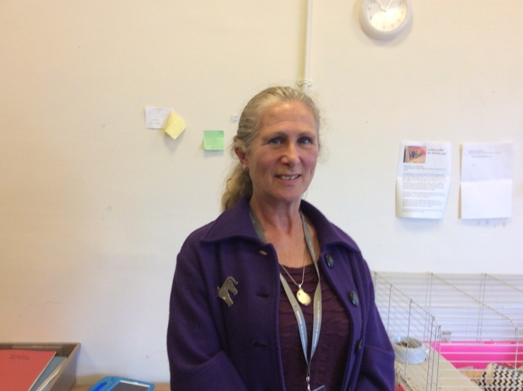
Miss Johnson
Mon- Wed
Mrs Gadd
Wed - Fri
Mrs Rogers
Mon/Tues/Thurs - Fri

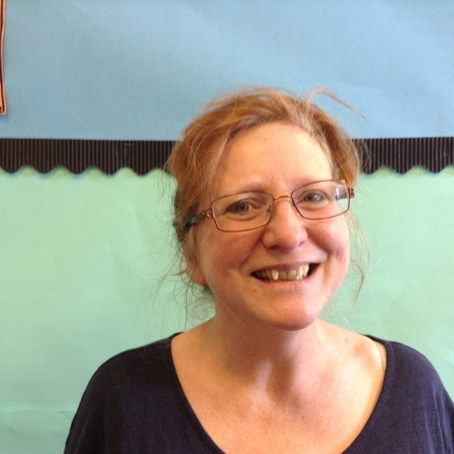

Miss Thomas
Mon/Tues
Mrs Cansdale
Wed/ Thurs/ Fri
( and Tues for this half term)

This term our topic will be Marvellous Me. You can find our planning by following the link on our ARC blog.

As always, we really appreciate the partnership established between home and school. The home-school books will continue to be used as a regular link and it would be really helpful for us if you could let us know via these books a brief outline - how your child slept, whether breakfast has been eaten, mood, how weekend went, or anything out of the ordinary etc. This information will help us support and understand your child in school. We will also be posting regular photos via our Seesaw app of your child and their learning.

Please do not hesitate to contact us with any query/ problem. We will always try and return phone messages as soon as we are able.

We are looking forward to a fun term of learning!
Thanks
Miss Thomas and Mrs Cansdale.

