What are we learning in Fistral class this term?
Autumn Term
September 2021
Important things to remember this term!

Mrs Cansdale teaches the class on a Monday and Miss Evans teaches Tuesday to Friday. We are supported by the wonderful Mrs Hannaford and Mrs Trapp.

Our PE day is a Wednesday,
children can wear PE kit to school on this day.

Regular active breaks will happen throughout the week.

Children can bring a drink into class in a sealed plastic drinks bottle.

Reading will take place in school and books will come home but we are waiting on a delivery of reading diaries.

During this term there will be no tuck shop available at break times but KS1 children are entitled to free fruit so will be provided with a healthy snack. However if you wish to provide your child with their own snack, please ensure it is a healthy snack.
Many thanks.

I sent home a letter to enable you to join Seesaw yesterday. Hopefully you received it and are able to connect as this is the platform I will be using to post important updates and also photos of your children’s learning each week.

Dear Parents/Carers and children,

Welcome back, I hope that you have all had a wonderful Summer holiday. It has been so lovely to welcome the children in Year 2 back to school.
Fistral class have already settled in brilliantly and made an excellent start to the academic year. It is nice to see new friendships developing and so many happy faces in the classroom. I am excited about the year ahead.

This term we will be learning about:

Toys
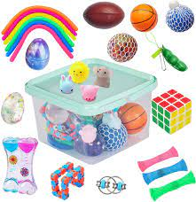

We will be learning about the materials toys are made from in Science, learning about toys from around the world in Geography, comparing old and new toys in History and in R.E. we are focussing on Judaism. We will also be doing music on a weekly basis. We will continue with the same topic after half term through different subjects.

Kind regards,

Miss Evans, Mrs Cansdale, Mrs Hannaford and Mrs Trapp

