Year 5 Spring 1 – Non Fiction
English Learning Journey
Start the journey here…

Write our own diary entry based on what we got up to over the Christmas holidays. Explore how it should be set out.
To begin to learn how write about emotions using self-reflection. Thinking about if a war was to break out now, how would they feel about it and what would their thoughts and emotions be.
To begin to build an understanding of the characters through what they do and what they say. Understand actions they take and the reason as to why. Create a timeline of events of the story to help with chronological understanding
Introduction to book. Discuss layout and create a list of features you would expect to see in a diary entry. Explore the reasons as to why they have been included in the book.

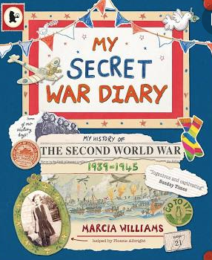
Vocabulary:

Overthrow, compassion, retrieve, pedestrian, solitary, deprive, industrious, exasperate, exert, impressive
Pupils to pick someone from the German side to write a diary entry for. What would they be thinking?
Using the same timeline, pupils decide which character they would like to take the role of to write a diary and choose a section from the timeline to write. Ask them to choose their theme carefully. Pupils work out and annotate the timeline for the ways in which the character would be affected by the events.Take pupils through visualisation activities to ‘see’ some of the events and what happened to them in role. Pupils tell a partner about the event.

Explore a range of sentence constructions, identifying why they have been used. Pupils use the constructions to write a diary entry about their day yesterday.
Collect sentences containing dashes and categorise their role. Practise writing sentences using dashes in the same way.

Grammar
Choose parts of the text where the level of formality changes. How has the author created this shift? Consider vocabulary, sentence construction, etc.

Where our journey ends…

