Welcome back! We hope you all had a fantastic Christmas Holiday and we are now looking forward to a term of exciting learning!

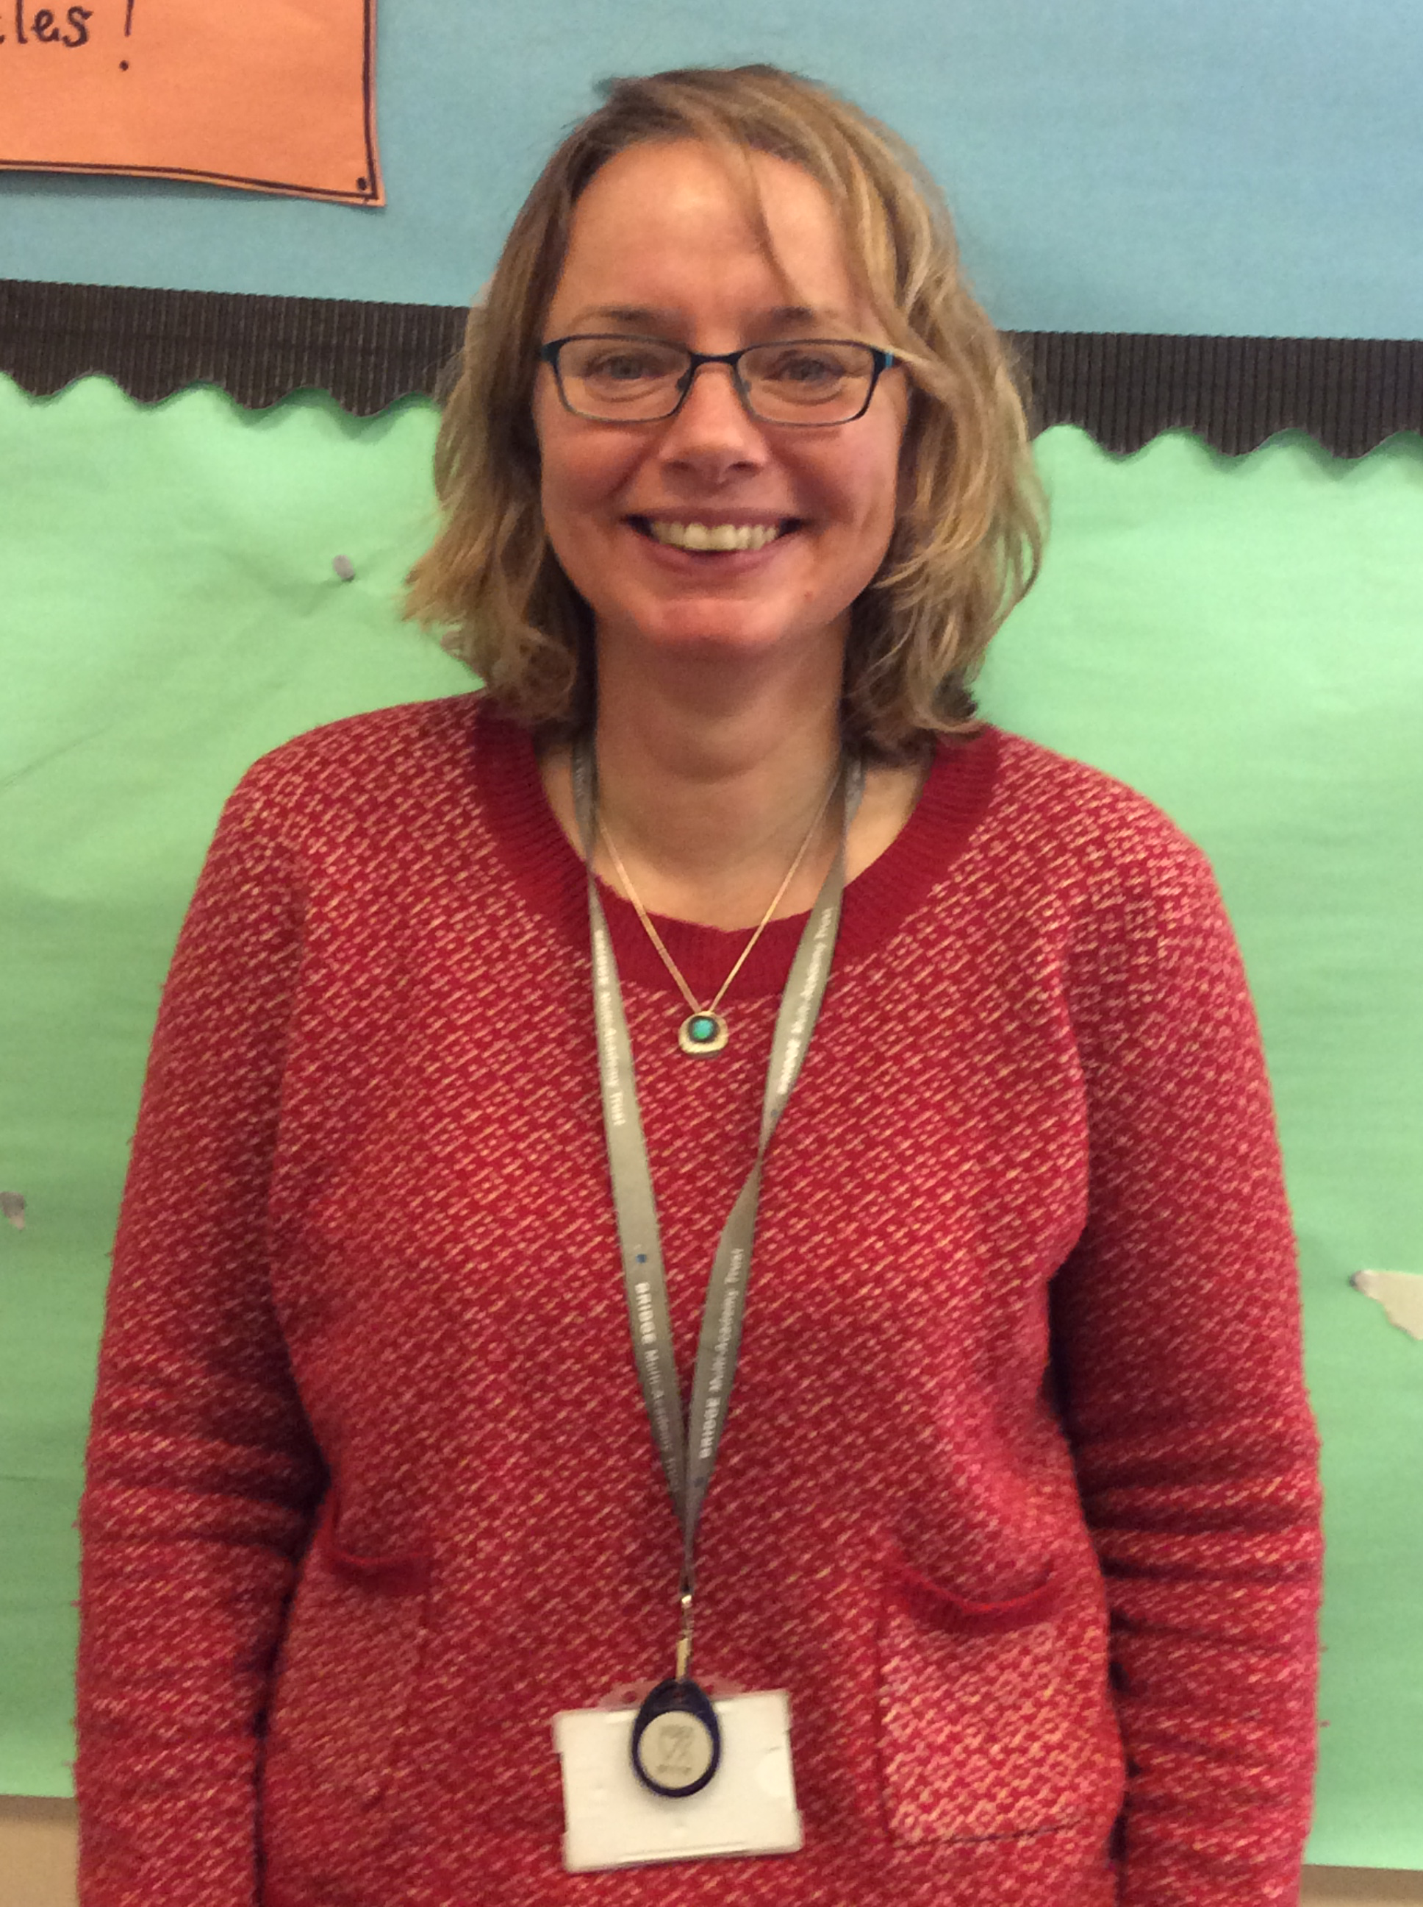
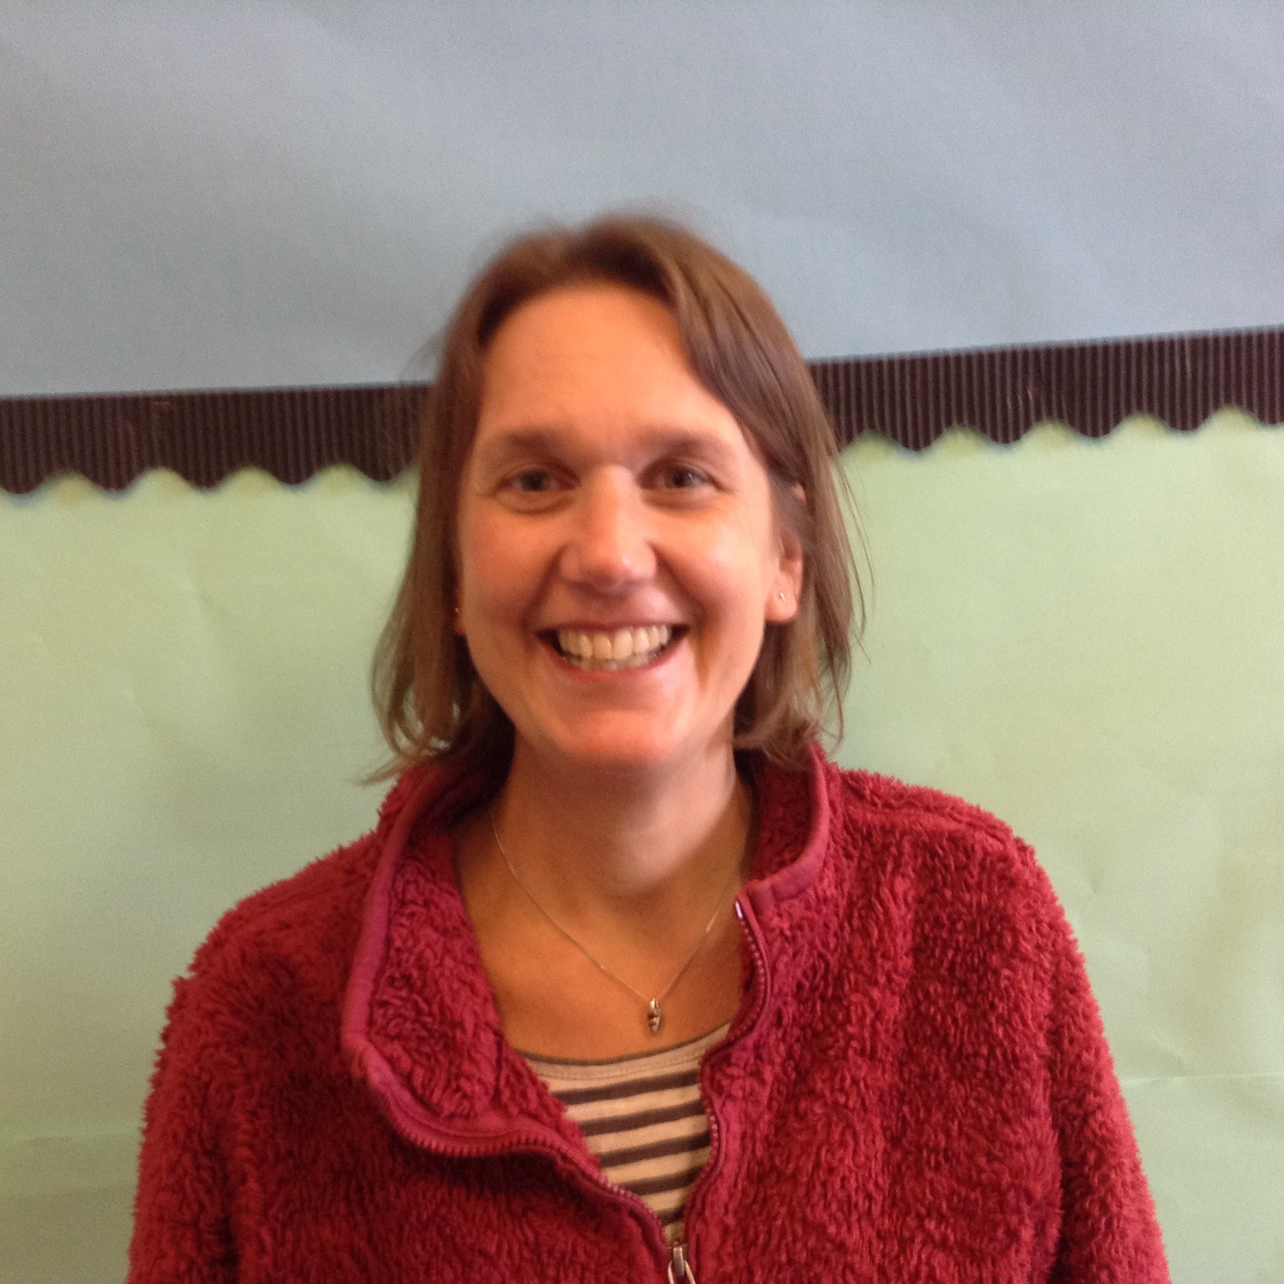
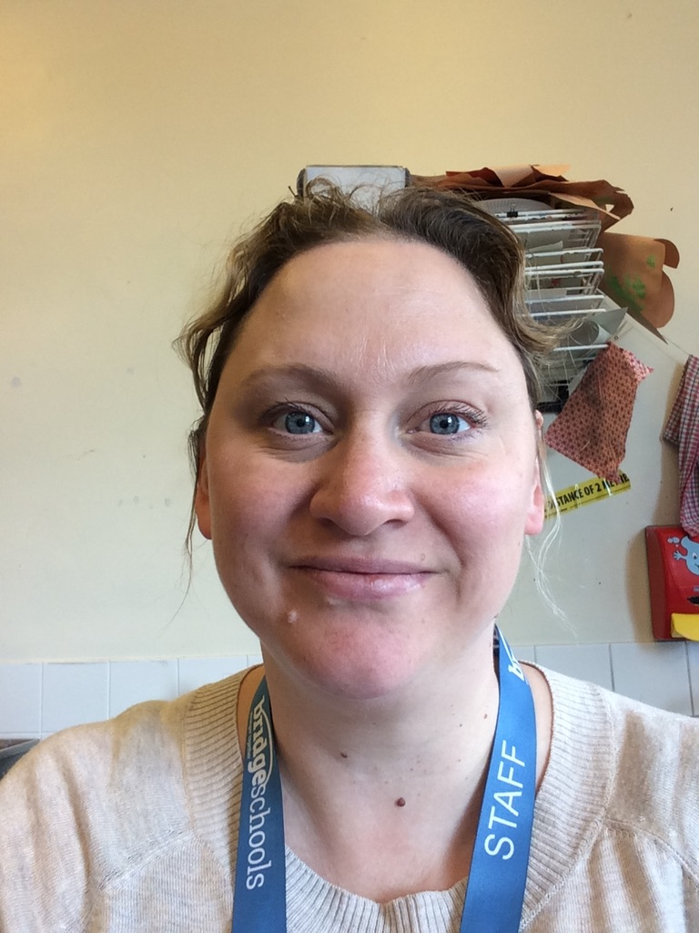
It's often useful to put a name to a face. Here are our current ARC Staff;

Miss Thomas
Monday/Tuesday
Mrs Gadd
Wed/Thurs/Fri
Mrs Jones
Daily
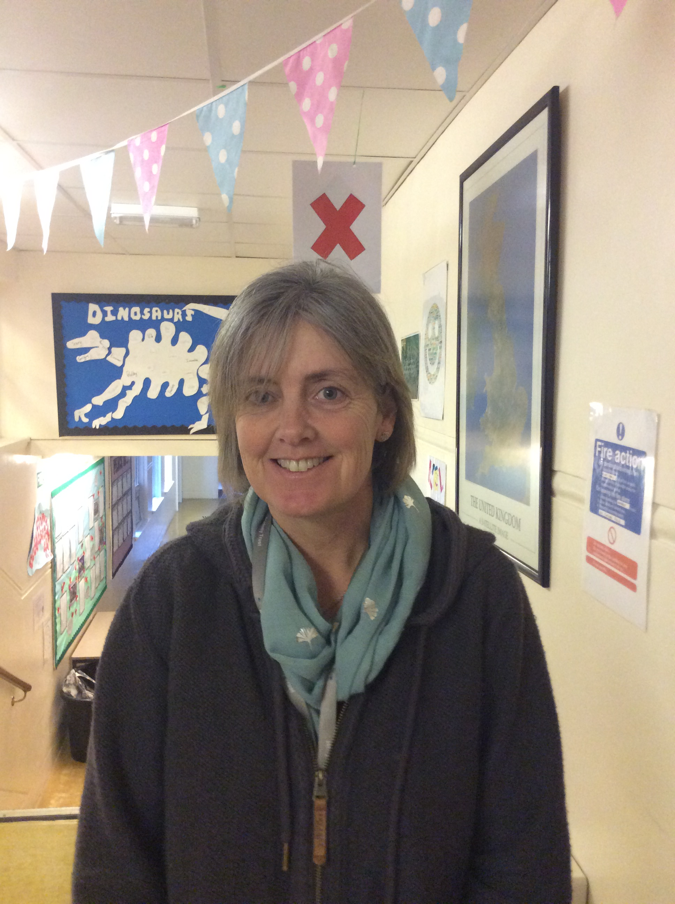
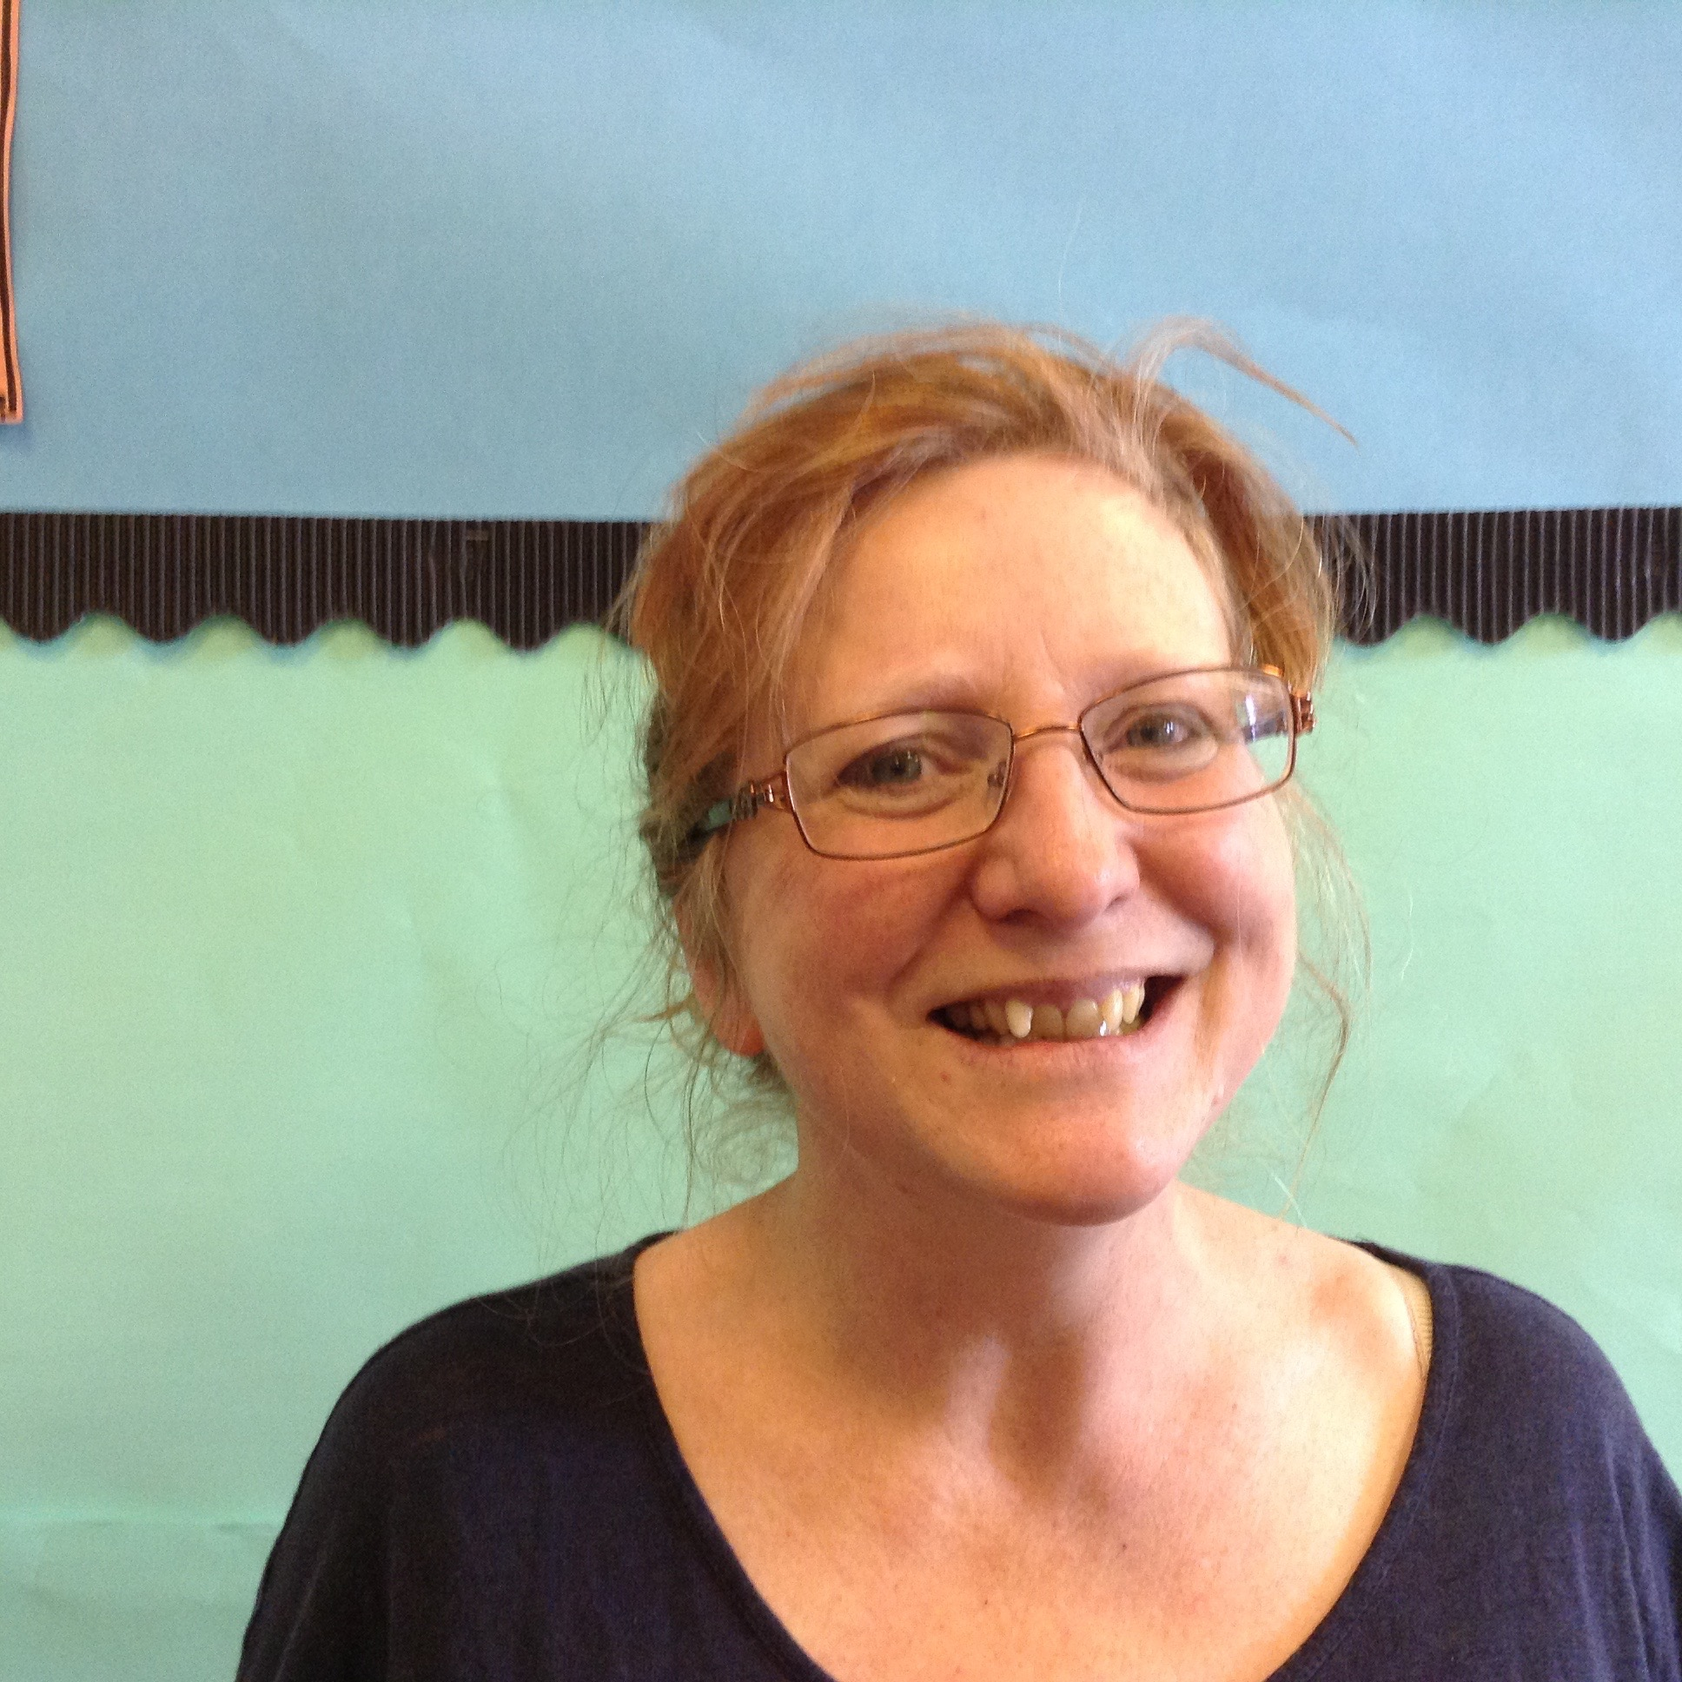
Mrs Cansdale
Tuesday/ Wednesday/ Thursday/ Friday
Miss Johnson
pms
Mrs Rogers
Mon/Tues/Wed/Fri am
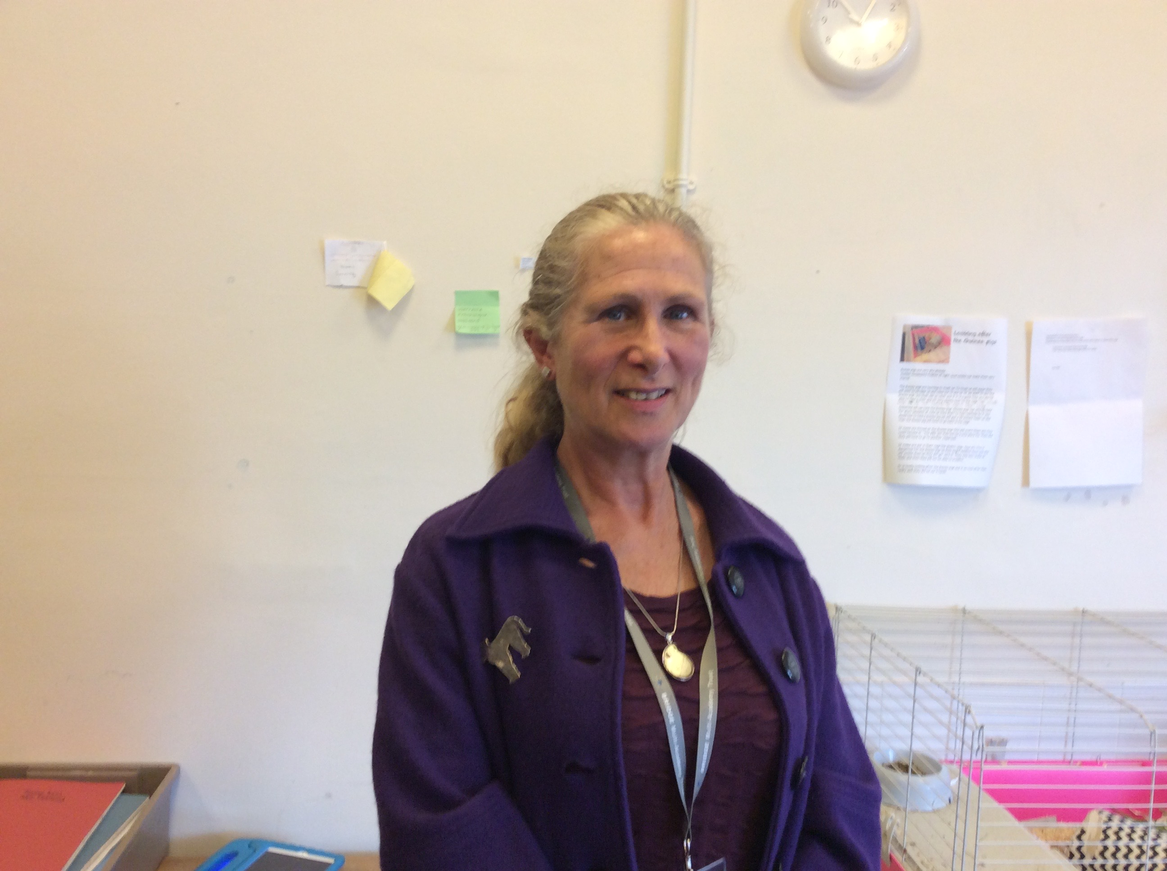
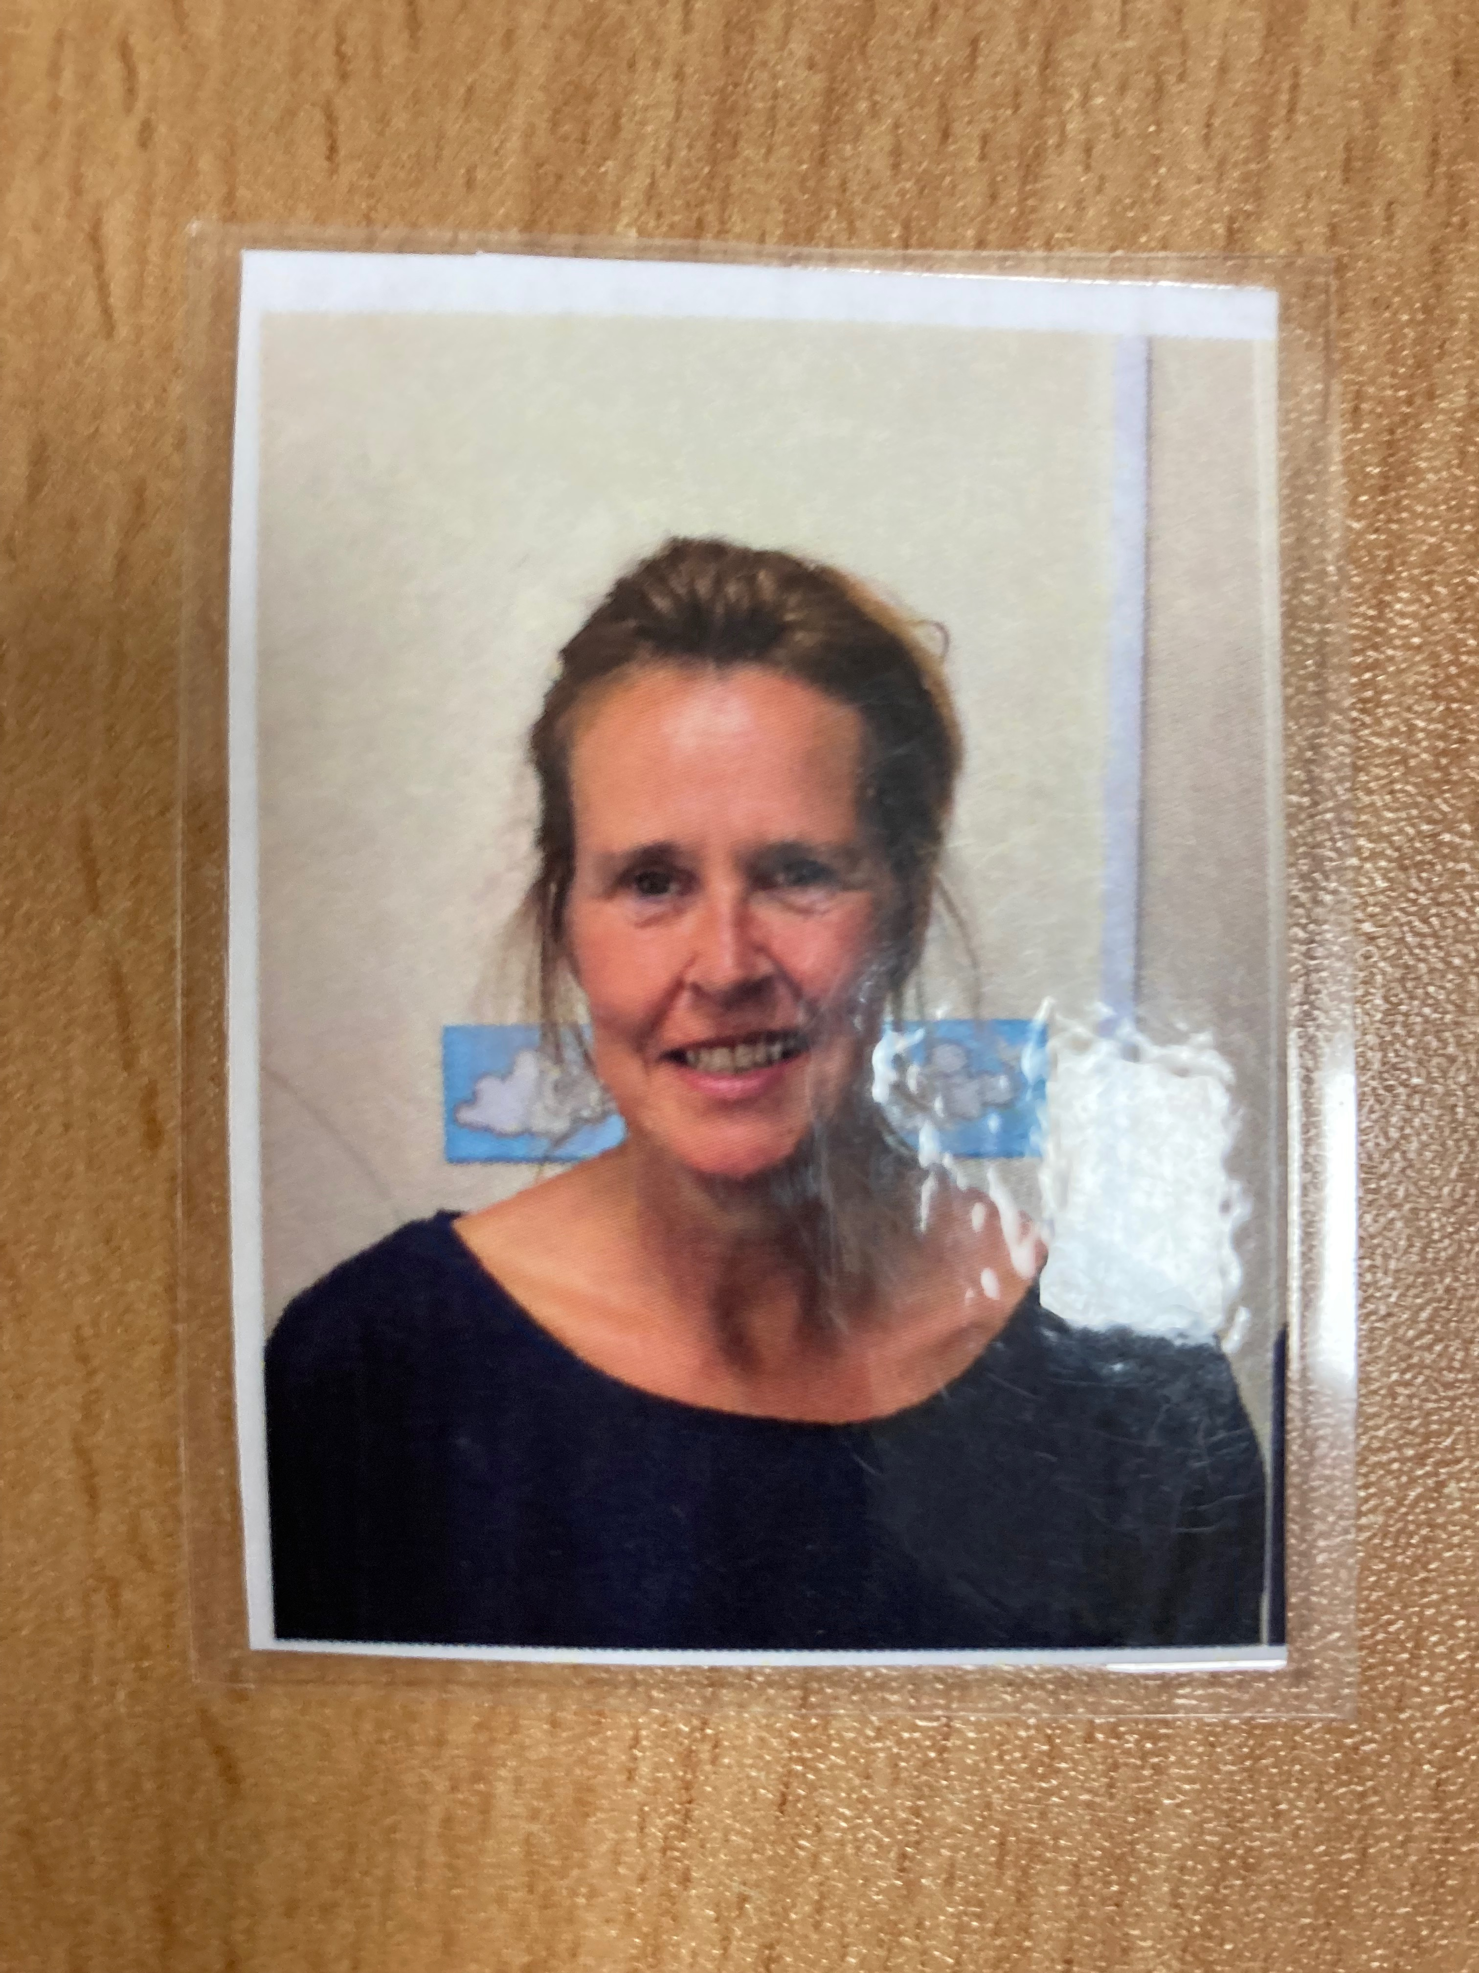

Mrs Hill
Daily
Miss Tate ( student)
Monday or Tuesday

Home/ School Link Books: The home/school link books will continue to be used as a regular link. We appreciate that this is not always easy to fill these in when a morning is hectic but is extremely valuable information which will enable us to best meet the needs of your child.

See-Saw : Our See-Saw system of sharing photos/ information is up and running again. Let us know if you need support to log in.

We also regularly update the Delaware Website via The ARC classroom. Check out our learning opportunities.

We have some exciting learning planned this term. Our topic is Growing - this includes life cycles, planting and weather. We will also be working on some environmental Art.
Our PSHE theme is Goals and Dreams.

If your child brings a reading book home, it would be really helpful for you to make a note in their reading record of what they have read. We can then update this information so that they achieve reading karate points. The boys like to get their new bands!

Please don’t hesitate to contact any of the ARC staff if you have any queries or problems. We will always try and contact you via phone on the same day if you need to discuss anything.

